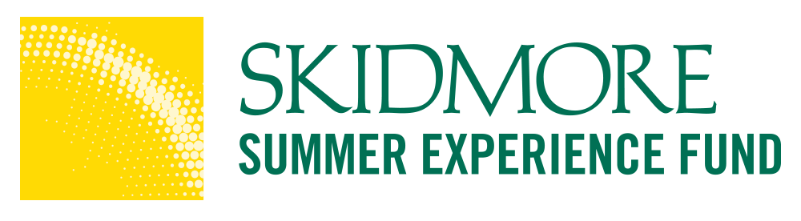
Summer 2024 Supervisor Verification Form
Student Name: Click or tap here to enter text.
Position Title:Click or tap here to enter text.
Organization Name: Click or tap here to enter text.
Supervisor Name: Click or tap here to enter text.
Supervisor Email: Click or tap here to enter text.
Supervisor Phone:Click or tap here to enter text.
Start and End Date: Click or tap here to enter text.
Hours per week: Click or tap here to enter text.
Skidmore College’s Summer Funded Awards are granted on a competitive basis, to help students bridge the gap between their academic studies and career goals, by completing an unpaid internship, research experience, or community service or volunteer position. The awards were designed to provide opportunities for students participating in unpaid or limited-stipend activities over the summer to gain relevant experience in a field of study that they may wish to pursue after college.
Students will receive their award payment in early June, once they have submitted all of their required documentation, including this form. Supervisors will also be asked to complete a brief, final report, at the conclusion of the student’s work. **Note for students completing independent projects supervisors must complete a weekly check-in. Students are required to submit a deliverable of their independent project at the end of the experience.
☐ Please check this box to confirm you reviewed the "primary beneficiary test" and determined that the student is the primary beneficiary of this internship, and not an employee under the Fair Labor Standards Act (FLSA).
In the event that the student is not able to complete the required number of hours or the internship, please contact the SEF Coordinator, SEF@skidmore.edu.
I, Click or tap here to enter text. , agree to oversee the student named above during the course of the internship, and to contact the SEF Coordinator (SEF@skidmore.edu) in The Career Development Center at Skidmore College, should a problem arise or if the internship is terminated for any reason during the course of the summer.
I fully understand the requirements of the Skidmore Summer Funded Internship Program and agree to all that is stipulated above.
Signature: Click or tap here to enter text. Date: Click or tap here to enter text.

