**Build a Better Battery1**

[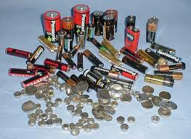](http://www.google.com/imgres?q=batteries&num=10&hl=en&biw=1920&bih=958&tbm=isch&tbnid=mbqmmq2hPN6vXM:&imgrefurl=http://www.acceler8or.com/2012/07/batteries-not-included-or-needed-2/&docid=ao5JzVQqKNxetM&imgurl=http://www.acceler8or.com/wp-content/uploads/2012/07/bunchofbatteries.jpg&w=400&h=292&ei=vD4YUOz4GoOS9QSHxICAAQ&zoom=1&iact=hc&vpx=996&vpy=323&dur=11962&hovh=192&hovw=263&tx=113&ty=99&sig=106702737713436862042&page=1&tbnh=143&tbnw=173&start=0&ndsp=37&ved=1t:429,r:13,s:0,i:189)

It is midnight and you are desperately trying to finish all your calculations for your 8:00 am chemistry lab when the non-rechargeable batteries in your calculator die. No one else is awake to borrow a calculator from so you hop in your car and run to Walmart to buy more batteries. While you are standing in the battery aisle trying to remember if you need AA or AAA size batteries your tired brain gets distracted by the array of choices in front of you. You start wondering:

What's the difference between AA, AAA, C and D batteries?

Why do you need to use a particular size?

Why do batteries die?

Why are some batteries rechargeable and others are not?

How can a little button battery have more volts than a big battery?

What's the difference between alkaline, lithium ion, metal-hydride and Ni-Cd?

You know these are chemicals, but how do they make energy?

How do they decide what chemicals to use?

Breaking-out of your reverie, you buy your mega-pack of AAA batteries and go back to finish your calculations. Still, you wonder, is there anything you are learning in general chemistry that might help answer some of your questions?

**Background**

Once again chemical equilibrium and LeChatelier's principle play a role in everyday life. Good batteries are systems that are not in equilibrium and, as we know from LeChatelier's principle, systems not at equilibrium tend to shift to achieve equilibrium. Inside a battery, two parts of the system are separated so that the shift toward equilibrium cannot occur until a circuit is completed that allows electrons to flow from one part to the other. When we put something like a lightbulb or an electric motor in the circuit we can use the energy generated by the flow of electrons to produce light or run the motor.

So, where in the world of chemistry do we have electrons moving from one chemical to another? Redox reactions! In redox reactions, one material gets oxidized (loses electrons) while another gets reduced (gains electrons). An example of a typical redox reaction that could be used to create a battery is the reaction between solid zinc metal and the copper (II) ion (equation 1) which has a large equilibrium constant (Keq = 2 × 1037) so that the equilibrium lies far to the right.

Zn(s) + Cu2+(aq)  Zn2+(aq) + Cu(s) (1)

If we want to see how the electrons move to produce energy, in relation to the reactants and products, we can split the reaction into an oxidation half (equation 2) and a reduction half (equation 3).

Zn(s) Zn2+(aq) + 2e- (2)

Cu2+(aq) + 2e- Cu(s) (3)

Now we can see that electrons are removed from the Zn and moved to the Cu2+. If we think of each half as a separate part of the reaction, the oxidation half and the reduction half can be located in separate places and the reaction will still happen as long as there is some connection that allows the electrons to move. To do this we take advantage of the fact that electrons can be conducted through a wire. Figure 1 shows what our Zn/Cu battery might look like if we created one in the lab.

voltmeter



+

-

salt bridge

wire

Cu cathode

Zn anode

Zn(s) → Zn2+(aq) + 2e-

**Figure 1.** Diagram of a beaker battery.

Cu2+(aq) + 2e- → Cu(s)

Another name for a battery is an electrochemical cell therefore each of the beakers is a half-cell. The oxidation half-cell (anode) contains both the species involved in the oxidation while the reduction half-cell (cathode) contains both the species involved in the reduction. As the oxidation half reaction produces electrons they travel through the wire to the site of the reduction half reaction. You'll notice in the diagram there is one more key part to make it all work, the connecting salt bridge. The bridge contains positive and negative spectator ions that move toward the anode and cathode to prevent the buildup of a charge in either half-cell.

As long as the reaction occurs spontaneously, it produces an electromotive force (emf) that pushes the electrons through the wire. When a voltmeter is connected to the wires going to the anode and cathode, the emf can be measured in volts. Since a volt is defined as a joule per coulomb (charge), the voltage is a measure of the maximum amount of energy or work produced per unit of charge (think electron) that passes through the cell. So how does this measured voltage relate to equilibrium? Well........

* The reaction is only spontaneous when the system is not at equilibrium.
* So the maximum amount of energy is the amount released when it goes from its current state to equilibrium.
* Therefore the cell's potential (Ecell) depends on how far away from equilibrium it is.
* Since, at equilibrium, the ratio of concentrations of products to reactants is constant (Keq), cell voltage (Ecell) has a mathematical relationship to the concentrations.
* Because Ecell will be zero at equilibrium we can figure out what the concentrations would be at equilibrium using the mathematical relationship.
* 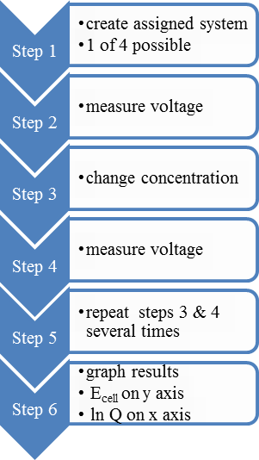This allows us to determine the Keq for the cell reaction without to waiting for the system to equilibrate.

How, you might ask, are we going to figure all this out? Logically, to find how Ecell relates to concentration it makes sense to vary the concentration of one of the reactants or products and measure the voltage at each concentration (see figure 2). Each group will be assigned a system and measure the voltage as they change the concentration of either a product or reactant. An excellent way to see relationships is by creating a graph of the results. While we could simply graph concentration of the component varied versus Ecell (in volts) this doesn't allow us to find the relationship to the concentration of other components of the system. A better graph would be to use the reaction quotient (Q) that includes the concentration of all system components instead of the concentration of only one component. As you have already seen with other equilibrium expressions such as pH, concentration changes have an exponential effect so we will graph ln Q.

**Figure 2.** Part A, concentration vs Ecell.

To make it easier to compare results between groups, everyone will use the same oxidation half-cell which is characterized by the reaction given in equation 4.

Ag(s) + Cl−(aq)  AgCl(s) + e- (4)

Ag wire

AgCl coating on wire

KCl solution

membrane, acts as salt bridge

wire to meter

An advantage of using this reaction is that we can purchase an electrode (Figure 3) that already contains everything needed for this oxidation half-reaction (or reference half-reaction) which minimizes waste and ensures consistency between groups. *The overall reaction for your particular cell will then be the combination of this oxidation half-reaction and your specific reduction half-reaction. Your Q and Keq will be for this overall reaction.*

**Figure 3.** Reference electrode.

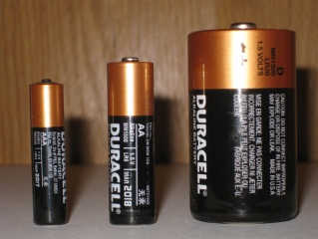Great, now we've determined how concentration affects voltage but how is that related to the array of batteries you see in a store? Consider figure 4, all the batteries are 1.5 volts even though they are different sizes, why? They all use identical chemistry at the same concentrations!

**Figure 4.**  All 1.5 volt.

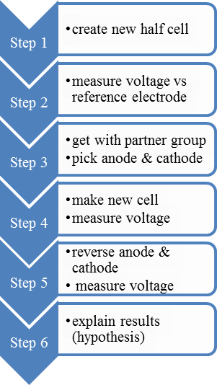But what's going on in figure 5? Taking a quick look at the battery aisle in any store we can see that batteries come in a variety of shapes, sizes and voltages designed for different purposes. Sometimes bigger batteries have a lower voltage than smaller batteries. While this can be due to different concentrations, we can also see that different batteries use different chemistry (alkaline, lithium, metal-hydride). Is there anything about the different chemical reactions in different batteries that allows us to create a small battery with a higher voltage than a big battery? Is there any way we can design a better battery (predict the Ecell) without measuring the potential of each possible reaction at a variety of concentrations?

**Figure 5.** Various voltages & chemistries.

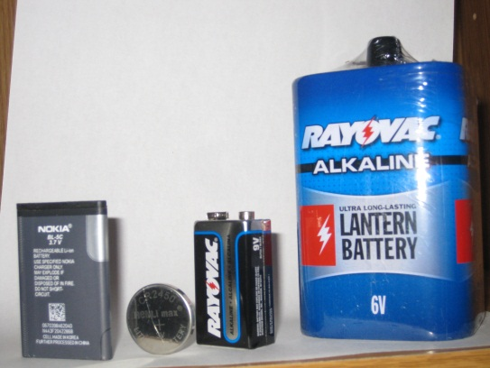

3.7 volt, M-H

Alkaline, 6 volt

9 volt

3 volt, Li

This is what we are going to try to do in the second part. When we measured the potentials in the first part, we used a common reference electrode for the oxidation reaction so that we could compare results between groups. Because the oxidation half-reaction is the same for all the systems, we can consider the potentials that we measured to be due to the reduction half-cell. This allows us to use the information to predict what the potential of a new cell would be that combines two of the reduction half-reactions without the reference electrode.

**Figure 6.** Part B, new cell?

For part B, you will prepare a new half-cell (Figure 6). After measuring the potential relative to the same reference electrode used in part A, you will get with your partner group and create a new cell made by combining your two half-cells. After measuring the potential of the new cell you will try to come up with a hypothesis for why you got what you got.

**Procedure**

*Note: You will be assigned one of the systems in tables 1& 3. Check Blackboard for your assignment and adapt your procedure and tables accordingly.*

Part A: What is the relationship between concentration and Ecell?

**Table 1.** Half-cell solutions for the determination of concentration effects on Ecell.

|  |  |  |  |  |
| --- | --- | --- | --- | --- |
| system | cathode solution directions | stock solution | diluted solution | Q = |
| Ag+/Ag | only Milli-Q H2O | 0.10 M AgNO3 | 1.0 × 10−3 M AgNO3 | 1/[Ag+][Cl−] |
| Cu2+/Cu | 1 mL 0.1 M HNO3 + Milli-Q H2O | 1.0 M Cu(NO3)2 | 0.10 M Cu(NO3)2 | 1/[Cu2+][Cl−]2 |
| Fe3+/Fe2+ | 1 mL 18 M H2SO4 + 1 mL 0.10 M FeCl3 + Milli-Q H2O | 0.10 M (NH4)2Fe(SO4)2 | 1.0 × 10−3 M (NH4)2Fe(SO4)2 | [Fe2+]  [Fe3+][Cl−] |
| quinhydrone *(Qu:QuH2 in 1:1 ratio in solution)* | 100 mL Milli-Q H2O, add solid quinhydrone to **beaker** until solid left after stirring | 1.0 M HNO3 | 0.10 M HNO3 | [QuH2]  [Qu][H+]2[Cl−]2 |

1. Prepare 25 mL of diluted solution (Table 1) as follows:
   1. Get approximately 30 mL of the stock solution for your assigned system.
   2. Rinse a 25 mL volumetric flask with Milli-Q water.
   3. **Add the amount of stock you calculated before lab** and dilute to the line with Milli-Q water.
2. Prepare 100 ml of cathode solution for your assigned system (Table 1) as follows:
   1. Rinse a 100 mL volumetric flask with Milli-Q water.
   2. Fill the flask part way with Milli-Q water. *(This is especially important if your system contains a strong acid.)*
   3. Add any additional *solutions* given in Table 1 for your system.
   4. Fill the flask to the mark using Milli-Q water*.*
   5. Transfer the solution into a clean and dry 250 mL beaker. Add solid if needed.
3. Pipet 3 mL of the dilute solution into your cathode beaker and mix well with a stirring rod. Carefully lower the reference electrode into the beaker until the tip is submerged. Attach the sample electrode (Table 3) to the red clip and place it in the beaker. Set the meter to millivolts (mV) and read the result.
4. Without removing the electrodes or stirring rod, add additional aliquots of the dilute solution as given in Table 2, mixing and measuring the mV after each addition. When all additions of the dilute solution are complete you will have added a total of 20 mL and the total volume will be 120 mL
5. Now continue adding to the solution in the beaker using aliquots of the original stock solution (Table 2) instead until a total of 20 mL of stock has been added. The final volume in the beaker will be 140 mL.

**Table 2.** Effect of concentration on Ecell for *(insert your system)* half cell.

|  |  |  |  |  |  |
| --- | --- | --- | --- | --- | --- |
| solution to add | amount to add (mL) | total volume (mL) | [your cation] | Q | Ecell (V) |
| dilute | 3.00 |  |  |  |  |
| dilute | 3.00 |  |  |  |  |
| dilute | 4.00 |  |  |  |  |
| dilute | 5.00 |  |  |  |  |
| dilute | 5.00 |  |  |  |  |
| stock | 3.00 |  |  |  |  |
| stock | 3.00 |  |  |  |  |
| stock | 4.00 |  |  |  |  |
| stock | 5.00 |  |  |  |  |
| stock | 5.00 |  |  |  |  |

Part B: Can we predict cell potential?

**Table 3.** Half-cells for the determination of full cell potentials.

|  |  |  |  |  |
| --- | --- | --- | --- | --- |
| system | stock solution | half-cell solution | additional items in solution | sample electrode |
| Ag+/Ag | 0.10 M AgNO3 | 1.0 × 10−2 M Ag+ | none | Ag wire |
| Cu2+/Cu | 1.0 M Cu(NO3)2 | 0.10 M Cu2+ | + 1 mL 0.1 M HNO3 in 100 mL flask | Cu wire |
| Fe2+/Fe3+ | 0.10 M (NH4)2Fe(SO4)2 | 1.0 × 10−2 M Fe2+ | +1 mL 18 M H2SO4 & 1 mL 0.10 M FeCl3 | graphite rod |
| quinhydrone (Qu) | 1.0 M HNO3 | 0.10 M HNO3 | add solid quinhydrone to **beaker** until solid left after stirring | graphite rod |

1. Prepare your assigned half-cell solution in a 100 mL volumetric flask as given in Table 3 *(not the same as Table 1)* **using the amount of stock you calculated before lab**. Be sure to include any additional items listed. Transfer this solution to a clean, dry 250 mL beaker. Attach the sample electrode (Table 3) to the red alligator clip and measure the Ecell versus the reference electrode.
2. Get with your assigned partner group. Compare the values that you got for Ecell versus the reference electrode and decide which half-cell will undergo reduction and which undergo oxidation.
3. Prepare your full cell as follows:
   1. Soak a piece of string in Milli-Q water followed by several minutes of soaking in about 20 mL of 1 M KNO3.
   2. *Detach* the reference electrode from one of the meters and then attach the sample electrode for the oxidation half-cell to the black alligator clip. Put the sample electrode in the oxidation half-cell.
   3. Attach the sample electrode for the reduction half-cell to the red alligator clip on the same meter and place it in the reduction half-cell.
   4. Put the two beakers next to each other and drape the string between the beakers so that one end is submerged in the solution in each beaker. Do not let the string dry out.
4. Measure the Ecell for the new full cell.
5. Attach the red and black leads to the opposite electrodes and measure Ecell again.

**Data Collection**

Copy tables 1-4 into your notebook making appropriate changes for your assigned systems. **Fill in the volume, concentration and Q columns for Table 2.**

**Table 4.** Determination of full cell potentials.

|  |  |  |
| --- | --- | --- |
| systems | *insert your system* | *insert partner system* |
| amount of stock solution to make half-cell solution (mL) |  |  |
| Ecell versus reference electrode |  |  |
| predicted anode or cathode? |  |  |
| color wire initially used for full cell |  |  |
| full cell Ecell |  | |
| reverse Ecell |  | |

**Calculations and In Class Analysis**

1. **Before lab you must complete the following calculations and show one example of each in your notebook:**
   1. amount of stock to use to prepare dilute solution for part A
   2. amount of stock to use to prepare half-cell solution for part B
   3. for Table 2:*(Using Excel will make it easier**and give you a spreadsheet to use in class for 2 below.)*
      1. total volumes
      2. cation concentrations *(for the iron system you will need to calculate concentrations for both the reactant and the product & create 2 cation columns in your table)*
      3. Q (*assume 4 M KCl for reference electrode when calculating Q*)
2. In class, plot Ecell vs ln Q.
3. Write balanced equations for overall reactions for the following full cells:
   1. your half-cell + the reference half-cell
   2. your partner group's half-cell + the reference half-cell
   3. your half-cell + your partner group's half-cell (should be written in correct direction based on your results)
4. Write a conclusion that:
   1. discusses the relationship between ln Q and Ecell for part A
   2. explains the Ecell and reverse Ecell you got for the new cell in part B including:
      1. reason you set-up the cell the way you did
      2. size
      3. direction
      4. correct anode and cathode and why

**Reference**

1. Adapted from Electrochemistry 1: Spontaneous Reactions and Equilibrium Constants In*Introduction to Equilibrium and Reactivity, CH-231 Lab Manual*; College of the Holy Cross, Spring 2009.