Which Juice has the Highest Concentration of Antioxidants?
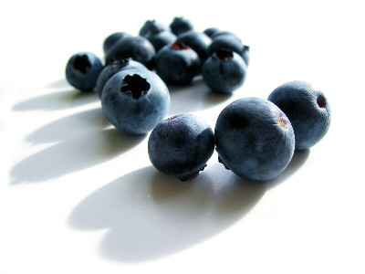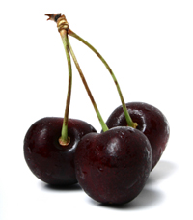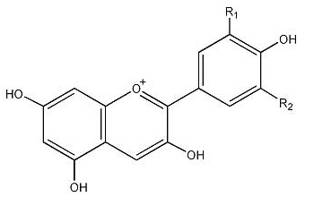

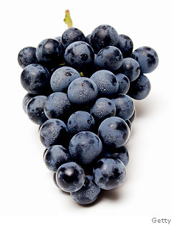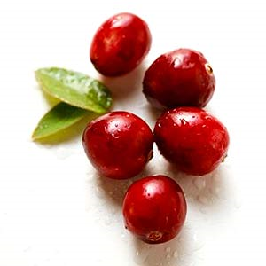

You have recently joined SNAC (Skidmore Nutrition Action Council) and the club is planning their annual Nutrition Awareness Week. To promote awareness about health and nutrition for students that regularly eat in the dining hall, the club is interested in finding out which fruit juice has the largest amount of antioxidants. In particular, the club has decided to measure the anthocyanin content of four different fruit juices, two of which are already in the dining hall. With your background in chemistry, the SNAC president asks you to figure out which juice - black cherry, blueberry, concord grape, or cranberry has the highest concentration of anthocyanins.
Background

Antioxidants have gained popularity recently, as the media has exposed their potential health benefits. Antioxidants are often linked to free radicals, molecules than can be damaging to the human body if there is constant exposure. Antioxidants work to stop the damage caused by free radicals by inhibiting oxidation reactions that produce free radicals, thus preventing any harm that could be caused to the human body.

There are many types of antioxidants, which include flavonoids¹, the parent class for anthocyanins. While there are approximately 600 anthocyanins that occur naturally, only 17 of those are aglycones, which are the primary anthocyanins found in fruits and vegetables. Of the aglycones, delphinidin, cyanidin, petunidin, pelargonidin, peonidin, and malvidin are the most common and differ in concentration for different fruits and vegetables². These compounds provide the principle colors of fruits and vegetables, namely the reds and blues.
The composition of anthocyanin compounds provides benefits for both plants and humans. In plants, anthocyanins provide brightly colored flowers and fruits that aid in pollination and seed dispersal. They also act as a natural sunscreen for plants, as the antioxidant compounds protect the plant against ultraviolet radiation³. In humans, anthocyanins have large health benefits, as they are strong antioxidants.
When the mL of base added is graphed as a function of the pH, the concentration of anthocyanins in each of the fruit juices can be determined by measuring the equivalence point, the point at which the moles of base are equal to the moles of acid present in the solution before the titration. This is characterized by a large increase in pH with the addition of a small amount of base.

Depending on the acid, more than one equivalence point may be observed. For acids with more than one dissociable proton (i.e. H₂SO₄), the number of equivalence points is equal to the number of dissociable protons. Acids with a single equivalence point are characterized as monoprotic, while acids with more than one equivalence points are polyprotic.

Procedure
You will be assigned one acid and one juice. Check Blackboard for your assignments and adapt your procedure and tables accordingly.
- Using a volumetric pipette, measure the required volume of your assigned acid or juice and add it to a clean, dry beaker. Using a graduated cylinder, dilute the acid or juice with DI water.
- Rinse and fill a burette with NaOH (~0.1 M), making sure that the tip of the burette is filled with solution.
- Following the instruction sheet, calibrate the pH meter using pH 4 and 7 buffers.
- Place the electrode into the diluted solution. Record the initial pH reading before any base has been added.
- Add NaOH into the solution, recording the pH and actual burette readings after each addition.
  - At the beginning of the titration, add approximately 1 mL aliquots of NaOH until the change in the pH of the solution approximately doubles. This is a signal that the equivalence point is being approached.
  - Before and at the equivalence point, 0.1-0.2 mL of NaOH should be added.
  - After the equivalence point, add 0.2 mL until the pH increases by less than 0.1 units, then 0.5 mL until the pH increases by less than 0.1 units, and finally 1 mL until the pH has reached 12 or until you see the change in pH increase again.
  - If you see the change in pH of the increase again, you have a polyprotic acid which has more than one equivalence point. Follow steps 5a-5c above to determine any additional equivalence points.
- Clean and dry the beaker. Follow the same procedure for your second solution.

Data Collection
In your notebook, include the following tables:

Table 1. Analysis of _______________ (acid or juice) in a titration with 0.1 M NaOH.
volume in burette (mL) | total NaOH added (mL) | pH | volume in burette (mL) | total NaOH added (mL) | pH
 | 0.00
Continue | until | you have | 25 lines

Table 2. same as table 1 for the other solution. (also need 6 columns/25 lines

Table 3. Determination of the concentration for (your acid) and (your juice).
acid/juice | equiv. pt. volume of ______ M NaOH (mL) | concentration (M)

In Class Analysis: Determining the Equivalence Point

- Prepare a graph for each solution with pH on the y axis and volume of NaOH added on the x axis (figure 1).
- On the graphs for each of your acids, locate the first area of steep change in pH; use a ruler to draw a vertical line from the midpoint of the pH change down to the x-axis. This value represents the volume of base at the equivalence point.
- Calculate the concentration of your acid of the amount of NaOH added at the equivalence point.
- If you have a polyprotic acid, each equivalence point represents the removal of one hydrogen from the acid. Use the last equivalence point and the stoichiometric ratio between the acid and NaOH to calculate the concentration of the acid.
References

1. Curtwright, R.D.; Rynearson, J.A.; Markwell, J. J. Chem. Ed. 1994, 71, 682.
2. Wu, X.; Beecher, G. R.; et. al. J. Agric. Food Chem. 2006, 54, 4069.
3. Curtwright, R.D.; Rynearson, J.A.; Markwell, J. J. Chem. Ed. 1996, 73, 306.

