Which is a Better Green Alternative to Remove Soap Scum?

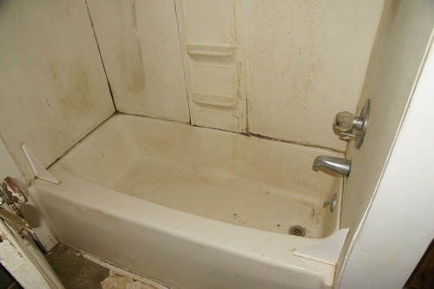
It is getting close to the end of the semester and the soap scum in your bathroom is getting really thick. You and your suitemates decide that, in the interest of sustainability, you would like to use a "green" cleaner. One of you has heard that you can use lemon juice to clean soap scum and another has heard that you can use vinegar to do the job. A discussion ensues about which one would be better to use.
As a student of chemistry you realize that these are both acids (citric acid and acetic acid respectively) and soap scum must therefore be a base. You wonder if there is any property of acids that you can use to decide which, lemon juice or vinegar, will be more effective without having to try them out first. Also should you use them full strength or dilute them down? Will diluting them make any difference in how well they clean?
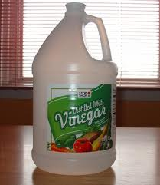
Background
Way back in the early part of last semester, you learned that biggest difference between strong acids and weak acids was the amount of dissociation in water. Strong acids dissociate completely while weak acids do not. When weak acids dissociate in water an equilibrium is established between the undissociated acid (HA) and the ions produced when it dissociates (equation 1). Since the protons from the acid interact with water, this reaction can also be written as shown in equation 2.
HA_{(aq)} H⁺_{(aq)} + A⁻_{(aq)} (1)
H₂O_{(l)} + HA_{(aq)} H₃O⁺_{(aq)} + A⁻_{(aq)} (2)
Just as for other reactions that do not proceed all the way to completion, the amount of dissociation is characterized by an equilibrium constant. Because water is the solvent and its concentration is so large compared to the concentration of the other participants it is essentially a constant. Water, therefore, is not included in the equilibrium expression (equation 3). In this case the equilibrium constant is designated as K_{a} to show that it is specifically for the dissociation of acid.
${\text{K}}_{\text{a}}\text{= }\frac{\left[{\text{H}}_{\text{3}}{\text{O}}^{\text{+}}\right]\text{[}{\text{A}}^{\text{-}}\text{]}}{\left[\text{HA}\right]}$ (3)
Since very little of the HA dissociates and we cannot simply calculate the concentration of the products from the initial concentration, we need to be able to measure the equilibrium concentration of one of the products to determine K_{a} experimentally.
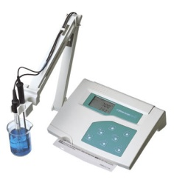
This is where our friend the pH meter (Figure 1) comes into play. A pH meter has an electrode that measures the voltage across a membrane that separates a known concentration of H₃O⁺ on the inside from a sample with an unknown concentration of H₃O⁺ on the outside. That voltage is compared to the voltage of a stable reference electrode which allows it to be converted into pH units displayed on the meter. As pH is defined as the negative log of H₃O⁺ concentration, we can get the equilibrium concentration by doing the reverse math (equation 4). As with other equilibrium expressions, an ICE table can then be used to determine the equilibrium concentrations for HA and A⁻ which can be used to calculate K_{a}.
Figure 1. pH meter.
$\left[{\text{H}}_{\text{3}}{\text{O}}^{\text{+}}\right]\text{=}{\text{10}}^{\text{-pH}}$ (4)
This is all well and good for weak acids, but what about weak bases? Rather than dissociating when added to water, weak bases form hydroxide ions by grabbing a proton from water to establish the equilibrium given in equation 5. As with acids, a specific equilibrium constant for bases, K_{b}, can be expressed as in equation 6.
H₂O_{(l)} + B_{(aq)} BH⁺_{(aq)} + OH⁻_{(aq)} (5)
${\text{K}}_{\text{b }}\text{= }\frac{\left[{\text{BH}}^{\text{+}}\right]\text{[}{\text{OH}}^{\text{-}}\text{]}}{\left[\text{B}\right]}$ (6)
For weak bases, as with weak acids, the equilibrium lies far to the reactant side. So the question becomes, how can we measure the concentration of one of the products? We do not have a pOH meter that we can use to measure the concentration of OH⁻ directly; that would be too easy. Instead we have to make use of another equilibrium reaction that always occurs in aqueous solutions, the autoionization of water (equation 7).
2 H₂O_{(l)} H₃O⁺_{(aq)} + OH⁻_{(aq)} (7)
Notice that this reaction contains a common ion (OH⁻) with our equilibrium for the base. Again there is a specific equilibrium constant, K_{w}, associated with the (equation 8). At 25 °C, roughly room temperature, K_{w} has a value of 1.0 × 10⁻¹⁴.
${\text{K}}_{\text{w}}\text{= }\left[{\text{H}}_{\text{3}}{\text{O}}^{\text{+}}\right]\text{[}{\text{OH}}^{\text{-}}\text{] =1.0 ×}{\text{10}}^{\text{-14}}$ (8)
We know from LeChatelier’s principle that the hydroxide ions are just one big pool so the concentration will be the same in both equilibrium expressions. And so, the H₃O⁺ concentration adjusts to compensate for the OH⁻ produced when the base is added to water to keep the constant the same. Using this information, we can calculate the hydroxide ion concentration by inserting the H₃O⁺ concentration obtained from measuring the pH into the K_{w} equation and solving for OH⁻ concentration. Once we have this equilibrium concentration, we can find the equilibrium concentrations and K_{b} in the same manner as used for K_{a}.
Procedure
- Put approximately 10 mL of your assigned acid in a clean, dry test tube.
- Dilute the solution by a factor of 10, by pipetting 1 mL into a 10 mL volumetric flask and bringing to volume with DI water.
- Transfer the solution to a clean, dry test tube and rinse out the volumetric flask.
- Dilute the new solution by a factor of 10 using the same instructions as step 2. Transfer the solution to a clean, dry test tube.
- Repeat step 4 two more times. You will have a total of five solutions.
- Standardize the pH meter with pH 4.00 and 7.00 solutions as indicated on the provided instructions.
- Measure the pH of each of the solutions.
- Repeat steps 1-7 with your assigned base.

Data Collection
Copy the following tables into your notebook filling in the appropriate information for your solutions.
Table 1. Concentration effect on the pH of (put your acid here).
dilution | concentration (mol/L) | pH
none
10 fold
100 fold
1000 fold
10000 fold
Table 2. Concentration effect on the pH of (put your base here).
dilution | concentration (mol/L) | pH
none
10 fold
100 fold
1000 fold
10000 fold
Calculations and In Class Analysis
- Prior to lab, calculate the initial concentration of acid or base for each of the solutions. Show one example of each calculation in your notebook.
- In lab:
  - Graph your results in Excel with log of the initial concentration on the x axis and pH on the y axis. Put both acid and base on the same graph.
  - Calculate K_{a} for one dilution of your acid using pH and an ICE table. Be sure to take the correct number of significant figures into account.
  - Calculate K_{b} for one dilution of your base using pH, K_{w} and an ICE table. Be sure to take the correct number of significant figures into account.

