Cultivating Seeds of Change: Knowledge, Perception and Behavior Outcomes of an Experiential Plant Literacy Curriculum

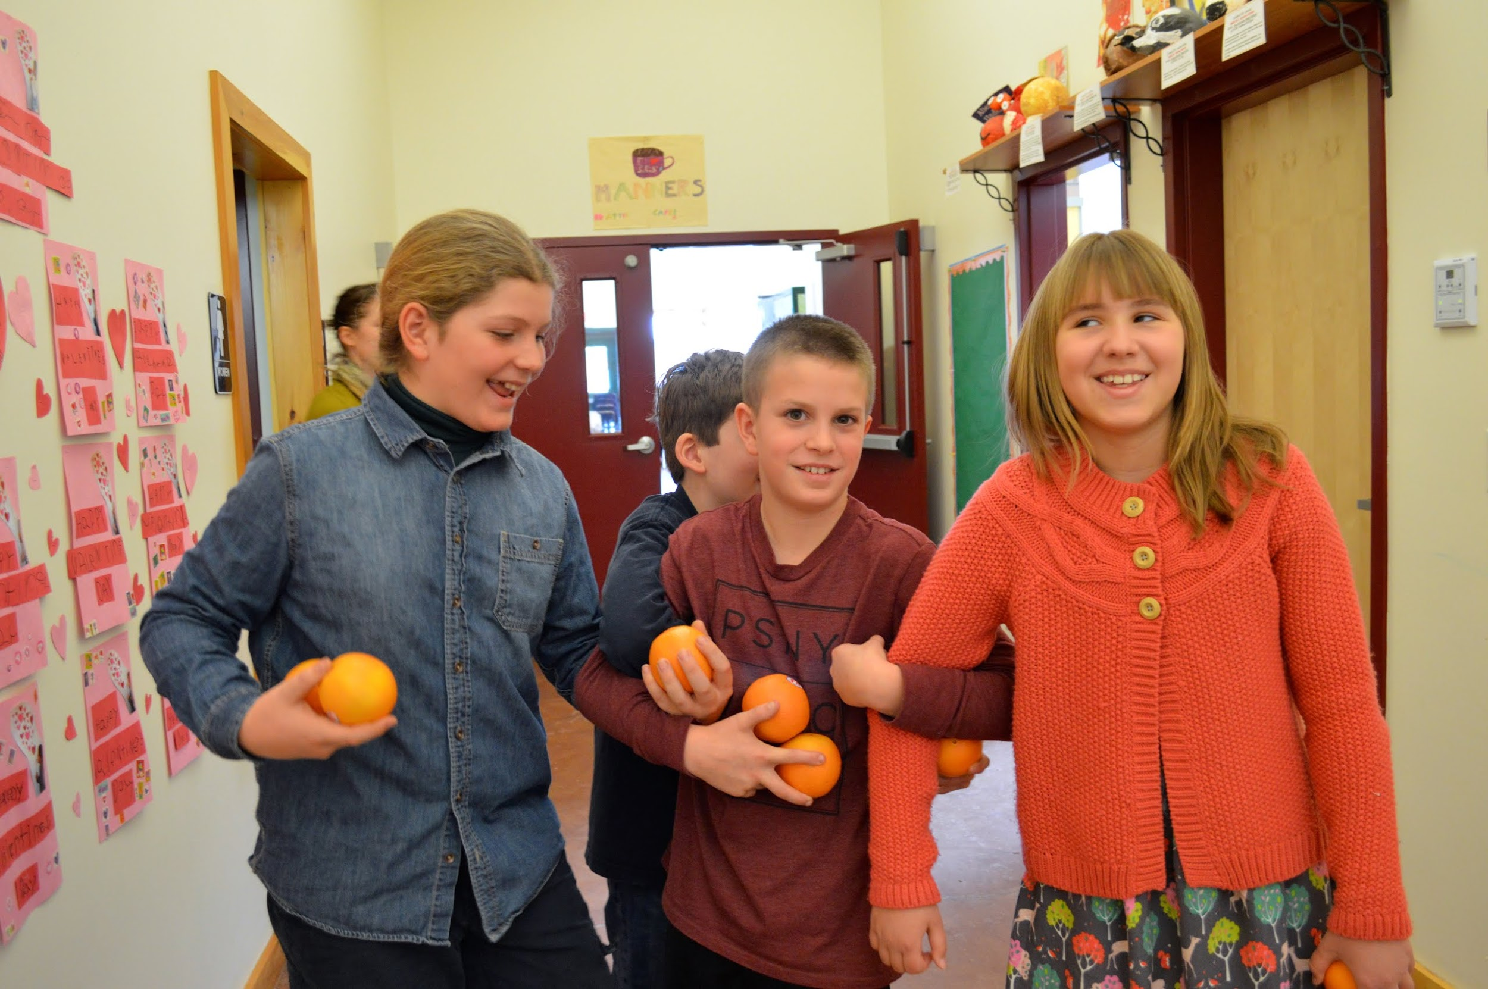

Lauren Mamuszka, Jenna Frank, Eliza Hollister
Advisor: Dr. Andrew Schneller
Environmental Studies
Senior Capstone Project 2014-2015

TABLE OF CONTENTS

Abstract
Introduction
Review of the Literature
Overview of Environmental Education
Environmental Knowledge
Environmental Perceptions
Environmental Behaviors/Actions
Experiential Education
Garden-Based Learning
Aquaponics in the Classroom
Literature Review Conclusion
Methods
Our Curriculum
Measuring Knowledge, Perception and Behavioral Outcomes
Measuring the Most Influential Aspects of the Curriculum
Results
Knowledge Outcomes
Perception Outcomes
Behavior Outcomes
Unexpected Outcomes
Limitations to the Research
Conclusion
Appendix A (Test & Interview Questions)
Appendix B (Transcribed Interviews)
Student Pre Test Interviews
Student Pre Test Focus Group
Student Post Test Interviews
Student Post Test Focus Group
Parent Post Test Interviews
Post Test Interview with Primary Teacher
References

Abstract
This mixed methods study measures the environmental knowledge, perceptions and behavior outcomes of an experiential plant literacy curriculum designed for 5th and 6th graders. The treatment group for this study was 15 fifth and sixth grade students at an independent elementary school in Saratoga Springs, NY. The control group consisted of 17 students at a private elementary school in a neighboring town. Students’ environmental knowledge, perceptions, and behaviors were measured using both qualitative and quantitative research methods including testing, surveys, interviews, and focus groups. This study aims to reinforce existing literature and to provide a better understanding of how experiential pedagogy and small scale agricultural systems can be used as effective teaching tools. Treatment group students showed statistical improvement in environmental knowledge and behaviors at posttest. The control group did not change significantly in any category from pretest to posttest.

Introduction
In recent decades, a fear has come to light that youth in the United States are losing their connection to the natural world and consequently, to their food sources. The disconnect between people and the origin of their resources is often attributed to humans being too far removed from the outdoors and their local ecosystems in their daily life (Louv 2005). One strategy for mitigating this disconnect is integrating environmental education into primary school curricula. Experiential learning is one educational framework that is particularly effective in introducing students to food systems, local ecosystems and other environmental topics.
However, integrating experiential learning into the classroom is not always easy, especially given the requirements of state standards and the additional effort involved in creating new curricula. Yet it has been proven, especially in the subject of science, that teachers are much more likely to implement these techniques and activities after having seen the positive effects they have on students desire to learn (Carrier, 2009). A common avenue for teachers to integrate experiential learning and environmental education into their classrooms is through garden-based curricula and place-based learning.
Schools all over the nation are turning to garden-based education which has been proven to increase healthful eating and environmental attitudes (Libman, 2007). In 2009, New York State created its Environmental Literacy Plan, calling for stronger environmental education programs in public schools across the state. However, it has been a slow-moving process. This study focuses on bring experiential environmental education to students at a private elementary school in Saratoga Springs, NY, with hopes to spur local interest in experiential education and place based learning in public and private schools.
The purpose of our research is to measure the environmental knowledge, perceptions and behaviors of 5th-6th graders before and after implementing a plant literacy program, and to determine the effectiveness of our curriculum. We aim to utilize experiential education to address environmental knowledge, perception, and behaviors in our students, providing them with the tools to live environmentally responsible and healthy lifestyles.

Review of the Literature

This research project assesses the effectiveness of a Plant Literacy curriculum on the environmental knowledge, perceptions and behaviors of 5th-6th graders. The intent of our study is to utilize experiential environmental education to foster environmental awareness in children. The impetus of our research is a response to Richard Louv’s Nature-Deficit Disorder, within which children are increasingly losing their connection to the natural world, which is resulting in a myriad of behavioral and nutritional problems. This literature review seeks to recognize the importance of experiential pedagogy in altering environmental knowledge, perceptions and behavior in adolescents. The literature also recognizes successful implementation of hands on and agriculture-based curricula.

Literature Review Contents:
Overview of Environmental Education
Environmental Knowledge
Environmental Perceptions
Environmental Behaviors
Garden-Based Learning
Aquaponics in the Classroom

Overview of Environmental Education

As a discipline, environmental education is concerned with both the biophysical environment, as well as human interaction with the natural world (Hungerford, 1990). If environmental education is to address the issues that threaten human survival, it must acquire a comprehensive understanding of how humans, as humans, not environments, can be educated (Rejeski, 1982). The purpose of education is to influence human behavior, whereas the aim of environmental education is to create environmentally responsible citizens (Hungerford, 1990). As outlined by the 1977 Tbilisi Intergovernmental Conference of Environmental Education, the discipline’s objectives include: awareness, knowledge, attitudes, skills, and participation in environmental issues (Tbilisi, 1997). Therefore, an environmentally responsible citizen would be defined as one with an awareness of the environment and its associated problems, a fundamental comprehension of environmental issues, empathy towards the environment, skills to solve environmental issues and active participation to resolve them (Hungerford, 1990). To shape environmentally responsible citizens, we must “coordinate a psychological view of the child with an ecological view of the world (Rejeski, 1982, p. 27)” by influencing children’s knowledge, attitudes, and behavior towards the environment.

Environmental Knowledge

Environmental knowledge is the intellectual foundation for environmental action. There are three accepted forms of environmental knowledge; environmental system knowledge, action-related knowledge, and effectiveness knowledge (Roczen, Kaiser, Bogner, Wilson, 2013). Environmental system knowledge encompasses an understanding of natural processes, action-related knowledge is the comprehension of how to conserve resources and preserve the environment, and effectiveness knowledge gauges the success of various environmental behaviors (Roczen et al., 2013). The model of choice for measuring individual differences in environmental knowledge is the Rasch model, which was developed by Frick et al in 2004 (Roczen et al., 2013). Roczen et al. utilized the model to assess whether adolescents’ environmental knowledge could be empirically divided into environmental system knowledge, action-related knowledge, and effective knowledge (Roczen et al., 2013). Unfortunately, the scholars found that their participants lacked all three types of knowledge, which may have resulted from irrelevant questions utilized on the Rasch model. Various studies have linked environmental education curriculum to an increase in environmental knowledge in students. The Louisiana Sea Grant Program implements plant curriculums at elementary-high schools, in which students grow coastal plants for use in wetland restoration projects (Karsh, 2009). In a 2009 study, eight hands-on lessons, which transmitted basic horticulture knowledge, were taught in one private and three Louisiana public schools. Tested on science content pre and post curriculum implementation, students improved their horticultural knowledge scores by 11.4 points in year one, and 25.07 points in the second year of study (Karsh, 2009).

Environmental Perceptions

While environmental knowledge forms the intellectual foundation, the “attitude toward nature represents the motivational source behind a person’s ecological lifestyle (Roczen, et al. 2013, p. 976).” One of the first and most popular environmental perception, or worldview, measurements is the New Environmental Paradigm (NEP) (Johnson and Manoli, 2008; Dunlap and Van Lieve, 1978; Dunlap, Van Lieve, Mertig and Jones, 2002 ). Bogner and Wilhelm (1996) proceeded to develop this model further by taking a two-dimensional approach to environmental perceptions: preservation and utilization of nature, thus proposing the Model of Ecological Values (2-MEV) (Bogner and Wilhelm, 1996). MEV measures a person's preference for environmental preservation versus their preference for the utilization of natural resources using a Likert scale (Johnson, et. al, 2003). Johnson and Manoli (2008) utilized this measurement to investigate changes in the environmental attitudes of European adolescents partaking in an Earth Education program. The scholars administered pre and post tests to the children using the Environment Questionnaire (TEQ), measured using a Likert scale. The questionnaire is broken up into five categories: intent of support, care with resources, enjoyment of nature, human dominance, and altering nature (Johnson, et. al, 2003). Johnson and Manoli found that the Model of Ecological values offers a “powerful perspective for examining environmental perceptions in children and for evaluating the effects of environmental learning programs on those perceptions” (Johnson, et. al, 2003, p. 125).
Some scholars, including Schneller, Johnson and Bogner (2013) have modified the MEV to serve similar purposes in varying cultural contexts. Schneller, Johnson and Bogner (2013) developed a Spanish language 2-MEV for use in Baja California Sur, Mexico. These scholars discovered various benefits of the 2-MEV, including its fixed dimensional structure, its viability for interstudy comparisons, and its relevance to the psychology of sustainable development (Schneller, et. al, 2013). Moreover, the 2-MEV has been found to be an “accurate tool for measuring changes in children’s environmental attitudes and values in relation to a variety of environmental program designs” (Schneller, et. al, 2013, p. 3). Schneller, Johnson, and Bogner (2013) evaluated the effect of an environmental service learning program with 22 children in Baja California Sur using the modified Spanish 2-MEV. The authors found the preservation and utilization scores to indicate pro-environmental values and attitudes.

Environmental Behaviors/Actions

The objective of fostering environmental knowledge and positive environmental perceptions in children is to create responsible citizens who practice pro-environmental behaviors. Hungerford and Volk (1990) developed the Behavior Flow Chart, based on three categories of behavior variables: entry level variables, ownership variables, and empowerment variables. Entry level variables are concerned with “environmental sensitivity, knowledge of ecology, and attitudes towards pollution/ technology/ economics” (p. 258). Ownership variables incorporate in-depth knowledge of environmental issues, as well as personal investment in these problems. Finally, empowerment variables, which are crucial to developing environmentally responsible citizens, include knowledge of and perceived skill in using environmental action strategies, an internal locus of control, and intention to take action. Hungerford and Volk propose to change learner behavior through environmental education by addressing these variable levels. Positive environmental behaviors have been noted by various scholars who conduct environmental education studies pre and post curriculum implementation. In a 2008 study, Schenller noted positive behavioral outcomes after implementing an experiential environmental learning program in Baja Sur, Mexico. Schneller found 81% of students claimed to have discussed their intent to change certain environmental behaviors with their families post-test and of these students, 82% reported that their families had successfully changed their behaviors (Schneller, 2008).

Experiential Education

Experiential education can be defined as “a holistic philosophy, where carefully chosen experiences supported by reflection, critical analysis, and synthesis, are structured to require the learner to take initiative, make decisions, and be accountable for the results, through actively posing questions, investigating, experimenting, being curious, solving problems, assuming responsibility, being creative, constructing meaning, and integrating previously developed knowledge” (Itin, 1999). This definition draws upon two prominent figures in environmental education, John Dewey and Kurt Hahn.
Before relating experiential learning to this study, it is important to make the distinction between experiential education and experiential learning. Experiential education implies an external educator or guide separate from the student, whereas experiential learning can occur of the students’ independent accord (Itin, 1999). There is a wealth of literature supporting the success of experiential education, which stems originally from John Dewey’s and his philosophies discussed in Experience and Education, published in 1938. Dewey was one of the first to write of experiential education for the purpose of educational reform in the mid 20th century. His main argument asserts that students need opportunity to connect what they are learning in a classroom with tangible experience for the knowledge to have lasting impact (Dewey, 1938). Dewey argues that many students within the traditional American educational system “...were rendered callous to ideas, and how many lost the impetus to learn because of the way in which learning was experienced by them.” Dewey refers to the “ennui and boredom” that students risk facing as participants of the traditional American school learning process (27). This is not to say that the traditional system is wholly lacking, only that it would greatly benefit from advances in implemented experiential education. While Dewey’s pedagogy has been proven successful in countless studies, it takes immense effort from teachers and change within institutional frameworks to implement experiential education into curricula, and as such, experiential education is still lacking in the United States and beyond.
One important aspect of experiential education that this study is grounded in is self-efficacy. Instructors may instill self efficacy within their students by giving those students freedom to collaborate and make decisions on their own regarding how to meet the objectives of the lessons and goals of the instructor. It is clear that when students become involved in project or lesson, they are more likely to assume responsibility for the subject matter (Orr, 2005). This is exemplified in a project completed by teacher Laurette Rogers with her fourth graders at a school in San Anselmo, CA. The students aided in the restoration of an endangered shrimp species through public outreach and habitat restoration. One student concluded that the experience showed her that “kids can make a difference in the world, and we are not just little dots” (Orr, 2005). This project serves as an example of how students can gain self efficacy through experiential education.
Measuring the exact outcomes of experiential education is difficult. Often, studies implement experiential education as a tool to measure other variables, complicating quantifying the effectiveness of experiential education (Gosenpud, 1990). Johnson and Minoli have used experiential education as a tool to measure environmental perceptions in elementary school students in the eastern United States (2008). The purpose of Johnson and Manoli’s study was to measure environmental perceptions using Bogner and Wiseman’s Model of Ecological Values. In their study, experiential education was used to convey important ecological concepts using the IAA (Inform -- Assimilate -- Apply) Learning Model. Students completed the “Inform” section by reading about the topics, the “Assimilate” portion by participating in a hands-on activity, and the “Apply” portion by by finding a local example of the topics and then writing about and drawing them. This study also implements the IAA Learning Model when applicable. For example, in the pH and Water Quality lesson of this study, the “Inform” portion will come from lecture and note taking, the “Assimilate” portion comes from a hands on activity to measure pH in different kinds of water, and the “Apply” portion is completed by the students determining what level of pH should be used for their hydroponic and aquaponic systems. It is not explicitly clear whether the experiential education component of the study contributed directly to the outcomes in Johnson and Minoli’s study. Similarly, this study does not quantify successes of experiential education, but rather draws up on it as a teaching tool known to have positive results for student engagement and self-efficacy.

Garden-Based Learning

Many of the most successful programs for fostering plant literacy and healthy eating behaviors in children are garden-based, experiential learning courses or opportunities. There is also evidence that gardening programs change children’s dietary preferences and activity levels, leading to more healthy lifestyles in general (Somerset et al 2005). McAleese and Rankin (2007) have proved that school garden activities, when incorporated into a nutrition-education program, increase fruit and vegetable consumption in children between the ages of 10 and 13. Children in this study participated in a 12-week program that focused on the intersection between horticulture and nutrition. Throughout the program, students kept food journals, tracking what they learned as well as what they ate. This drew attention to food habits and provided students with alternatives to unhealthy eating habits through gardening. When children have put in the effort to grow something themselves, they are more familiar with the fruit or vegetable and more comfortable eating it. As a result of school gardening programs, many students are even inspired to take their new knowledge home and ask for more healthy foods from their parents (McAleese and Rankin 2007).
Current research shows that vegetable and fruit consumption helps prevent a multitude of diseases, including; certain cancers, coronary heart disease, stroke, cataract formation, chronic obstructive pulmonary disease, diverticulitis, and hypertension. There are over 100 healthful vitamins, minerals, and fibers in vegetables and fruits that aid in disease-defense (Duyn & Pivonka 2000). Based on these findings, several national and international governing bodies have produced their own daily intake recommendations. Several years ago, the World Health Organization and the United Nations Food and Agriculture Organization set the minimum fruit and vegetable intake at 400 grams per day. However, recent studies have suggested that the amount should be even higher (Bazzano, 2006). Although we have the proof, the typical American diet still lacks a sufficient amount of either fruits or vegetables. In order to fix that, it is essential to educate with the intent of changing behavior. In order to change behavior, one must intervene at the correct time in a child’s education and development. Studies show that continued experiences with the natural environment at an early age are most effective at changing student’s concern for environmental issues (Cohen & Horm-WIngerd, 1993). In an attempt to change eating behaviors and environmental knowledge, researchers designed and implemented several classes about fruits and vegetables and gardening in general, targeted at different age groups. Nine out of ten classes in elementary schools showed significant behavior change afterwards, whereas only one in four high school classes showed significant change (Bazzano, 2006).
There is evidence that garden-based education, especially in an attempt to teach healthy eating behavior and lifestyle, impacts students of different genders and ethnic backgrounds differently. Several experiments conclude that garden curricula has a stronger effect on girls than boys. In a 2011 study by Jaenke, Collin, Morgan & Lubans found that girls not only had a higher fruit intake before the garden-based program, but they also found that the same girls ate even more vegetables and fruits afterwards. The researchers hypothesized that this may be because girls are typically socialized to enjoy gardening and cooking more than boys. Other experiments found that garden-based education has the greatest impact on caucasian females, perhaps because caucasian girls are more likely to have been exposed to gardening and cooking at home (Aguilar et al 2008). Boys, on the other hand, tend to be more interested in how the garden can be used for play and adventure (Harvey 1989). In order to target boys and all ethnicities, Aguilar suggests making the garden a place that students can play, not just garden. Additionally, there should be more emphasis on how plants can be used for fibers and building materials, creating urban forests and community landscapes.
Another argument that is frequently discussed in existing literature is that garden-based learning itself is not enough to change behavior or environmental attitudes in the long run. Instead, many social scientists suggest that actions must be taken in the home environment to truly change behavior, requiring parent involvement.

Aquaponics in the Classroom

Aquaponics, or the combination of aquaculture and hydroponics, is emerging as a teaching tool throughout the country, as it has the potential to enhance interdisciplinary science education (Hart, Webb, Danylchuk, 2013). Because aquaponics simultaneously grows edible plants and raises fish in a closed-loop system, the technology can increase the availability of nutritious food, thus addressing food security. Aquaponics is scaleable and flexible, as small-medium systems require minimal space and maintenance. For these reasons, aquaponics systems are ideal for school use. Hart, Webb, and Danylchuk (2013) measured the use of aquaponics systems in schools across North America. The authors interviewed educators (10 participants total) who had used a system in a formal educational environment (k-12 and higher education) within the past five years.The authors found that three categories encompassed the main reasons for aquaponics incorporation in the classroom: the application of academic subjects (especially math and science), hands-on, experiential and integrated learning, and connections to food, agriculture and global trends. Challenges included technical difficulties due to the nature of aquaponics and restrictions due to school settings (Hart, Webb, Danylchuk, 2013).
Aquaponics classroom applications have numerous possibilities for use as an interdisciplinary teaching tool. Hart, Webb, and Danylchuk (2013) propose that “using aquaponics in education may serve the dual purpose of preparing future practitioners while giving students the opportunity for active learning, which parallels the goals of contemporary science education in the US (p. 462).” School aquaponics applications thus simultaneously address nutrition issues in children while allowing them to partake in hands-on learning and develop the skills to lead environmentally responsible lifestyles. Moreover, classroom aquaponics systems create the possibility for reaping the benefits of a garden curricula (i.e. extending the growing season), while serving children who live in cold climates and cannot partake in garden activities throughout the winter.

Literature Review Conclusion

As is evident in the literature review, environmental education with experiential components have been proven to foster behavior change in children in recent studies. This study seeks to further the literature by adding to the existing body of work on garden based and experiential environmental education programs. To do so, this study measures changes in environmental knowledge, perceptions, and behaviors in 5th-6th graders pre and post an authentic plant literacy program. Since the literature shows that garden-based education in a formal classroom setting generally does not yield longer-term behavior change results by itself, this study incorporates parent involvement in the learning process thereby reinforcing the lessons and encouraging intergenerational learning. Some of the environmental behaviors taught in this study which students can practice at home include composting, healthier eating habits, and recycling. Additionally, this study proposes a multidimensional, experiential, and interdisciplinary approach to garden-education in order to reinforce the importance of plant literacy. By partaking in a school garden and aquaculture project, students constructed educational tools for long-term school wide use across all age groups and class subjects. As an extension of the garden, a classroom aquaponics system brings the natural world into the classroom in a tangible way, while encouraging the use and experimentation of all teachers and students. These projects lay the groundwork for a lasting environmental/garden-based education program for elementary-aged children, thus enhancing child-nature interactions in a multidimensional and interdisciplinary way.

The research questions guiding our study are as follows:

- What are the environmental knowledge, perception, and behavioral outcomes of a plant literacy curriculum taught to fifth and sixth graders?
- What specific aspects of the plant literacy curriculum do students find most influential?

Methods

Research Overview
The purpose of this study is to measure the environmental knowledge, perceptions and behaviors of 5th and 6th graders pre and post a plant literacy program using one treatment group and one control group. It was hypothesized the treatment group, students participating in the literacy program, would show positive results in environmental knowledge, perceptions and behaviors, while the control group, the group that did not participate in the curriculum, would not show statistically significant changes in any category. This section details both the qualitative and quantitative research methods used in this study including data collection and data source methods and analysis. The methods used in this research draw upon successful methods from similar studies measuring outcomes of experiential learning, with a specific focus on environmental knowledge, perceptions, and actions. Data collection methods broadly include pre and post semi-structured interviews and focus groups with students, parents, and teachers, as well as pre and post written assessments and surveys for students.

Research Questions

- What are the environmental knowledge, perception, and behavioral outcomes of a plant literacy curriculum taught to fifth and sixth graders?
- What specific aspects of the plant literacy curriculum do students find most influential?

Population & Setting

Treatment Group:
The treatment group participants were fifteen fifth and sixth grade students at the Saratoga Independent School in Saratoga Springs, NY. The school was founded in 1991 and provides private education for students in Kindergarten through sixth grade. Other associated participants included the students’ primary teacher and the parents and siblings of participating students.

Control Group:
The control group consisted of seventeen fifth grade students at St. Mary’s Catholic School in Ballston Spa, New York. St Mary’s has been providing private elementary school education since 1960.

Our Curriculum

We designed this curriculum to fit in with Saratoga Independent School’s guiding theme of the year: Plants. Each year the school chooses a new theme which teachers are then asked to incorporate into their usual curriculum. This challenges students and teachers alike to look at material in new and exciting ways. Some examples of past and upcoming themes at SIS include; animal physiology, oceans, and engineering. The curriculum we designed is entirely authentic and unique to the environmental education field. The curriculum is a twelve-week, twelve-class plant literacy course with accompanying labs, homework assignments, and take-home projects. The majority of our 55 minute lessons were broken up half and half between lecture and a following hands on project relating to the lecture. This curriculum was designed to involve students in hands on agriculture and food related projects in a manner that instills self-efficacy and provides a space for students to grow food of their own.
Four guiding themes were utilized to structure our curriculum; aquaponics, hydroponics, composting, and food systems. Each topic has several associated key terms and concepts that were taught using the themes as a teaching tool (Figure 1).
The first of the four themes used in this curriculum was aquaponics. Aquaponics is scaleable and flexible, low maintenance when set up properly, so it makes a perfect teaching tool for an elementary school setting. Hart, Webb, and Danylchuk (2013) measured the use of aquaponics systems in schools across North America. The authors interviewed educators (10 participants total) who had used a system in a formal educational environment (k-12 and higher education) within the past five years.
During the first few lessons of our curriculum we had the students participate in setting up an aquaponics system that we custom designed for their science classroom. Our system was built using a custom stand, a lamp from a local hydroponics store, a fifty gallon fish tank from the elementary school, five goldfish, a water pump, and various other small essential materials. Aquaponics systems serve as an excellent experiential teaching tool to teach topics such as the nitrogen cycle, pH, and closed loop systems, among many other concepts (Figure 1). Students interacted with the system by planting seeds to grow, observing plant and fish growth, feeding fish, and checking pH and temperature levels in the water.
The second theme was hydroponics. For this project we set up two hydrofarms, each using a different type of grow lamp. One of the hydrofarms sat under a fluorescent lamp from a local hydroponics store and the other was set up underneath an LED lamp loaned from Heliospectra, a Swedish Hydroponics company. The students were broken into lab groups at the beginning of the semester and each group was assigned two cells within the hydrofarms to observe throughout the semester. Each week they observed plant height and number of leaves as well as a variety of other qualitative assessments. At the end of the semester students used data they had collected to write a cumulative lab report. We also utilized the hydrofarms as teaching tools for pH, water quality, photosynthesis, and pesticides and other concepts (Table 1).
Our third guiding theme was compost. Compost was used to teach kids about decomposition, vermicomposting and other related topics. The main project under the compost theme was creating small scale vermicomposting systems for the students to take home with them. We also provided students with instructions on how to make a larger vermicompost bin at home when their worm populations outgrew the miniature bins.
Our last theme was food issues. Food issues were the underlying theme of our entire curriculum and therefore discussed throughout our time in the classroom. The main project we used to teach about food systems was a food miles assignment. Students were each assigned a common meal or food (lasagna, vanilla ice cream) and provided a short ingredients list. They were then given one week to research the origins of the ingredients and calculate their food miles. An in-class activity pertaining to food issues was a debate on food justice, wherein students were given statements about food justice and were asked to decide how they would respond and support their argument. For example, one statement was “Healthy, fresh food is available for everyone in my community all year round”. Students were asked to agree, disagree, or be neutral on the statement and tell the class why they chose their stance. This activity was done right after students learned about conventional, local, and organic foods via lecture. Food issues were also used to teach about medicinal and local plants, as well as other topics (Table 1).

Aquaponics | Hydroponics | Compost | Food Issues
pH  Nitrogen Cycle  Ammonia  Closed Loop System  Symbiosis  Food Production | Grow Lights  Photosynthesis  Pesticides  Food Production | Decomposition  Vermicompost  Worm Anatomy  Soil Health  Food Production  Food Waste | Organic Food  Local Food  Conventional Food  Globalization  Food Justice  Food Miles  Medicinal Plants  Native & Invasive Species
Table 1. Plant Literacy Curriculum Themes and Associated Key Terms and Topics

Sampling

The group of fifth and sixth grade students we worked with at the Saratoga Independent School (SIS) all participate in the same science course three times per week. Our curriculum was taught during one of the three 55 minute science blocks every week, for twelve weeks. Our research focused on assessing the knowledge, perception and behavioral outcomes as well as the most influential aspects of our curriculum. We collected both qualitative and quantitative data from students, parents, and teachers. The environmental knowledge, perception, and behavioral assessments were administered to both the control and treatment groups just before the curriculum began with the treatment group. The same assessments were administered to both groups again one week after the curriculum ended. Interviews and focus groups with students, their parents, and the science teacher were used to measure environmental behavioral outcomes and to gather qualitative data to determine which aspects of the course were most influential for students.

Measuring Knowledge, Perception and Behavioral Outcomes

To determine knowledge outcomes students took an authentic 21 question exam that we created based on our curriculum. The test consisted of both multiple choice and short answer questions and focused on comprehension of key topics and term recognition (Appendix 1). Students were given 40 minutes to complete the tests. Knowledge test data was analyzed using Independent and Paired Samples T-Testing.
Students’ environmental perceptions were measured quantitatively using Bogner and Wiseman’s Model of Ecological Values (2-MEV). 2-MEV measures a person’s preference for environmental preservation versus their preference for the utilization of natural resources. The questionnaire is comprised of 16 statements which are graded on a Likert scale (Strongly Disagree, Disagree, Neutral, Agree, Strongly Agree). (Appendix 1) Students’ environmental perceptions results were analyzed using Independent and Paired Samples T-Testing.
Environmental behaviors were measured using both qualitative and quantitative methods. A single quantitative question “What environmental behaviors do you practice at school or at home” was used to measure behaviors at pre and post test via written assessment. Questions regarding environmental behaviors were also asked during pre and post interviews with the students, their parents, and their teacher to ensure data source triangulation. (See Appendix 1 for Interview and Focus Group questions).

Measuring the Most Influential Aspects of the Curriculum

Semi-Structured Interviews

We conducted semi-structured interviews with eight students pre and post curriculum to assess environmental behaviors and to determine which aspects of the curriculum were most influential and useful to the students. We also interviewed and 5 parents and the primary teacher post-curriculum. All interviews were conducted at the Saratoga Independent School. All interviews were audio recorded. See Appendix I for a list of interview questions for students, parents and the teacher.

Focus Groups

We conducted one student focus group with the same seven students pre and post curriculum, asking the same questions asked in the student semi-structured interviews. The student focus group was led by two facilitators, with one non-participatory scribe. One parent focus group was conducted post curriculum. Focus group sessions were audio recorded. See Appendix I for a list of focus group questions for students and parents.

Results

Research Question 1:

What are the environmental knowledge, perception, and behavioral outcomes of a plant literacy curriculum taught to fifth and sixth graders?

Knowledge Outcomes

When the treatment and control groups were initially tested on environmental knowledge, we found no statistical difference in their average knowledge scores. Students at SIS scored, on average, 11.3 out of 21 while students at St. Mary’s scored an average of 9.2 out of 21 (Figure 1). At post-test, we found a statistically significant difference in average knowledge test scores between the two groups (Sig. = .000, Figures 1, 2). At post test, SIS students scored on average 18.9 out of 21 while our control group scored 10.5 out of 21 (Figure 2). The treatment group improved significantly from pretest to posttest (Figure 3). The control group did not show a statistically significant difference in scores from pretest to posttest (Figure 4). Due to the small sample size, Nonparametric Wilcoxon Testing was also used, and the results were consistent (Figures 5, 6).
In summary, it is clear that on average, our treatment group students learned and retained the terms and concepts taught to them over the twelve week period. Additionally, it is clear that on average, our control group did not improve significantly from pretest to posttest.

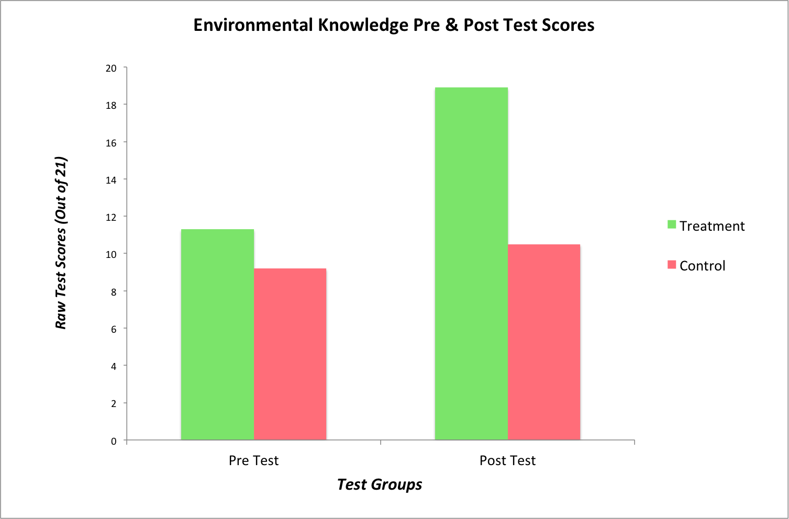

Figure 1. Control & Treatment Group Environmental Knowledge Test Average Scores Pre & Post Curriculum Implementation

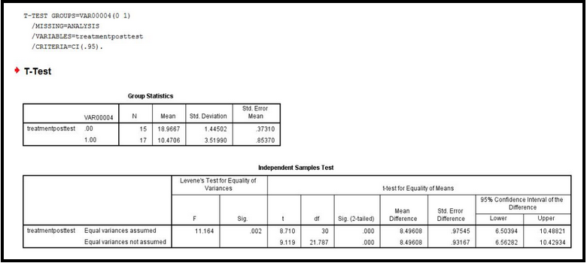
Figure 2. Paired Samples T-Test for Knowledge Test: Treatment Post vs. Control Pos

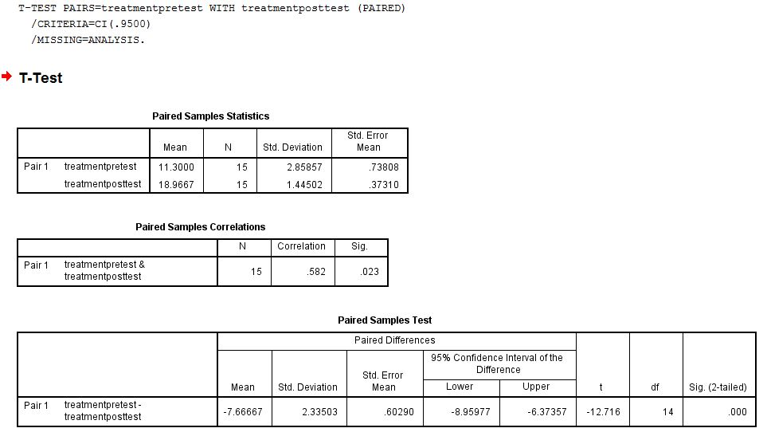
Figure 3. Independent Samples T-Test for Knowledge Test: Treatment Pre vs. Treatment Post

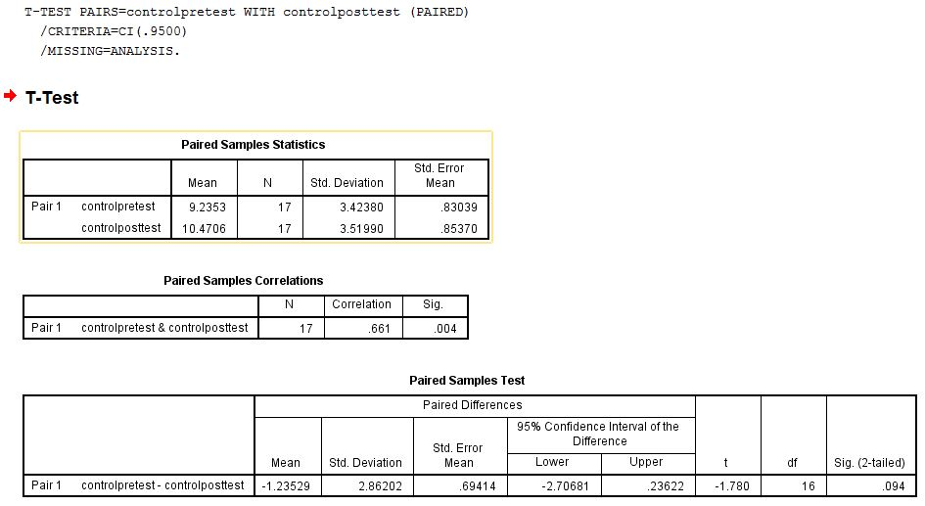
Figure 4. Paired Samples T-Tests for Knowledge Test: Control Pre vs Control Post

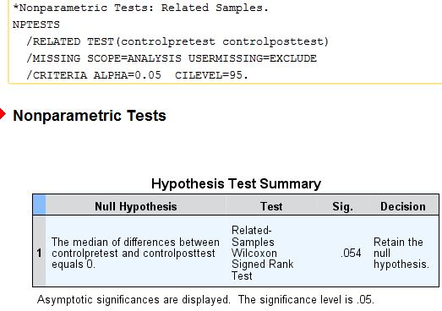
Figure 5. Nonparametric Wilcoxon Test for Knowledge Test: Control Pre vs Control Post

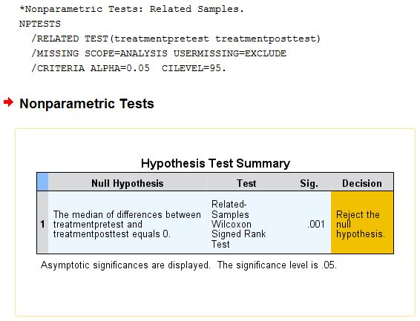
Figure 6. Nonparametric Wilcoxon Test for Knowledge Test: Treatment Pre vs Treatment Post

Perception Outcomes

Pre-implementation of our program we found that there was no statistically significant difference between preservation or utilization scores in our treatment and control groups. They all started with similar values. At post-test we did find a statistically significant difference between our two groups for preservation scores. However, this is most likely because we actually saw a decrease in preservation scores in our control group. Our treatment group’s preservation scores only increased slightly. We believe that these results were due to a ceiling effect. Saratoga Independent School is a fairly progressive, liberal private school and many of the students that attend the school come from families that are already environmentally responsible. It was clear to us at pre-test that many students in our class already had strong environmental values. We did see a downward trend in preference for utilization of natural resources in our treatment group. While these findings are encouraging, they were not statistically significant.

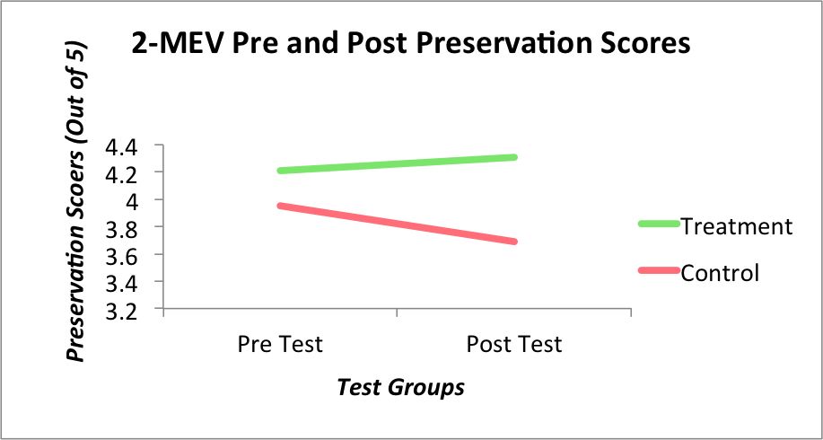
Figure 8. 2-MEV Environmental Preservation Scores Pre and Post

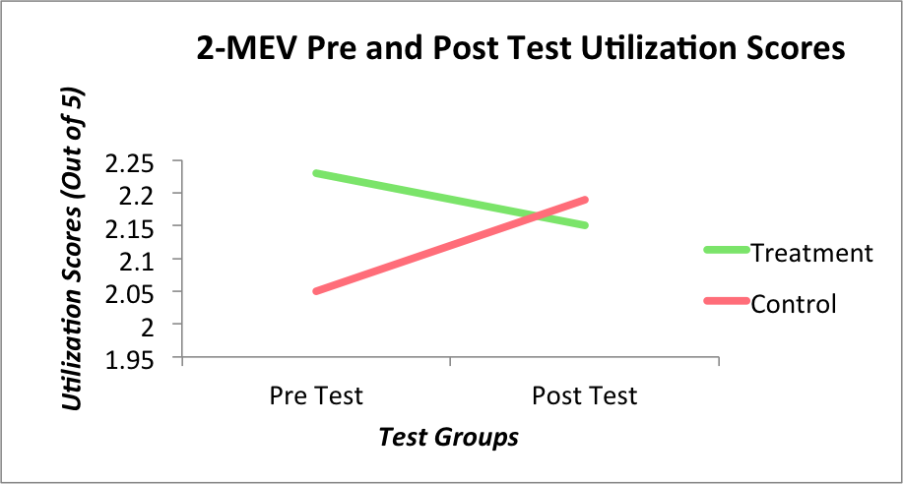
Figure 9. 2-MEV Environmental Utilization Scores Pre and Post

Behavior Outcomes

We found that students were practicing, on average, 4 environmental behaviors before our curriculum and 7 afterwards (Figure 17). These numbers were determined from both self reported behavior on surveys and student and parent interviews and focus groups. After our curriculum, students were most likely to have picked up composting as a new environmental behavior. Before our curriculum only one student reported composting at home. Afterwards, 13 out of 15 students, or 87% stated that they composted either at school or at home. Kiera, a sixth grade student, reported that she “composts using worms” at school while Adrianna, a fifth grader, said she “has a tiny compost bin” at home. The second most common behavior that students had started practicing at post test was gardening. At pre test only 20% of students gardened. Afterwards, 60% listed gardening as an environmental behavior that they practiced. Kiera mentioned that she now “helps grow vegetables in the garden at school”, something that she had not reported pre-curriculum. Rachel, 11 years old, said she now “grows some of our food”. Madison, a sixth grader who will be leaving SIS next year, said that she talked to her family about “how maybe we should grow some more organic foods so we don’t have to pay for it, like maybe apples, or we can do more vegetables, like my dad and I are talking about making a list”.
It was apparent in our behavior outcome findings that many students had taken a stance on the conventional versus organic debate. Pre-curriculum there was no mention of eating sustainably as an environmental behavior. At post-test roughly half of students reported that they were trying to eat more local and organic foods. Mallory stated that in her family “we eat as many organic foods as we can”. For Madison it became more of a hard and fast rule, “go organic or grow organic”.

Other behaviors that students reported post-curriculum & NOT pre-curriculum:
- “Only put as much food on my plate as I need.” Rachel
- “Buy local food.” Taylor
- “Don’t use pesticides on our lawn.” Adrianna
- “We have an aquaponics system.” Matt
- “Our hydroponics system.” Ella
- “I plant flowers and seedlings.” Katherine
- “Fish for fish instead of buying them.” Elijah
- “I don’t waste paper.” Mallory

To triangulate our findings and validate that the students actually adopted these new behaviors, we interviewed parents and the teacher we worked with. Jeny reported that she did notice a change in behavior in the classroom regarding composting. She explained that the school had been trying to get a classroom compost bin up and running in the past but it had failed due to lack of interest. However, in the past couple months, she noted that “some of (the students) have been asking me, if they have snacks, where the compost is. They seem more likely to want to compost their food waste in the classroom.” In addition to composting more, Jeny confirmed that students had been internalizing and thinking critically about the food debate. “In terms of food choices and farming choices students were very aware of what was going on and starting to make changes in their own lives.”

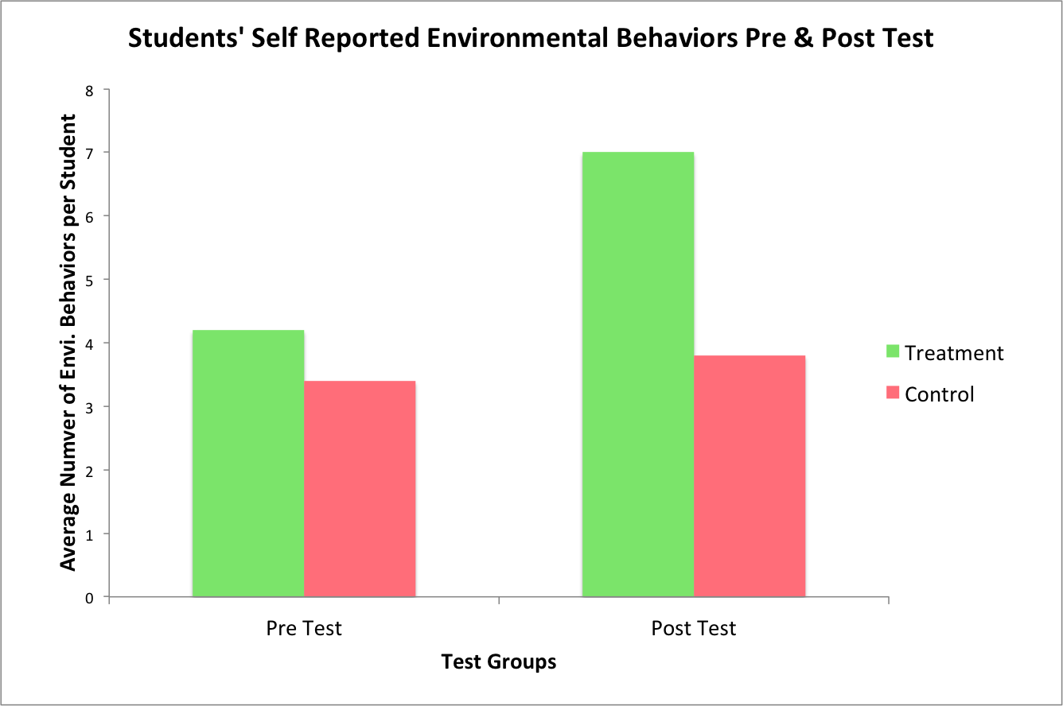Figure 10. Control & Treatment Group Average Environmental Behavior Survey Scores Pre & Post Curriculum

Research Question 2: What are the most influential aspects of this curriculum?

It was clear that intergenerational learning was present and influential within our curriculum. Of the 14 students interviewed post curriculum, 86% said they had talked to their families about our course during the three months. Many of the students had explained how the aquaponic and hydroponic systems worked to their parents or siblings, and some even said they brought parents in to see them. Elijah, and sixth grader in our class, said he had talked about “the aquaponics system, about how it circles around and about what’s good for the plants and what’s good for the fish and what’s not good for the fish”. Kiera, another sixth grade student in the class, said that her brothers had been “very interested” when she described the systems to them, and even expressed interest in building her own small version at home.
A common topic discussed in focus groups and interviews with students and parents was hands-on and experiential learning. When students were asked which aspects of the class they liked best, hands-on or lecture, 100% said they preferred hands-on.

“I liked all of the things we did with you guys just because it was really interactive and hands-on. And I really like that because then you’re not just sitting and learning and learning.”
- Ella,11

“I liked how there’s a big process, we had to put in the pebbles, then the water, then the fish, and the most fun part is that we saw that it actually works. So, the plants are growing.”
- Elijah, 11

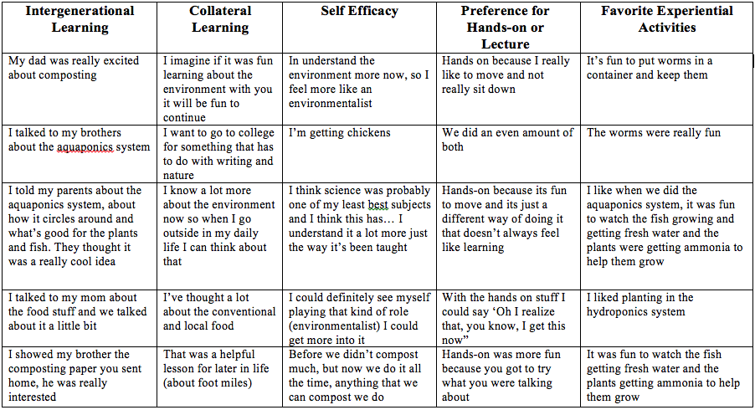
Table 2. Student Quotes about Teaching Pedagogies

Type 1 Tabs:

- 100% of students preferred hands-on activities
  - “I liked all of the things we did with you guys just because it was really interactive and hands-on. And I really like that because then you’re not just sitting and learning and learning.” - Ella,11
- 87% of students were most influenced by food issues
  - “My whole life we’ve gotten local or organic food, we’re lucky for that, but I never knew really why we were getting it. I didn’t know about all the conventional and organic and local food and all the differences between them...that was a helpful lesson for later in life.” -Taylor, 11
  - “Umm, well I think, this isn’t as big of a problem, but I’ve been thinking about the food miles more. I’ve been more aware when I buy stuff, of what I buy and where it is from.” - Elijah 11
- 86% of kids that talked to parents about what we are doing in class
  - “Yeah. How maybe we should grow some more organic foods so we don’t have to like pay for it, like maybe apples, or we can do more vegetables, like my dad and I are talking about making a list.” - Madison
  - “Like the aquaponics system, about how it circles around and about what’s good for the plants and what’s good for the fish, and what’s not good for the fish.” - Elijah 11
  - “When we talked about organic and conventional food, my mom tried to buy more organic food now instead of conventional” - Mallory, 10
  - “I talked to them about the aquaponics systems and a little bit about the hydroponics systems… (they were) very interested!” - Kiera (talking to siblings about what we did in class)
  - “I’m talking to my mom about getting a compost bin, or building one.” - Kiera
- 100% of students reported increased environmental awareness
Unexpected Outcomes

Since using aquaponics in the classroom is a fairly new concept and there is little existing research on the subject, we had several unexpected outcomes. We were surprised to find that once the aquaponic and hydroponic systems were in place, kids were taking time out of their other class periods and activities to come check on the systems. Jeny Randall noticed that “kids were interested in both (systems), they were checking the systems even outside of class time… they would notice and let me know if there were changes or if something cool had happened”. This also meant that students in our class were the first to know if something went wrong with the systems. When we experienced difficulty with the systems the kids were eager to jump in and try to help remedy the issue. This was especially apparent in March when we had all five of our aquaponics fish die. When we arrived in the classroom that week, five or six students crowded around the tank offering up their suggestions of what had happened. Kieran, age 11, informed us that the pump and aerator for the system had been unplugged by a substitute teacher for several days. He explained that without the water cycling through the system, neither the plants or fish could get what they needed. It was obvious to us at this point that students truly understood the way aquaponics systems worked.
While designing our curriculum we assumed we would be working with students with a variety of learning styles. However, we did not take into account that we would be working with students that had learning disabilities. We found that our hands-on approach to teaching allowed students with ADHD to pick up difficult concepts more easily and effectively. This was confirmed by teachers and parents in post interviews. Jeny Randall, the science teacher who we worked with said:
“ I have students with a variety of learning styles and learning abilities and I have found, and I watched this happen again through the implementation of this curriculum, that the hands on aspect is an equalizer. So for the kids who have a little bit more trouble learning and for the kids who are super advanced, they’re all in there having the same kind of discussions and conversations so there’s more collaboration, there’s more engagement, there’s longer term memory. It contextualizes what they're learning, it sticks with them.”
While in the classroom we were impressed with the level of collaboration and sophisticated interaction between students. We engaged students in activities that let students interact with the material at their own pace but also encouraged them to start dialogue with their peers. For example, at the beginning of every class we had students observe their plants growing in the hydroponics systems. Students were given that time to observe their own plants, but always spent a good portion of that time asking other students about how their plants were growing and trying to determine why some plants were growing better than others. This was an ongoing conversation that every student could be part of, no matter their learning styles or abilities.
We were also happy to see that cogenerational learning took place. Post-curriculum our student’s ability to define terms increased, but so did their ability to think critically about environmental issues outside the classroom. On a field trip towards the end of the school year, Jeny was surprised when the students started questioning why their lunch included paper bags and plastic water bottles. As Jeny describes, the students were mildly outraged, “persistent in questioning why we were doing this, not really taking no for an answer in terms of why they had to use non-reusable bags and water bottles and why we couldn’t compost.” Our students were able to apply what they had learned in our class to their daily lives and recognize when and question why environmental behaviors were not being practiced.
Limitations to the Research
One significant limitation to this research is the small sample sizes of the experimental and control groups. This study would be strengthened by further similar studies in additional locations. Additionally, the period of time in which the study was conducted may have limited the success of the research. The posttest was administered to students one week after the curriculum ended, so it is difficult to know whether the students will retain their knowledge, perception, and behavioral changes over an extended period of time.
We conducted the post interviews with students and their parents, which could have led to inaccurate information from the interviewees. A future remedy to this would be to have a non-participating interviewer.
We also experienced a ceiling effect with the environmental perceptions of both our control and treatment groups, limiting the amount of change visible within students’ environmental perceptions from pretest to posttest.

Conclusion
Adaptability
The curriculum we have created is adaptable to many classrooms, given that those classrooms have the flexibility and freedom to participate in non-traditional educational practices. A common barrier to implementing curricula such a this are the extra time commitment, resources, and a need for teachers to adhere to state teaching standards. As this study was conducted in a private school setting with a decent amount of flexibility, we did not encounter state standards limitations, and we were fortunate enough to be funded and have the time to commit to the curriculum. While it may be challenging to integrate this curriculum into a public school classroom setting, many small sections of the curriculum could be extracted as stand-alone lessons or activities to be integrated into pre-existing lessons.

Key Findings
Our first research question was to assess the environmental knowledge, perceptions, and behaviors in fifth and sixth grade students in Saratoga Springs, NY. In terms of environmental knowledge, it was clear from improved test scores that treatment group students retained key terms and concepts taught throughout the curriculum, whereas control group students did not improve their knowledge scores significantly.
Environmental perceptions outcomes were less clear. We experienced a ceiling effect with our treatment and focus groups for environmental preservation perceptions, and did not find a significant increase in treatment group preservation scores at post test. While some subcategories within environmental preservation and utilization scores improved with statistical significance, scores did not change drastically from pretest to posttest.
The treatment group’s environmental behaviors showed an increase from pretest to posttest. Qualitative data from interviews with the students’ parents confirmed much of the students’ self-reported environmental behaviors.
Our second research question asked which aspects of our curriculum were most influential for our treatment group students. The most common positive responses we received from parents, students, and their teacher were the effectiveness of hands-on learning and positive responses to classroom projects, specifically aquaponics.

Reflections
This study integrated the philosophy and teachings of many influential figures in environmental education. Our focus on agricultural systems and local food systems addresses Richard Louv’s Nature Deficit Disorder by involving students in their local ecosystems via aquaponics, hydroponics, composting, and food systems. We also successfully integrated the philosophies of John Dewey by creating an experiential curriculum that gives students a direct connection to the material they are learning by providing hands-on experiences. Additionally, our focus on self efficacy reinforces the findings of Orr and many others.

Recommendations & Potential for Future Research

While we found aquaponics and other small scale agricultural systems to be effective teaching tools, more research in this field is necessary. This study adds to the research by Hart, Webb, and Danylchuk who found that aquaponics is a useful teaching tool for the application
of math and science, experiential learning, and making connections to food systems and globalization. We recommend that in the future, additional studies be done on the effectiveness of small scale agricultural systems in elementary school classroom settings. We also recommend future studies be completed in other areas throughout the United States and the world to assess curriculum success in different social and ecological climates.

Appendix A (Test & Interview Questions)

Knowledge, Perceptions and Behaviors Test

Part I: Circle the best answer to the following questions
Which of the following is NOT a native plant to upstate NY?
a. mint b. tomato c. blueberries d. shallots
Which is a poisonous result of nitrogen fixation?
a. hydrogen b. nitrous oxide c. ammonia d. ozone
Some pesticides can be harmful to...
a. invertebrates b. mammals c. reptiles d. all species
A a relationship between two organisms that is helpful to both of them is called...
a. symbiosis b. parasitism c. osmosis d. dependency

Part II: Short Answer:
List as many places that you can where healthy/fresh food is available in your community.

Make a list of all the ways we can reduce human effects on the environment.

List 2 ways humans can reduce the amount of wasted food that gets thrown away.
A)
B)
List how invasive plant species could have a bad effect on nature.

Why do you think it is important to have a school garden?

How do fish and plants help each other by living in the same ecosystem?

Name 2 plants that can be used as medicine, and how they are used.
Name of Plant 1:
Uses:
Name of Plant 2:
Uses:
List 3 vitamins or minerals that come from fruits and vegetables.
1)
2)
3)

Part III: Circle the correct definition of the following terms:

Compost
a. A computer posting site like “Twitter”
b. Living (or biotic) material has been decomposed into a nutrient-rich soil
c. The process where plants use carbon dioxide to make oxygen
d. Fish excrement (poop) that can be used as a fertilizer to grow plants

Food Justice
a. Treating all fruits and vegetables fairly
b. When everyone in a community can get healthy, fresh, nutritious food that doesn’t cost too much
c. Making sure everyone in a community can get to all the junk food they want
d. A judge who decides how homeless people in the community receive food

Aquaponics
a. A system of growing food in which fish and plants are grown together in water.
b. Sea creatures that filter water through their bodies to clean the ocean floor
c. A fish tank used to display large fish such as sharks and whales
d. The study of water

Globalization
a. An increase in the average temperature on Earth
b. The sharing of ideas, technology, and resources across the world
c. The term for the discovery of the world being round rather than flat
d. An explanation for the development of life on earth

Closed-loop system
a. A system that excludes plants and animals that do not get along
b. An ecological system that is made of of circular-shaped objects
c. A system where everything that is produced is also recycled in the same place
d. A system within which larger animals eat smaller animals

pH is a measure of what?
a. How acidic or non-acidic water is
b. Photosynthesis
c. Water temperature
d. Pollution

Decomposition
a. Sitting in front of a computer for a long amount of time
b. A story about compost
c. The breaking down of living material
d. The release of carbon dioxide by plants

Sustainability
a. Using resources thoughtfully now, so that they may also be enjoyed in the
future
b. Using as many resources as possible in a short amount of time
c. Maintaining the lives of phytoplankton in the ocean
d. When rabbits reproduce during the winter months

Food Miles
a. The number of miles food travels from where it was picked to your plate
b. The length of a vegetable farm (in miles)
c. The amount of miles a pollinator travels between flowers
d. The distance between your house and McDonalds

The Environment Questionnaire – revised ENV items – arranged by Model of
Ecological Values factors

Preservation
Intent of support
If I ever have extra money, I will give some to help protect nature.
I would help raise money to protect nature.
I try to tell others that nature is important.
Care with resources
To save energy in the winter, I make sure the heat in my room is not on too high.
I always turn off the light when I do not need it any more.
I try to save water by taking shorter showers or by turning off the water when I brush my teeth.
Enjoyment of nature
I would really enjoy sitting at the edge of a pond watching dragonflies in flight.
I really like to be able to go on trips into the countryside – for example to forests or fields.
I feel good in the silence of nature.

Utilization
Altering nature
People have the right to change the environment (nature).
I like a grass lawn more than a place where flowers grow on their own.
To feed people, nature must be cleared to grow food.
Weeds should be killed because they take up space from plants we need.
Human dominance
Building new roads is so important that trees should be cut down.
Because mosquitoes live in marshes and swamps, it would be better to drain these and use them for farming.
People are supposed to rule over the rest of nature.

Pre-Curriculum Student Interview Questions
- What is your name?
- How old are you?
- How long have you lived in this area?
- Where else have you lived?
- How many brothers and sisters do you have?
- How many years have you been going to SIS?
- Have you ever studied the environment at SIS with Ms. Randall or any other teachers? If so, try to explain what types of lessons you've had about the environment.
- Do you have a garden at SIS? If so, what do you grow and eat from the garden? How do you personally participate in the garden here at SIS?
- Does your family have a garden at your house?
- If so, what do you grow and eat from the garden?
- How do you personally participate in the garden at your house?
- Does your family spend much time outdoors? Can you explain the types of activities that you do in the outdoors?
- What does the word "environmentalist" mean to you?
- Do you consider yourself an "environmentalist"?
- Can you please list the environmental behaviors or actions that you regularly practice? (you might have to give an example, like, "It's something that you personally do or don't do, in order to protect the environment or save resources")
- Can you please list the environmental behaviors or actions that your family regularly practices?
- Have you ever tried to talk to your family about changing their environmental behaviors? If so, what happened, or what did they change?
- At home, does your family ever talk about the environment? If so, what topics do you talk about?
- Are you able to name any environmental issues or problems facing your community and the planet?
- Do you think that there are any environmental issues or problems where you live or on the planet that are more important than others? If so, which ones?

I always do this - Sometimes I do this - I almost never do this - I never do this
Food
1. I try to eat lots of fruits and vegetables.
2. I try to eat organic foods (without pesticides) when possible.
3. I try to eat natural foods that are not too processed.
4. I am a vegetarian

Food Waste
1. I eat everything that I take/ am given.
2. If I have any extra food, I compost it.
3. My family composts any food we don’t eat.

Post-Curriculum Student Interview Questions
- What is your name?
- Are you aware of any environmental issues in saratoga/ this region?
- Which problems do you think are the most important here and in the world?
- What was your favorite projects that we did with your class, and why?
- Did you have fun with hands-on projects and experiments? Why? Did you prefer lecture or hands- on more?
- Think you had enough hands on projects? Would you like more or less?
- Are you currently practicing any environmental behaviors at home or at school?
- Have you tried to talk to family members about changing their behavior
- towards the environment?
- Has your family changed their behavior towards the environment?
- Was it that you spoke about behaviors that you learned in class or you looked practicing particular behavior?
- Do you think that this class can help increase your awareness of the environment?
- Have you been more interested in environmental issues since you took the course? Yes that is the case, what are the issues that interest you?
- Do you find yourself having more appreciation for nature since you took the course?
- Do you take more time in nature since you took the course?
- What other form or manner this course has affected your life or your schoolwork?
- What does the word environmentalist / ecologist mean to you?Do you consider yourself an environmentalist? If that's the case, do you you considered an environmentalist before taking the course?
- Do you think that later will be interested in taking other classes on the environment?
- Why?

Post-Curriculum Parent Interview Questions
- Has your son or daughter talked to you about their experiences with our environmental education curriculum? What have they told you?
- Do you believe that your son or daughter had a generally positive or negative experience during our environmental education curriculum?
- Have you noticed changes in your son or daughter’s behavior since he or she began our environmental education course?
- Have you noticed changes in your son or daughter’s school work after finishing our EE course?
- Has your child talked to your family about changing their envi behaviors in the past four months?
- Have you or your family adopted any new environmental behaviors? Give examples.
- Your son/daughter said that they started composting/ recycling. Can you verify that this is the truth? and could you give me explanation of how they’ve changed?
- Is there anything that you would like to add in relation to the class your son or daughter took?

Post-Curriculum Teacher Interview Questions
- To what extent did the experiential plant literacy curriculum fit into your broader teaching needs for the year?
- Can you please describe the most useful or meaningful components of the experiential plant literacy curriculum…and why?
- Can you please describe the least useful or meaningful components of the experiential plant literacy curriculum, and suggest areas for improvement.
- To what extent did you see an increase in students' interest in environmental issues as a direct result of the plant literacy curriculum (please list if possible).
- To what extent did students' pro-environmental behaviors change over the course of the year, specifically in relation to the plant literacy curriculum. Please provide specific examples if possible.
- Can you explain how students positively and/or negatively responded to the hands-on and experiential nature of the plant literacy curriculum?
- To what extent will this plant literacy curriculum inform and advance any of the school's future classroom EE projects and/or sustainability or garden related projects?

Appendix B (Transcribed Interviews)
Pre Interviews
Students

Student Pre Test Interviews
Ella Mason
What is your name?
E:Ella Mason

How old are you?
E: 10

How long have you lived in this area?
E: 9 Years

Where else have you lived?
E: Michigan

How many brothers and sisters do you have?
E: One Brother

How many years have you been going to SIS?
E: The whole time (8 years)

Have you ever studied the environment at SIS with Ms. Randall or any other teachers? If so, try to explain what types of lessons you've had about the environment.
E: Um i remember we learned a lot about seeds and like different kinds, we just finished a unit on different kinds of leaves and stuff.

Do you have a garden at SIS? If so, what do you grow and eat from the garden? How do you personally participate in the garden here at SIS?
E: Well I remember the first time we made it and we made little letters. We‘ll plant new ones and use the fruits and vegetables for lunch. I’ve planted new things, watered them, and pulled the weeds out.
What have you eaten from the garden?
E: I usually like eating the watermelon.

Does your family have a garden at your house?
E: No but my mom wants to.

If so, what do you grow and eat from the garden?
N/A

How do you personally participate in the garden at your house?
N/A

Does your family spend much time outdoors? Can you explain the types of activities that you do in the outdoors?
No Data

What does the word "environmentalist" mean to you?
E: Someone who works to help save the environment and keep the air clean make sure that no pollutions and make sure that is a safe healthy environment.

Do you consider yourself an "environmentalist"?
E: Um, yeah.
Why the shrug?
E: I wouldn't really consider myself a complete environmentalist but I try to help save the environment.

Can you please list the environmental behaviors or actions that you regularly practice? (you might have to give an example, like, "It's something that you personally do or don't do, in order to protect the environment or save resources")
E: Like turning off the water when you’re done, turn the light off, shut the door, lock the door before you go to bed.

Can you please list the environmental behaviors or actions that your family regularly practices?
E: Um, my mom and my dad always say to make sure that your eyes aren’t bigger than your belly.

Have you ever tried to talk to your family about changing their environmental behaviors? If so, what happened, or what did they change?
E: Well we’ve talked about getting like a little compost bin because we’re not like a big nature family so we’re trying to do a little bit more of that.

At home, does your family ever talk about the environment? If so, what topics do you talk about?
N/A

Are you able to name any environmental issues or problems facing your community and the planet?
E: Well like this isn’t really my family but at school Ms. Randall is really big on recycling
Pollution and littering, I think that those are the top ones because pollution i feel like we are using so much gas and its spreading around in the air like car exhaust is just overloading. And then litter its just kinda sad to see that. I’ve like picked it up and its kinda gross.

Do you think that there are any environmental issues or problems where you live or on the planet that are more important than others? If so, which ones?
E: Well it kind of depends. Composting could be not that big of a deal but then other times it could be a bigger deal like if people are just like wasting a whole meals worth. When I waste food I try and think of people that aren't as fortunate and that they don’t, they might not get even one meal a day. So it kind of depends on the amount.

Food
1. I try to eat lots of fruits and vegetables.
E: Sometimes
2. I try to eat organic foods (without pesticides) when possible.
E: Sometimes
3. I try to eat natural foods that are not too processed.
E: Almost Never
4. I am a vegetarian
E: Never

Food Waste
1. I eat everything that I take/ am given.
E: Almost Never
2. If I have any extra food, I compost it.
E: Sometimes
3. My family composts any food we don’t eat.
E: Almost Never

Katherine

What’s your name?
K: Katherine
What’s your last name?
K: Mariott

How old are you?
K: 10

So are you in fifth grade here?
K: Yes

And how long have you lived in Saratoga?
K: Seven years

Where did you live before?
K: Well, I’ve always lived in Saratoga but now I’m living in Stillwater.
Okay, is that far away from here?
K: No it’s a town in Saratoga

How long have you been coming to SIS?
K: This is my first year.
Your first year! Are you liking it?
K: Mhm

So now I’m going to ask you a little bit about your family. How many brothers and sisters do you have?
K: One younger brother.

How old is he?
K: He’s six.
Does he go here too?
K: Ya
Does he like it also?
K: Mhm.

Good! So you’re studying with Ms. Randall. What kind of things are you learning in science this year?
K: Well we’re doing a tree project on SIS trees.
What are you learning about the trees?
K: To recognize the different shapes of their leaves.
So do you get to go outside a lot?
K: Sometimes.
Fun! And have you studied anything else about the environment with Ms. Randall?
K: Uh, well, we planted tulip bulbs with our buddies outside for a science experiment.

Cool, was that in the garden right behind the school?
K:Uh huh.
Do you get to go out into the garden a lot?
K:Not right now because it’s winter.
Do you think you’ll go out in the spring?
K: Yeah.
That makes sense because that’s when you plant! Do you have family garden at home?
K: Yeah.
What does that look like?
K: It’s got quite a few beds and we’ve got tomato plants and strawberries.
What’s your favorite thing you grow?
K: The strawberries!
What do you do with the strawberries you pick?
K: We take them inside, wash ‘em and eat ‘em!
Yum! So do you know what happens to the food you grow here at SIS?
K:It goes to the kitchen
What kind of food do you eat here at school?
K: For buying or bringing?
When you buy?
L: We usually have some kind of vegetable.
Do you think the vegetables usually come from the SIS garden or only sometimes?
K: I think mostly they come from the garden.
Very cool!
So does your family spend a lot of time outside?
K: Yeah
What kind of activities do you like to do?
K: Well, we take our dogs on walks, and go over to our next door neighbor, and hang out with our chickens, and sometimes garden in the spring.
Does your neighbor have a farm or do they just have backyard chickens?
K: Well we share the chickens, and she has a big fenced in yard and four dogs.
Wow that must be fun! Do you get your eggs from there?
K: Mhm.
How long have you had your chickens for?
K: I wanna say like six years, or five years.
Do you feel like that’s helped you learn about animals and food? What have you learned from them?
K: That a lot of people are afraid of them (chickens)! But they are friendly.

So this is a little bit of a tricky question but what does the word “environmentalist” mean to you?
K: Um like someone who studies the environment and knows a lot about it

Yeah, definitely, do you consider yourself an environmentalist?
K: In science, yes.
What about at home too?
K: Mhm.
Do you think your family members are also environmentalists?
K: A little bit.

Are there any environmental behaviors or actions that you practice at home?
K: Um, well we don’t litter.
Do you recycle too?
K: Yes.

What else?
K: We don’t spray chemicals on our garden
That’s always a good thing!
K: We turn off the water too.
Cool! Are these all things your parents taught you or did you learn them at school?
K: Some I just know and some they taught me.

Do you feel like you ever teach your parents anything about the environment?
K: Sometimes.
What kind of things have you taught them?
K: I’ve taught them a little bit more about trees and about how we identify them.
Okay, and do they seem really interested to learn about trees?
K: A little bit.

Yeah, it’s pretty cool to learn about! Okay, so can you name any environmental issues that we might deal with in Saratoga?
K: Mhm, like littering. Some people do spray chemicals on their gardens.
They do, do you know why that might be bad?
K: Mhm because it can hurt or kill creatures if they eat like a tomato from the garden that was sprayed.
Do you think it could hurt humans too?
K: Mhm.

Can you think of any environmental problems that might be affecting the whole world, so not just Saratoga?
K: Um, littering and chemicals and cutting down trees.

Do you think there are any problems that are more serious than others? What is the biggest environmental problem you can think of?
K: I think one of the biggest ones I can think of is cutting down trees. It makes less habitat for animals and less shelter too.

Mhm. You know a lot about trees! So for the last part of this interview, I’m just going to say a sentence and you all you have to do is answer; i always do this, i sometimes do this, i almost never do this, or i never do this.
K: Okay.

Food
I eat a lot of fruits and vegetables.
K: I always do this.
I try to eat organic foods without pesticides.
K: I always do this.
I try to eat natural foods that are not too processed.
K: Sometimes.
That one can be really hard. I am a vegetarian.
K: No.

Food Waste
I eat everything that I take or am given.
K: Not always. Sometimes.
How about: If I have any extra food I compost it.
K: Never.
Do you have composting at home?
K: No
Is there composting here?
K: Yeah.
So after lunch do you guys put your food in the compost or how does that work?
K: Um sometimes they do, and sometimes we don’t.

Okay. And the last one is: My family composts any food we don’t eat.
Never.

Elijiah
What’s your name?
E: Elijiah
And how old are you?
E: 11

How long have you lived in Saratoga?
E: My whole life.
Okay! Are you from Saratoga Springs or do you live in one of the other towns?
E: Well, Saratoga Greenfield Center.
So that’s pretty close to here right?
E: Yeah.

Do you have any brothers or sisters?
E: I have a brother who’s 37 and he lives in California.
Wow, cool. Do you get to visit him a lot?
E: Not really, I’m gonna see him when we go on break though!
Fun! Have you been to California before?
E: Yeah we have a place in Palm Desert also, he lives in Santa Cruz though. He has two daughters so… one is 16 and one is 10
Are they nice?
E: Yeah they are nice.

Cool that’s going to be awesome! So, how many years have you been going to SIS?
E: This is my ninth year.
Wow, so you started going here in kindergarten?
E: Pre-K.

Okay and have you ever studied the environment with Ms. Randall?
E: Yeah a few years ago and a little bit this year.
Okay what kind of things did you learn?
E: We did gardening, and stuff like that.
And what was your favorite part about that?
E: Um I really liked doing the activity, it was fun to plant everything and to learn different ways to plant.

It’s always fun to get outside. Okay, so you have a garden here at SIS. What kind of things do you grow in it?
E: We grow carrots, and lettuce and yeah. Some stuff like that. Flowers, plants, different plants and I think we grow mint.
And what do you do with the things that you grow?
E: Sometimes the lunch lady uses them, like carrots for lunch or something. But sometimes we just let them grow to watch them.
Do you study the way they grow or how fast?
E: Yeah.

Cool. Alright, so do you have a garden at home too?
E: Yes I do.

Okay what does that look like?
E: It’s small, it has a small fence around it so deer can’t get over and stuff because we live in the woods and we grow beets, lettuce and carrots and strawberries.
Wow that sounds awesome! What’s your favorite thing to eat that you grow?
E: Probably strawberries.
Very cool, and you grow those in the summer?
E:Yeah.
So are you usually the one who helps plant or pick, or what do you do in the garden?
E: I usually do both.
And do your parents both help out too?
E: They help pick it mostly. We have a gardener but I usually help the gardener.

Does the gardener only come in the summer?
E: I think he comes in the summer and in the spring.

Nice! Does your family spend a lot of time outside?
E: Not really, I do. My parents are more like indoor people but I spend a lot of time outside with my friends when I can.
Okay! So what do your parents like to do?
E: Well my dad works at, we have a barn, like not with animals, but it’s his office, so he works there mostly. And my mom, she does go running. She goes running every day in the summer like 11 miles.
Wow!
E: Yeah she runs marathons sometimes so she does I guess spend a lot of time outside, and I play tennis a lot outside.
So you like to play sports oustide?
E: Yeah.
Do you go hiking and swimming also?
E: Uh yeah I go hiking and swimming.

Okay this is a big question but what does the word “environmentalist” mean to you?
E: Someone who studies the environment.

Do you consider yourself an environmentalist?
E: Uh, yes. Like at school. And at… I guess everywhere because when I look at stuff I say “ooh that grew a little bit”. I don’t always take notes on it but I always see.

Yeah, sounds like you’re good at noticing your surroundings! So can you list some environmental behaviors or actions that you practice? So that could be, for example, recycling at home or…
E: Yeah I recycle, we compost, we do compost here also…
Do you ever ride your bike somewhere instead of going there in a car?
E: Oh yeah, yeah. I ride my bike, or scooter sometimes. I take short showers and stuff too.

That’s a good one. Are there any environmental behaviors besides composting that your family always practices?
E: Well recycling, we have a big recycling bin. We have a garbage and recycling and we just switched them because the garbage was bigger, but we made the recycling one bigger so we could put more recycling it it.
Cool, so would you say your parents are strict about recycling?
E: Um, kind of yeah.
So if you threw something away that was recyclable by accident, would they tell you to switch it?
E: Yeah.

Have you ever tried to talk to your parents or brother about environmental issues? Or do they talk to you about environmental issues?
E: Sometimes. Yeah I usually talk to them about it. Sometimes they talk to me, not as much though. It doesn’t always come up, but I sometimes I talk to them like after school I would tell them what’s going on and they would talk to me.
Cool, so do they seem interested when you bring up things about the environment?
E: Uh, yeah pretty interested.
Do you feel like you’ve taught them anything about the environment?
E: Yeah I think I have.

Great! So do you think you could name some environmental issues that are facing your community?
E: Global warming, littering, sometimes even in California with water, there’s not enough water and some people are using too much water.
Does your brother struggle with that?
E: Uh, well he lives in Santa Cruz so he’s a little, like in Palm Desert it’s, we don’t really struggle with it but it’s pretty dry there so it’s yeah.
Okay so how about littering, do you know what happens when someone litters around here?
E: Well there are people who do pick it up, like people who are supposed to pick it up. But sometimes animals can take it and that would kind of be bad for them if they ate it.

Yeah that would not be good. So now I’m going to say a few sentences and all you have to do is answer with: I always do this, I sometimes do this, I almost never do this, or I never do this. Okay?
E: Mhm.

Food
Okay so the first one is: I try to eat lots of fruits and vegetables.
E: I think sometimes.
Okay how about: I try to eat organic foods without pesticides whenever possible.
E: Always. I always try to yeah.
Awesome! I try to eat natural foods that are not too processed.
E: Yeah always.
I am a vegetarian.
E: No.

Food Waste
I have three more, same thing. I eat everything that I take or I am given.
E: Not always, it depends what it is but yeah.
Okay so like for example if you don’t like something, you don’t finish it?
E: Um well it depends, like if someone gave me a huge cake or something I wouldn’t finish it all because first of all I know it’s not healthy and also it would be so much. So, now always.

If I have any extra food I compost it.
E: Yeah always.

My family composts any food we don’t eat.
E: No, not any food.
But some of it?
E: Yeah, sometimes.

Madison
What’s your name?
M: Madison
What’s your last name?
M: Moynihan

How old are you?
M: 11

How long have you lived in this area?
M: In Saratoga or where I really live?
Where do you really live?
M: Charlton, near Burnt Hills, in that district.
Okay how far away from here is that?
M: Like 40 minutes, not an hour but half an hour.

Have you ever lived anywhere else?
M: I lived, I don’t know what it’s called but it’s Brew Street, that’s the street that it was but I don’t know what town that is.
Is it near here though?
M: No, it’s not. It’s not near here but it’s around here.
Is it in New York?
M: Yeah.

Okay cool. Do you have any brothers or sisters?
M: Yes.
Okay, how many?
M: Two brothers.
Are they older or younger?
M: Younger.
How old?
M: Six and eight.
So you’re the oldest, nice. Do they go here too?
M: Yeah.

How many years have you been going to SIS?
M: This is my second year.
And have you taken any other classes with Ms. Randall?
M: Just science this year and senior seminar.
So you’re a senior, which means you’re in sixth grade?
M: Yeah.

Cool. Have you had any lessons about the environment?
M: There’s a camp called Ndokkina, I’ve gone there.
Have you taken any here or just at camp?
M: We’ve done trees but that’s it.
What about trees?
M: Like we’re learning the leaves and the bark and what kinds of trees they are.
Okay cool, did you get to go outside a lot?
M: Yeah.

Awesome. Do you have a garden here too?
M: Yes we have gardens.
Do you go during class, or after class to the garden?
M: Well we just planted tulips a couple weeks ago, and then we planted some vegetables last year.
So do you plant in the fall and pick in the spring?
M: Usually, yes.
Great, what are some of the other kinds of things you grow in the garden?
M: We grew tulips, carrots, I think we did some rosemary and that’s all that I can remember.
Okay that sounds awesome. And do you have a garden at home?
M: Yup.
What do you grow there?
M: Garlic, corn, we did beets, tomatoes, and we have blueberry bushes but that’s not really in the garden.
That still counts! So what do you personally do in the garden at home?
M: I usually help pick and plant the garlic and I’ll pick the tomatoes and I’ll help plant some things.
Do your brothers help too?
M: Yeah they help my dad.

So does your family spend a lot of time outside?
M: Yeah we usually do.
What kind of things do you like to do?
M: We’ll go skiing, we have a snowmobile that we’ll ride a lot, we have a pond so have fun on the pond and then our friend has a really awesome sledding hill that we’ll go down and they’re right across the street so it’s easy to get there, so that’s it. And we’ll go hiking too.
So can you ice skate on the pond in the winter?
M: Yeah. It was frozen a couple weeks ago but it’s gotten a little warm so I’m not really sure.

The weather has been weird lately! Okay so this is a big question but what does the word environmentalist mean to you?
M: A person who studies the environment.

Yeah, and do you consider yourself an environmentalist?
M: Not really, but I do know things about the environment but I don’t really like study it.
Are you interested in it though?
M: A little bit, like in senior seminar we’re doing a project and I’m doing it on birds and climate change so that’s kind of with birds and you know the environment.
Yeah very cool! What kinds of birds are you studying?
M: We’re not that in depth with it yet but I’m reading some articles on, I don’t know what the bird is called it’s like some crazy name, but they got endangered, so.
That sounds interesting. So did you pick that out of a list of topics that were chosen for you?
M: You can make up some topics, but Ms. Randall made one that was birds and climate change and it kind of interested me, so.

So can you list any environmental behaviors or actions that you regularly practice? Like if you go home and you drink a plastic bottle of water, do you recycle the plastic bottle afterwards? Anything like that.
M: Okay, well usually when I brush my teeth I’ll turn the water off or I recycle. I will make sure that my family recycles. I’ll turn off the lights when I’m not in the room, or the fan.
And when you try to get your family to recycle do they usually listen?
M: Um yeah usually they do.
Cool. So what are some things that your family does besides recycling (thanks to you)?
M: Like what do you mean? Their job or something?
Well, environmentally. So they’re recycling you said…
M: My dad is very picky about turning lights off when you’re done in a room. Um, also closing the doors and stuff. I don’t really know if this is by the environment but making sure the wood is split and stuff for the fireplace.
Where do you get the wood?
M: We split it ourselves.
So you get it from the woods in the back of your house?
M: Yeah.
Cool.
M: Also, my mom, it’s kind of hard. We do a lot of the same things.
Yeah totally! This is a great list. Do your parents ever explain why you should do any of these things?
M: Yeah usually. For the lights, when you’re not using them it costs money to run the electricity. And then getting the wood would be helping warm the house and not having to use the gas. Closing the doors will also keep the heat in.

Awesome. So when you’re at home does your family ever talk about the environment?
M: Yeah we will like how you should take care of it and not ruin any of the nature and stuff.
Do you think your parents try to get you to appreciate nature?
M: Yeah.

Can you think of any environmental issues or problems that may be facing your community?
M: Probably putting salt down when the roads are slippery because that can get into the ground and get into your well water.
That’s a good one. Can you think of any that may be affecting the entire planet, on a bigger scale?
M: The gas from cars and the exhaust that comes out of the car.
Do you know what that does?
M: It changes the temperature and it’s bad for the environment.

Do you think that there are certain environmental problems that are worse than others, or more important?
M: Yes. Like…
What’s like the worst one you can think of?
M: I’m not sure.
That’s okay, that’s totally fine! I mean you said gas from cars and exhaust affecting the environment, that’s a big one.

Food
I try to eat a lot of fruits and vegetables.
M: Always.
I try to eat organic foods without pesticides when possible.
M: Always.
I try to eat natural foods that are not too processed.
M: Always.
I am a vegetarian.
M: Well, a couple years ago I myself was trying to be a vegetarian but then my parents were like well if you have a little bit of meat that’s alright, so now I am not a vegetarian but I would like to be probably but still eat a little bit of meat so um, sometimes.
It can be hard when everyone else in your family isn’t a vegetarian.
M: Yeah, yeah it can be.

Okay I have a couple more statements and then you’re done. These work the same way, so you’ll respond with always, sometimes, almost never, or never.
Okay.

Food Waste
I eat everything that I take or am given.
M: Um, usually always.
If I have extra food I compost it.
M: Sometimes.
My family composts any food we don’t eat.
M: Sometimes.

Okay that’s it thank you so much!
Thank you.

**********still need to transcribe Colton, Adrianna, and Rachels pre interviews************

What is your name?
C: Chris MacDonald

How old are you?
10

How long have you lived in this area?
C: My whole life

Where else have you lived?
--
How many brothers and sisters do you have?
C: One brother

How many years have you been going to SIS?
C:7

Have you ever studied the environment at SIS with Ms. Randall or any other teachers? If so, try to explain what types of lessons you've had about the environment.
C:I remember doing like what leaves, well the parts of leaves, and, the parts of flowers, uh, thats about it.

Do you have a garden at SIS? If so, what do you grow and eat from the garden? How do you personally participate in the garden here at SIS?
C: um, I remember I planted, um I planted some herbs. I don’t remember what time. I also helped to build the garden. I also ate carrots from the garden.

Does your family have a garden at your house?If so, what do you grow and eat from the garden?
C: Yes. We grow tomatoes, pumpkins and corn. We mostly gave them away.

How do you personally participate in the garden at your house?
C: I mostly weed it or till it.
What do you use to do that?
C: A rototiller.

Does your family spend much time outdoors? Can you explain the types of activities that you do in the outdoors?
C: We have a treehouse. We have a backyard with a ravine in it, and in the ravine people throw plastic bottles in it that we collect.

What does the word "environmentalist" mean to you?
C: I think its someone who studies the environment or helps it.

Do you consider yourself an "environmentalist"?
C: I guess. Why do you think that? I like to go outside

Can you please list the environmental behaviors or actions that you regularly practice? (you might have to give an example, like, "It's something that you personally do or don't do, in order to protect the environment or save resource
C: Um like using low power stuff and turning lights off, short showers.s")

Can you please list the environmental behaviors or actions that your family regularly practices?
C: recycling our plastic bottles.

Have you ever tried to talk to your family about changing their environmental behaviors? If so, what happened, or what did they change?
no answer

At home, does your family ever talk about the environment? If so, what topics do you talk about?
C: We talk about like plant poisons and stuff like that. What kind of poisons? Like, plant diseases.

Are you able to name any environmental issues or problems facing your community and the planet?
C: Um, I’d say like water, like throwing stuff into clean water. What else? Um, like pollution in general.

Do you think that there are any environmental issues or problems where you live or on the planet that are more important than others? If so, which ones?
no answer

Food
1. I try to eat lots of fruits and vegetables.
C: Always
2. I try to eat organic foods (without pesticides) when possible.
C: Sometimes
3. I try to eat natural foods that are not too processed.
C: Sometimes
4. I am a vegetarian
C: Never
Food Waste
1. I eat everything that I take/ am given.
C: most of it
2. If I have any extra food, I compost it.
C: yeah
3. My family composts any food we don’t eat.
Sometimes

Student Pre Test Focus Group

Student Participants: Drake, Kieran, Taylor, Owen, Matthew, Mallory, Keira

Eliza: Okay so, Have you ever studied the environment with Ms. Randall’s class or any other classes?
Drake: I’ve done it at Ndokenda, my mom runs an environmental camp
Kieran: We did last year, a Square of Life Project and we’ve done a few other things
Taylor: Square of Life, with him
Jenna: What’s the Square of Life Project?
Kieran: It’s a meter...
Taylor: A square meter!
Kieran: It’s like a square meter we put down, and we put flags and we had to write down like everything that was in there, I think it was two days because it changed
Mallory: Like grass, insects, or anything that was ever in there
Taylor: Worms
Mallory: Trees
Taylor: I don’t remember what we did study it… We also did trees
Jenna: Tree identification?
Taylor: Yes
Jenna: Any other classes that you’ve studied the environment?
Drake: Yeah, so my mom does, she makes me, I mean this is just me, and then she, yeah, okay, I’m done
*Laughs all around*

Jenna: So any other classes that you’ve studied the environment in? Or mostly Ms. Randall’s class?
Kieran: Just Ms. Randall
Matthew: Yeah

Jenna: Cool. So the garden. Have you used the garden in any of your classes?
Kieran: Uh yeah, science mostly, with Ms. Randall
Taylor: Yes!
Kiera : We weeded and harvested the vegetables, and planted them
Drake: And made dressing!
Jenna: Cool! So did you do it during your class period? Or after school?
All: Class period
Kieran: And sometimes we’ve done it before or like one time um we planted tulips out there for Journey North and we… I don’t know what… I think that was…
Taylor: That was in the morning
Kieran: That was in the morning, but, so we’ve done it in the morning sometimes
Jenna: Have your parents ever come and helped in the garden?
Taylor: Yeah. When we made the garden they came and helped build it.
Kiera: Yes.
Eliza: Oh cool!
Jenna: Was that fun?
Taylor: Yeah.
Mathew (?) : That was my first year I think
Taylor: That was his visit
Owen: We also planted tulips around the edges for Journey North
Jenna: Oooh lovely!
Something ----

Eliza: Cool! Does anyone have a garden at home?
Jenna: What do you guys grow at home?
Owen: Everything
Taylor: Vegetables
Drake: Herbs
Kieran: Some herbs, a lot of vegetables. We have an herb garden, we have a flower garden, a vegetable garden. We grow a lot
Jenna: Do your parents take care of the garden or do you guys help?
Kieran: We help
Drake: Yeah I have to help
Jenna: Is that like a chore? You have to help in the garden?
Drake: Yeah.
Kieran: Eh, it’s more fun.
Someone: Except in the winter
*Giggles*
Taylor: It’s not really that bad
Drake: *Groans*
Jenna: Do you guys grow anything inside during the winter since you can’t go outside?
*Everyone speaks at once*
Kieran: We have house plants
Owen: Rubber plants!
Kieran: We have a rubber tree plant too!
Matthew: What is that?
Eliza: A rubber tree plant?
Owen: We used to have it in Oregon but we couldn’t take it

Jenna: Do you guys compost at home?
Kieran: Yeah
Taylor: Yes
Drake: It’s disgusting, I hate doing it, I have to throw stuff… *groans*
Kieran: We have chickens so we give them some stuff
Eliza: Oh cool
Kieran: We do a lot of compost
Taylor: Yeah same.
Jenna: Do you guys do a lot of compost at school?
Mathew: Yes.
Owen: Yes.
Taylor: Yes! Over there there’s stuff you can see it later
Eliza: Do you compost always, like at lunch time?
Taylor: Yeah
Kieran: Not always
Drake: We have a job for it. Nobody likes it
Kieran: Well you’re supposed to like it but it smells
Owen: You dump it into the big, um… mush
Jenna: So is it kinda gross?
Kieran: We throw away a lot of stuff at lunch
Mathew: Except you waste part of your lunch
Jenna: That’s a bummer
Taylor: Technically you could do it after
Matthew: Wastes class
Drake: Then the teacher would go “you were late for class again!”
Jenna: Do you guys do any other environment friendly things at school or at home?
Owen: Um we did the Bluebird houses
Mallory: Oh yeah
Eliza: That’s nice
Drake: So in the summertime my mom, actually not just during the summer time, but she helps out at an environmental camp and we do herbs and trees and yeah
Eliza: Cool did you say that was Ndoknda?
Drake: yeah
Eliza: That’s awesome I love that place

Jenna: Can you guys think of any environmental problems that are happening around here or in the world?
Kieran: Extinction
Drake: Climate Change
Taylor: Deforestation
Kieran: Global Warming
Owen: Global Warming
Kieran: Cars
Taylor: Pollution
Kieran: Pollution yeah
Someone: Dark Matter
Mathew: That’s space!

Jenna: Do you think that any of these problems are more important?
Kieran: Pollution
Drake: Not really, they’re all gonna cause something really big so you kinda have to pay attention to all of them. If you have extinction then you have a messup in the food chain…
Taylor: If you have deforestation then you have extinction
Drake: And that causes bad stuff
Owen: And climate change
Kieran: Pollution causes climate change so everything is linked somehow
Owen: Yeah but the climate change would do extinction. Extinction is a lot of things linked to another thing
Jenna: What do you guys think?
Mathew: Why don’t we just invent this giant freezer in the north pole
---the rest of this is missing right now---

Post Interviews

Student Post Test Interviews
Students: Ella, Katherine, Elijah, Madison, Colten, Adrianna, Rachel, Owen
What is your name?
E: Ella Mason

How old are you?
E: 11

Are you aware of any environmental issues in saratoga/ this region?
E: um well I’ve thought about the conventional local food
So food systems?
E: I’ve thought more about the ammonia and how that contaminates the water. And littering which I mentioned last time

Which problems do you think are the most important here and in the world?
E: pollution, you can't always see it but sometimes you can smell it. Sometimes animals overpopulate a certain area

What was your favorite projects that we did with your class, and why?
E: Its maybe between two, the hydroponics and aqua and the China and Mexico activity
Tell me why you liked one of them
E: Well I liked all of the things we did with you guys just because it was really interactive and hands-on. And I really like that cause then you’re not sitting just learning and learning.

Did you have fun with hands-on projects and experiments? Why? Did you prefer lecture or hands- on more?
E: I definitely like it a lot more than a lecture because its fun to move instead of sitting in the same spot and its just a different way of doing it that doesn’t always feel like learning like the jeopardy that we did earlier today like how ms randall was saying it's a different way of studying but its better than, like, flash cards and those kinds of things

Think you had enough hands on projects? Would you like more or less?
E: Yeah, I really like the way that you guys teach just because its a different thing every time and we’re really looking forward... we always look forward to your classes

Are you currently practicing any environmental behaviors at home or at school?
E: Sadly I don’t do a lot at home. I wish we did more like I asked my mom if we could create a compost bin, but we do give our extra food to our dog!
At school we haven’t done this a whole lot this year but in the past few years we’ve a had composting and a composting job so we have the compost bin and we have the giant one outside if you saw that and we did that for a really long time.
I actually just thought of this now, but instead of using like really hot water for the showers, use a little bit cooler and make your way up, kind of?
Why?
E: Well just because its saving water, well not really saving water particularly but its saving hot water which it takes a lot of energy to make that.
I’m sure you do stuff like recycling and stuff like that too
E: yeah

Have you tried to talk to family members about changing their behavior towards the environment?
E: I mean, we’re not like the most worst family but we’re not the best family about that. We occasionally compost…
But you feel like you can talk to them about stuff like that?
E: Yeah I’m think I’m going to start when I bring the compost bin home.

She has one brother. He is older, and is “kind of busy in his own world” so they don’t talk about things she learns much.

Has your family changed their behavior towards the environment?
didn't ask this because already talked about it

Have you talked to parents about it.
E: Yeah, they ask what I did that day,...
“Oh, we had the skidmore girls today, it was so fun”

Do you think that this class can help increase your awareness of the environment?
E: Definitely. I think its really brought up my awareness of like the things that you don’t really notice on a daily basis like throughout your routine you can really notice like just going to the grocery store, seeing how much they jack up the prices for organic food and how more convenient it is just to get conventional food, you know its not good.

Have you been more interested in environmental issues since you took the course?
E: Yeah, I thought its just, its a lot of fun just because you do it in a different way so it gets me intrigued and excited for more learning about it.

Do you find yourself having more appreciation for nature since you took the course?
Audio file glitch

Do you take more time in nature since you took the course?
E: well I always like to go outside, Ill probably go outside a lot during the day, especially because spring has started I’ve been getting outside a lot more cause its more convenient and not having to put on 20 layers because its 15 below zero

What other form or manner this course has affected your life or your schoolwork?
E: I think science was probably one of my least best subjects and I think this has, I understand it a lot more just in the way its been taught.

What does the word environmentalist / ecologist mean to you?
E: Theres a few different meanings just because theres a few different things within that, like there are certain people who focus on certain things. But to me it just means taking care of the environment and watching for things. Watching out for the environment, trying to help as much as you can to make it a better world.

Do you consider yourself an environmentalist? If that's the case, do you you considered an environmentalist before taking the course?
E: I could definitely see myself playing that kind of role, I could get more into it.

Do you think that later will be interested in taking other classes on the environment?
E: Yeah. I think earth science might be fun but I’ve also heard that its not the funnest. My brother didn’t like it but he doesn't love really any of his classes. But I still think it sounds interesting just because of what we’re learning might not be as hands-on as the middle school point of view but I still hope that I get good experiences out of it.

What is your name?
K: Katherine, 10

Are you aware of any environmental issues in saratoga/ this region?
K: Umm, yeah. Littering.

Which problems do you think are the most important here and in the world?
K: Um, litter and pollution.
Anything else?
K: Habitat destruction.

What was your favorite projects that we did with your class, and why?
K: I liked getting the fish.
What did you like about getting the fish?
K: Well it was really interesting to see, because I’ve never really thought about fish being in a tank and what happens to their waste, so it was interesting how their waste could be used to help grow plants and how how the waste could affect them.
Did you know that before?
K: A little bit, but not really.

Did you have fun with hands-on projects and experiments? Why? Did you prefer lecture or hands- on more?
K: I think setting it up was fun.
Which was your favorite?
K: Aquaponics.
What did you do with that system?
K: Well we checked the fish, the temperature for the water and um made sure it was set up properly.

Think you had enough hands on projects? Would you like more or less?
K: Yes

Are you currently practicing any environmental behaviors at home or at school?
K: well we set up in science that little compost system with the worms in them and at home we’re recycling like cat food cans and other recyclable things.
Great! And did you take your mini compost system home?
K: Yeah.
Did you show your parents?
K: yeah. What did they think?
K: They thought it was a pretty cool idea.
Do you think you’ll start composting more at home now?
K: Maybe but right now we’re in the middle of moving.

Have you tried to talk to family members about changing their behavior
towards the environment?
K: No not really.
Have you talked to them about what we’ve learned in class?
K: Yeah.
Like What?
K: Like the aquaponics system, about how it circles around and about what’s good for the plants and what’s good for the fish, and what’s not good for the fish.
Cool, what did they think of it?
K: They thought that it was a really interesting and creative idea to try and set that up.
Did they come see it?
K: Yeah.
Did you show them the fish?
K: Um no we didn’t have any fish then, that was the period of time when they all died.

Have you been more interested in environmental issues since you took the course? Yes that is the case, what are the issues that interest you?
K: Yeah.
How so?
K: With like the pesticides and food miles.
So that has changed the way you and shop for food?
K: Umm no, because my mom always tries to buy local, healthy, organic food but I never knew that some food could come from the other side of the world. Like I knew that chocolate ingredients and sugar did, but I didn’t think that a lot of other things did.

What does the word environmentalist / ecologist mean to you?
K: Someone who studies the environment and watches after it.
So if someone doesn’t study the environment but they care about it, are they still an environmentalist?
K: Yeah.

Do you consider yourself an environmentalist? If that's the case, do you you considered an environmentalist before taking the course?
K: Yeah.
Did you consider yourself an environmentalist before this course?
K: A little bit, but now that I know more about it, I feel like I can understand it better, so I feel more like an environmentalist.
Do you think that later will be interested in taking other classes on the environment? Why?
Katherine, 10
K: Well I really wanna learn about what kind of animals are around here, I know like squirrels and chipmunks and earthworms, but I want to know what other animals live around here.
Do you think you’ll get to study the environment more here?
K: Yeah, once we can go outside more.

Elijah, 11

What is your name?
Elijah, 11

Are you aware of any environmental issues in saratoga/ this region?
E: Kind of. Just Saratoga?
New York or the Northeast…
E: Well kind of like littering, sometimes when I go walk in town there’s a lot of stuff. Especially when winter’s over because the snow melts and all the trash shows up. So that’s pretty much all. I’m noticing more in New York City though, like more littering and stuff like that.

Which problems do you think are the most important here and in the world?
E: I think maybe global warming and umm animal hunting. And.. also littering.

What was your favorite projects that we did with your class, and why?
E: I missed a lot but I liked setting up the aquaponics system. What did you like about it? I liked how there’s a big process, we had to put in the pebbles, then the water, then the fish, and the most fun part is that we saw that it actually works. So, the plants are growing.

Did you have fun with hands-on projects and experiments? Why? Did you prefer lecture or hands- on more?
E: I kind of liked the hands on a little bit.
Favorite hands on project besides aquaponics?
E: Umm, I liked doing the other system… planting in the uh…
Hydroponics?
E: Yeah, because now the plants are really big.
What are you growing?
E: Rainbow Chard.
Under the fluorescent lamp?
E: No the LED.

Are you currently practicing any environmental behaviors at home or at school?
E: Uh at home we have recycle bins, and we actually just got a new recycle bin, so it’s actually bigger than our trash bin now, and it’s actually been helping. And I’ve been trying to get on my parent’s case about taking shorter showers, because they always take super long showers.
Everyday?
E: Yeah. Well one time, well we have this downstairs in the basement where we have like a place where we can shut off the hot water, so once my mom was taking a really long shower, so I shut off the hot water.
I bet she was pretty mad.
E: yeah.

Have you tried to talk to family members about changing their behavior
towards the environment?
E: I kind of tried but not really.
Have you told them about what we’ve been doing in class?
E: Yeah, the other day I got the paper that you guys sent out, showing everything. And I’ve been telling them about like the fish.
Mhm. Do they ask a lot of questions about them?
E: Umm, kind of, yeah.
Yeah I think so, they have. Like, well the shower thing they definitely have. Using less water in general. Umm, but I think that’s it.

Do you think that this class can help increase your awareness of the environment?
E: Yeah I think it has. Because when we first started we weren’t really sure as much. We knew about it but not really as much. Like the food miles, we didn’t know how it was coming from so far away.
Did you tell your parents about food miles?
E: Yeah I did.
What did they say about that?
E: Well, for the food miles project I did at home and so they saw, I did beef chili I think, so like I was shocked how far, how many miles away the stuff came from.

Have you been more interested in environmental issues since you took the course? Yes that is the case, what are the issues that interest you?
E: Umm, well I think, this isn’t as big of a problem, but I’ve been thinking about the food miles more. I’ve been more aware when I buy stuff, of what I buy and where it is from.
So you look at the packaging and see?
E: Yeah.
Has there been anything that you’ve bought in the last week or two that you’ve tried to buy more locally?
E: Uh, yeah. I think umm… I got mac and cheese from somewhere, and I looked at a few and found one that had ingredients that were from closer, so I decided to try that.

Do you find yourself having more appreciation for nature since you took the course?
Do you take more time in nature since you took the course?
E: Well yeah, one because it’s spring. But also yeah I think I’ve been spending more time outside like with friends and stuff.
Do you ever think about some of the stuff that we’ve talked about when you’re outside?
E: Yeah, like about picking up stuff, like at our house sometimes we have a lot of stuff at the end of the driveway, like on the side.
Like garbage?
E: Like garbage that someone just threw there.
Do you throw it away?
E: Yeah we do, we put in in the garbage.

What does the word environmentalist / ecologist mean to you?
E: Somebody who like studies the environment, and like knows a lot about it

Do you consider yourself an environmentalist? If that's the case, do you you considered an environmentalist before taking the course?
E: Uh yeah, I think I do after taking the course that we’ve been doing with you.
Very cool! So what are some of the behaviors that you do that make you an environmentalist, besides taking short showers and recycling?
E: Umm, I think well in school now we do more studying of the environment, so now I know a lot more. Like earlier in the year we did leaf identification, we had to know what kind of tree things came from. I know a lot more so when I go outside in my daily life I can think about that.
So when you go outside for recess, you know what kinds of trees are around?
E: Yeah, usually.

Do you think that later will be interested in taking other classes on the environment? Why?
E: Yeah I think I am, because next year I’m gonna homeschool, because I have to leave here. But I think there’s a bunch of other courses I can take. I think there’s some about the environment. So I think I might take one of those courses.
Awesome. Is it just a general environmental course?
E: I’m not totally sure but there’s a few different types of them.

Madison, 12

What is your name?
Madison, 12

Are you aware of any environmental issues in saratoga/ this region?
M: Umm, i don’t know

Which problems do you think are the most important here and in the world?
M: Umm, probably the climate change, like with bad gases going into the air and stuff, i think that’s a big problem. (in reference to food) maybe it’s processed or it’s not healthy food

What was your favorite projects that we did with your class, and why?
M: let’s see, probably getting the aquaponics system set up, that was really fun.
Why?
M: I kind of liked the whole thing, like growing the plants, getting the plants ready, and putting them in, and talking about what they looked like and stuff, I think that was fun

Did you have fun with hands-on projects and experiments? Why? Did you prefer lecture or hands- on more?
M: I think I liked hands on more. I liked the planting

Are you currently practicing any environmental behaviors at home or at school?
M: Umm, no, but we’re doing the composting, I don’t know if that counts?
Yes of course! And you’re doing that at school and at home now?
M: At home we’re starting and then we did a little bit in school

Have you tried to talk to family members about changing their behavior towards the environment?
M: Yeah. What do you talk with them about? How maybe we should grow some more organic foods so we don’t have to like pay for it, like maybe apples, or we can do more vegetables, like my dad and I are talking about making a list. Cool! That’s awesome. Do you know what you want to grow yet?
Not yet but we usually do basil, blueberries, we tried beets, radishes, LOTS of garlic, like 400 cloves. Wow! Did it all grow?. It’s sprouting, which is cool. That’s a good sign. And that’s it, but we want to grow cucumbers and squash and zucchini and stuff.

Has your family changed their behavior towards the environment?
M: Yes. Do you think that that’s partially because of the work we did in class? Probably, yeah.

Do you think that this class can help increase your awareness of the environment?
M: Umm probably, but also because I’m doing a big research project about birds and climate change, so that kind of got me more into it. Cool. So do you think that you’ve learned anything from us that you can use in your project? Yeah definitely, like I can definitely give some examples and stuff of what we did to help the environment. So yeah.

Do you find yourself having more appreciation for nature since you took the course?
M: Yeah
Do you take more time in nature since you took the course?
M: Not so much, because you know, it’s like this, but I probably will with the planting and stuff

What does the word environmentalist / ecologist mean to you?
Someone who studies the environment, or like helps it, or like does stuff to help it

Do you consider yourself an environmentalist? If that's the case, do you you considered an environmentalist before taking the course?
M: Yes probably, because I do care about keeping the earth healthy and stuff.

Do you think that later will be interested in taking other classes on the environment? Why?
M: Probably. What kind of stuff are you most interested in? Umm maybe the effects that are causing climate change, or like endangered animals, like how we can go out and help them

Colten

What is your name?
C: Colten

Are you aware of any environmental issues/ problems may be affecting this area?
C: ummm,maybe think about some dif envi problems we’ve learned about throughout this semester. I don’t know if this is what we’re talking about but people don’t care for compost.
Why might that be a problem? It kind of takes a little work, if people don’t take the time
Yeah and if people aren’t composting, what kind of environmental problems are they causing? Because like, garbage will build up. Yeah and where does that garbage go? To the dump.

Which problems do you think are the most important here and in the world?
C: Probably still like, dumps and trying to figure out a way to make it better so all the garbage doesn’t just get dumped in A PLACE. Cuz then they’re gonna have to figure out a way to move it because it’s gunna get too bigHave you ever been to a dump? Or seen pictures of a dump? Yeah I’ve seen some that have like dead animals in them. Those animals could be composted, right? They could make really good soil. I think it’s just sad.

What was your favorite projects that we did with your class, and why?
C: Uhhhhm, the worms. Because it was interesting to see, well one it was interesting to see how many worms I could actually get because 90 days just isn’t that much. I know the worms was really fun, I just thought it was fun. Any other projects? I know we didn’t really get to do this one, but I liked it when there was like 3 things and you had to go to the signs.

Did you have fun with hands-on projects and experiments? Why? Did you prefer lecture or hands- on more?
C: Hands on. Cool, why? Umm because I really like to move and not really sit down.

Think you had enough hands on projects? Would you like more or less?
C: I think it was a half and half. Because we did a lot of hands on and a lot of sitting down.
Was that good? Should we have done more? Yeah, I would have liked more hands on.

Are you currently practicing any environmental behaviors at home or at school?
C: Umm.. Do you know what an environmental behavior is? Umm not really. Ok, an environmental behavior is basically just something you’re doing that helps the environment. So, composting for example. Well that’s what we’re doing right now with the worms.
Awesome, can you think of any others? I don’t know, but maybe the fish. Because they’re helping the plants.

Have you tried to talk to family members about changing their behavior
towards the environment?-- parents? siblings?
C: Not yet. Did you talk to them about composting? Oh yeah my dad was really excited.
Tell me about that. When I showed them? Yeah. I just got home and I showed them and they were like cool and I immediately moved it to a huge bin and cut up more newspaper and put it in there. Did your parents like it? Yeah Did your siblings see any of it? Uh my brother thought it was cool and my sister didnt like it. So do you think your family will keep using the composting bin? Yeah.

Has your family changed their behavior towards the environment?
C: Ummm, I know my brother he always used to throw recycling in the garbaage. But he’s changed. Are you the reason why? Umm he’s learned from my mom and dad. They sat down with them. How about composting? Your family is composting now aren’t they? Yeah if I make it bigger.

Do you think that this class has helped increase your awareness of the environment?
C: Definitely. How so? UMM, so like you guys? Because you like showed us everything step by step. Like you showed us nitrogen and ammonia and how that works. And like you showed us composting, like you showed us step by step how that works.

Have you been more interested in environmental issues/ anything related to envi since you took the course?
C: Umm, composting. Anything else? Umm, like the system. Aquaponics? Yeah. So you’re more interested in aquaponics now? Definitely. Because I didn’t know about it until now.

Do you find yourself having more appreciation for nature since you took the course?
C: I mean, I guess the composting is nature. Yeah why do you think that composting is so cool? Well one I like worms and that stuff doesn’t go to the dump. And even if it goes to the dump, it will still be composted in the ground. Because like when it goes to the dump it just goes straight to the dump.

What other form or manner this course has affected your life or your schoolwork?
C: It’s probably helped me a lot in science. Because we were talking a little about nitrogen and when you came, it allowed me to know more. So i could do better in the class. Cool, so it gave you more in depth? Yeah cuz she explained it in a different way and the way you explained it helped more.

What does the word environmentalist / ecologist mean to you?
C: Umm, environmentalist. Maybe I haven’t heard the word. Think about it, what word is in it? Umm, someone who studies the environment.

Do you consider yourself an environmentalist? If that's the case, do you you considered an environmentalist before taking the course?
C: mmmm, I don’t really study the environment. You don’t? What do you do in your science class? Uh plants. I guess we’re studying the plants and the fish. What do you do every monday morning? Uh write down notes and what’s happening. So, if you are an environmentalist even just on monday mornings. Were you before the class? No, because I didn’t really know what it meant. So I wouldn’t really consider myself that.

Do you think that later will be interested in taking other classes on the environment?
Why?
C: Probably. Because I imagine if it was fun with you it will be fun to continue it and do it in middle school.

Adiranna Drindack

What is your name
Adrianna Drindack

Are you aware of any environmental issues in saratoga/ this region?
A: Maybe pollution. People throwing garbage on the ground. Anything else? Anything we may have learned about in class? Food miles. Conventional food. Can you say a little more about that? Because, the conventional food comes from places that are really far away. And it gets polluted and it pollutes. And it travels and stays fresh and that’s really disgusting.

Which problems do you think are the most important here and in the world?
A: Pollution. And garbage in the ocean. Because like the garbage in the ocean can kill the animals and the animals that are endangered. For example, like sea turtles if they eat the trash, it’s not going to help their digestive system. And another example is pelicans, they can get like little plastic things that gatorade come in around their neck. Any others? I think pollution is probably the biggest one. Why? Because it pollutes everything and there isn’t really a way to end it because the whole world does it.

What was your favorite projects that we did with your class, and why?
A: Umm, I liked the worms. I mean the mini vermicompost bins. Those were my favorites.
How come? Just because its fun to put worms in a container and keep them I guess.
Did you take them home? Did you check on them? Not since I brought them home.
Did you show your family? No not yet. I don’t know what my parents are going to think. I mean it’s in my room and I don’t think they feel comfortable with them in my room.

Did you have fun with hands-on projects and experiments? Why? Did you prefer lecture or hands- on more?
A: I think I preferred the hands on projects because you’re like right there and you can just do it.

Think you had enough hands on projects? Would you like more or less?
A: Yeah I think we did enough. Because we did an even amount of both of them. Like we did something that was hands on and then something that wasn’t. Did you like that way of learning? With the half and half? Yeah.

Are you currently practicing any environmental behaviors at home or at school?
A: Like am I doing anything that would help towards that?Yeah. Uhh eating organic. How about at school? What are we doing? Uh we’re making plants in no soil.

Have you tried to talk to family members about changing their behavior
towards the environment?
A: Um I don’t think so.

Do you think that this class can help increase your awareness of the environment?
A: Possibly. Maybe. How? I have no idea. I really don’t.

Have you been more interested in environmental issues since you took the course? Yes
that is the case, what are the issues that interest you?
A: Umm, I’m not sure. Any new things that you learned about? That you’re more interested now? Any subjects? Well, I’ve always liked worms. Like the hydroponics system that’s interesting. And the aquaponics system. I heard they do something like that in china, don’t they?
Yeah there’s mass production of rice using aquaponics.

Do you find yourself having more appreciation for nature since you took the course?
A: I’ve always appreciated nature anyways, like a couple years ago I wrote a piece about how I didn’t want to cut down trees.

Do you take more time in nature since you took the course?
A: Well, this is kind of off topic. But we have this property and we’re going to be moving there in the summer. I don’t have much woods now but We’ve been wanting to move up there. In school? Yeah we get a half an hour recess.

What other form or manner this course has affected your life or your schoolwork?
A: I’m not so sure.

What does the word environmentalist / ecologist mean to you?
A: Like a person who works with those kind of things. Like that’s their job.

Do you consider yourself an environmentalist? If that's the case, do you you considered an environmentalist before taking the course?
A: No.

Do you think that later will be interested in taking other classes on the environment?
Why?
A: Yeah. Why? Because um, I’m probably, I wanna go to college. For something that has to do with writing and probly nature and animals.

Rachel

What is your name?
Rachel

Are you aware of any environmental issues in saratoga/ this region?
R: Not really. What about something we have learned about in class? Umm, that;s not good?
Yeah. Growing conventional food. Anything else? Not recycling. Or throwing away leftover food. Definitely, food waste.

Which problems do you think are the most important here and in the world?
R: Umm, not recycling. Because when you don’t recycle, lots of stuff goes to the landfill and that can make global warming worse. So that’s the biggest envi issue for you? Yeah one of.
Any others? Growing conventional food. Because you’re growing it with lots of pesticides. It’s not as healthy as organic food. Could pesticides cause any environmental issues? They could affect the groundwater and the soil.

What was your favorite projects that we did with your class, and why?
R: Uh I like when we did the aquaponics system. Because it was fun to watch the fish growing and getting fresh water and the plants were getting ammonia to help them grow. And the plants grew up really fast. It was cool. I liked that. Any other projects? Yeah I liked when we had the two plants, one with the fluorescent light and one with LED. Because it was interesting to see that the fluorescent light was too strong.

Did you have fun with hands-on projects and experiments? Why? Did you prefer lecture or hands- on more?
R: Hands-on. How come? Because it was more fun. You got to try what you were talking about.

Think you had enough hands on projects? Would you like more or less?
R: I think that was a good amount.

Are you currently practicing any environmental behaviors at home or at school?
R: UMM, well at school we compost. And i compost all the time. Anything else? Umm, I always recycle. Both at home and at school. Any others? Not really.

Have you tried to talk to family members about changing their behavior
towards the environment?
R: Um, not really because they’re really good about it. Yeah what do they do? Whenever we leave the house we always turn the lights off. And we never leave the water running. Cool. So do your parents ever talk to you about the environment? It’s just something we always do.

Do you think that this class can help increase your awareness of the environment?
R: Yeah. How so?Umm, because I learned a lot more than I already knew. About like, how important it is to compost and recycling, and about growing conventional food.

Have you been more interested in environmental issues since you took the course? Yes
that is the case, what are the issues that interest you?
R: Yes. What kinds of new issues? Um, a lot of recycling and food waste. Because it’s not good to leave it sitting.

Do you find yourself having more appreciation for nature since you took the course?
R: Yes. How so? Cuz we learned how important is it to compost because it helps the plants. And with the aquaponics system, how the fish were helping the plants and the plants were helping the fish.

Do you take more time in nature since you took the course?
R: Uh a little bit.

What other form or manner this course has affected your life or your schoolwork?
R: Uh well it’s affected like when how much I’m aware of, if I was writing something like not to overuse paper and stuff like that. So just more aware of what you’re using? Yeah.

What does the word environmentalist / ecologist mean to you?
R: Uhm, someone who studies the environment and studies about what’s good for the environment and what’s not good.

Do you consider yourself an environmentalist? * If that's the case, do you you considered an environmentalist before taking the course?
R: Sometimes. Like when? Like when I think about when I’m composting. Before this semester? Uh, a little bit. Are you more of one now, or about the same? More because I’ve learned a lot more about the environment.

Do you think that later will be interested in taking other classes on the environment?
Why?
R: Yeah. Why? Because this was really fun. And it was really interesting to learn about the environment.

Owen Wild

What is your name?
Owen Wild, 9

Are you aware of any environmental issues in saratoga/ this region?
O: Composting and the landfill

Which problems do you think are the most important here and in the world?
O: Pollution

What was your favorite projects that we did with your class, and why?
O: The worms, it was fun to play with them.

Did you have fun with hands-on projects and experiments? Why? Did you prefer lecture or hands- on more?
O: Yeah, sometimes lecture is boring

Think you had enough hands on projects? Would you like more or less?
O: yeah but more

Are you currently practicing any environmental behaviors at home or at school?
O: Recycling, feeding the birds, composting

Have you tried to talk to family members about changing their behavior
towards the environment?
O: I need worm sitters

Do you think that this class can help increase your awareness of the environment?
O: yes

Have you been more interested in environmental issues since you took the course? If that is the case, what are the issues that interest you?
O: Composting, landfills, water pollution

Do you find yourself having more appreciation for nature since you took the course?
O: Yes

Do you take more time in nature since you took the course?
O: No, always outside

What other form or manner this course has affected your life or your schoolwork?
O: I don’t know

What does the word environmentalist / ecologist mean to you?
O: Someone who helps the environment

Do you consider yourself an environmentalist? * If that's the case, do you you considered an environmentalist before taking the course?
O: Kind of

Do you think that later you will be interested in taking other classes on the environment?
Why?
O: Yes.

Student Post Test Focus Group
4/20

Focus Group Participants: Matt, Kiera, Drake, Taylor, Kieran, Mallory

Jenna: Okay are you guys aware of any environmental issues happening in this area of the country?
Kieran: Pesticides could be killing animals that try to eat them
Jenna: Yes.
Drake: Habitat destruction
Matt: Dumping
Jenna: Okay wanna say a little more?
Matt: Like in the forest people dump their trash, like on trails.
Jenna: Why is that a problem?
Matt: Because then animals could get trapped in the trash.
Jenna: Definitely.
Kieran: Invasive species They’re crowding out other plants, and possibly ones the animals need to eat.
Taylor: Overhunting
Jenna: Sure. What are people hunting in this area?
Taylor: Mostly deer. Turkeys.
Kieran: Rabbits.
Jenna: Why might that be a problem?
Kieran: Because it’s lowering the population
Jenna: uh huh
Kiera: If we don’t kill deer, the deer might not have any predators
Kieran: Well if there’s not enough deer, there’s not enough wolves
Taylor: And then there’s not enough other animals
Drake: Actually there’s too many people.
Kieran: Then there’s too much grass and plants, and it will crowd them out
Drake: And then we start losing our roads

Jenna: Okay, what environmental problems are most important to you guys? They can be here and they can be throughout the world.
Kieran: Habitat destruction, invasive species, and too much trash
Taylor: Animal extinction
Kieran: Yeah, animal extinction
Jenna: Why are these the most important problems for you guys?
Taylor: Because I like animals
Drake: What she said.
Kieran: Because if an animal goes extinct, currently we have no way to get it back and if it’s too far in the future when we figure out how to get it back, the DNA samples we had might be destroyed
Taylor: Actually there is a way to get it back. It’s being approved.
Kieran: Oh great.
Taylor: It’s called cloning.
Jenna: Anything else guys?
Lauren: Mallory what’s important to you?
Mallory: Everything they said.
Kieran: Oh and littering
Taylor: Also invasive species because that just ruins the environment how animals can survive because a lot of these invasive species have no predators, like rabbits and deers, they have plenty of predators to keep them contained
Matt: And pollution because when the pollution happens it will get warmer and warmer because there’s too much pollution
Kieran: Personally humans are the worst I think, no offense to anyone but human evolution is probably the worst thing to happen to this world
Taylor: Yes, agree
Drake: There’s a book called the world without us, if we weren’t here this planet would be 79% better
Lauren: Better in what way?
Drake: Better in just, more animals, and how it’s surviving and how it’s not breaking apart pretty much
Kieran: And um oil, we shouldn’t be using oil. We’ve got enough sun anyways, just use that.
Matt: Use solar power cars!
Taylor: Solar power is less than two percent of our energy
Lauren: Sun is very expensive to use as energy, so that’s why sometimes we can’t do it
Jenna: Solar panels are very expensive to make, and do you know what solar panels are made of?
Drake: No, diamond?
Matt: Oh aren’t they electrons?
Jenna: Lots of metals and rare earth elements so that’s using other resources to make them
Kieran: But there’s a way to shorten that, how much you need. If you put a lot on the roof of your house and have a battery, you can use it to power your entire house and if you have an electric car you can just charge it through the solar panel on the roof
Jenna: But what if your house is covered in trees, can you get sun? What if your house isn’t south facing?
Drake: Then you put them on the other side of the house
Jenna: What if you have a really tiny yard and your neighbors don’t want you to use solar panels?
Kieran: I have a different idea. Solar power plants You get these huge fields of solar panels and then the electricity for them is stored in a mega battery underneath them which is then converted out into towns
Drake: That’s crazy
Matt: And it costs a lot of money
Lauren: Even if you just use one solar panel, it’s made up of metals, like it doesn’t matter if you have a bunch in one spot or just a few on your house, they’re made up of metals that are really hard to get, and you have to go mining for them, it’s expensive
Jenna: And it also causes environmental issues
Kieran: Or we could use hydropower
Jenna: But hydropower on a large scale destroys habitats for a lot of animals
Taylor: All renewables together count for less than five percent of all of our energy
Lauren: It’s crazy

Jenna: Now we’re gonna go back, less big issues, more of this class throughout the semester. What were your favorite projects that we did in class and why?
Matt: Hydroponics, no the aquaponics system
Jenna: Okay why?
Matt: Because we got to see the plants and the fish working together, two different categories
Jenna: Cool, great!
Kiera: I liked both the hydroponics and the aquaponics because between the hydroponics system you get to see the difference between the lights, how one works better than the other, and the aquaponics system because it’s just fun to watch it all interact
Jenna: Definitely
Drake: Aquaponics
Jenna: How come?
Drake: Because of the fish.
Jenna: Because of the fish? Yeah that’s a good reason, you’re into fish.
Drake: Into smelly fish
Jenna: Into dead fish?
Kieran: We should put the dead fish up in the plant thingy
Matt: Oh yeah
Jenna: We put them in the compost
Drake: We should give them a memorial
Kieran: Why can’t we put them in with the plants?
Jenna: Because they will get smelly
Matt: But the worms eat fish
Jenna: Certain types of worms can decompose fish, black soldier fly larvae for one, but red wigglers, no, they’re more into food scraps not fish, so vegetables and other foods. Taylor, favorite part of the class?
Taylor: I liked the aquaponics system and the compost
Jenna: How come?
Taylor: Um Aquaponics because it was fun to see the system. I told my mom and she thought it was really cool too and then the compost because it was kind of cool because it was interactive and we got to make our own little composters.
Jenna: Awesome. Kieran?

Kieran: Aquaponics, Hydroponics, and vermicompost. Well the aquaponics just because of the whole system with the fish and the plants working together so that they all could survive. And then the hydroponics because it was kind of neat how you put them in a bin with an air pump and they kind of grew and what they did and the vermicompost because of what the red wigglers can do and how fast they compost stuff. I took my bin, I just went outside and I dumped everything in our compost bin.
Jenna: That’s great
Kieran: In a year, we’ll have a whole colony in there eating everything for us!
Jenna: And probably some other types of decomposers as well
Drake: Weren’t you supposed to wait two weeks
Jenna, No, you could dump them in right away, but it was up to you guys
Mallory: I liked the hydroponics because it’s cool to see both lights like working and like which ones would work better and it’s really cool.
Jenna: Cool, and you guys will write a really cool lab report on that too.
Drake: Oh yay (sarcastic)

Jenna: Okay did you guys have more fun with hands on projects and experiments or did you prefer the more lecture stuff in front of the class on the smartboard? What did you guys like better?
Kieran: What you did with the presentation, it made it very, not interactive, but interesting and then the hands on stuff I kind of learned better with it you know, and then you could like say ‘oh i realized that… you know, i get this now’
Matt: I liked the hands on because we got to work with all the things that we did, and the things we were learning about
Taylor: I liked the hands on better but the presentations were good also
Mallory: I liked the hands on because, well…
Jenna: Did you like playing with stuff?
Mallory: Well yeah, and it’s like easy to see like how it works, so maybe easier for me to understand things
Jenna: Definitely, I learn better that way too
Kiera: I like the hands on because you get to prove whether your hypothesis was right or wrong or to prove the lesson, and it’s interesting to see how things come out in the end
Jenna: Definitely
Drake: Oh I like hands on because you get to do stuff, and you get to have your hands on!

Jenna: Okay, did you guys think we had enough hands on projects or would you have liked more or maybe a few less?
Kieran: It was perfect
Matt: Juuust right
Mallory: Yeah, just right.
Kieran: You guys had a hands on project and a presentation for just about every class.
Jenna: Mhm! Do you guys think you learn better that way?
All: Yeah
Taylor: With some presentation and definitions to write down
Kiera: And then we got to prove our answers and explore more with the hands on
Taylor: Yeah I love how we learned about it first and then we did a hands on thing
Kieran: Yeah and the thing with the symbolism I think it was
Jenna: Symbiosis?
Kieran: Yeah symbiosis, that was really cool, like the way you did it with the… we had the different imaginary creatures and what they had to do, that was really cool

Jenna: Cool guys! Okay, gonna switch gears a little bit. Are you guys practicing any environmental behaviors at school and at home?
Taylor: We compost at home and here
Lauren: Did you compost at home first?
Taylor: Yes.
Kieran: Yeah we compost at home, we have chickens, we have a garden, we have an herb garden and a vegetable garden, we are going to get bees
Drake: You are?
Kieran: Yeah
Drake: I’m getting chickens
Taylor: I know that my family makes sure we turn the water off and turn off lights and you know take shorter showers instead of staying in there
Kieran: And we also recycle as much as we can, like we have giant recycling bins
Mallory: Yeah I recycle a lot and my family does too
Jenna: Good. Any school behaviors?
Drake: I have the compost job right now!
Kieran: We have the school garden
Jenna: Awesome, that’s a smelly job!
Kieran: We do quite a bit of recycling, compost, we have the garden
Jenna: Anything else? What are we doing in the classroom?
Taylor: Um, well growing
Drake: We have the gardens outside
Kieran: Aquaponics
Taylor: We use these trays (points to reusable lunch tray from cafeteria)
Jenna: Instead of using disposable trays?
Taylor: Yeah, well sometimes for pizza we use paper plates
Kieran: Yeah we sometimes do have paper plates, but mostly these trays

Jenna: Reusable! Okay good! Have you guys talked to any of your family members about changing some of their environmental behaviors at home? Maybe siblings or maybe parents?
Taylor: I know I, they give you straws to drink water with, or drink your thing with, and I know me and my mom don’t use them, but my brother still does sometimes
Jenna: Have you talked to him about not using them?
Taylor: Yeah
Jenna: But he still does it?
Taylor: Sometimes
Kieran: We don’t use straws that much
Taylor: You just don’t open them and they take them back and reuse them

Jenna: How about since doing this class, have you guys talked to family about doing anything different at home?
Kieran: Not really
Taylor: We just talked about it, so maybe eventually
Kiera: I’m talking to my mom about getting a compost bin, or building one
Jenna: Mhm
Lauren: Cool
Jenna: Perfect, any of you guys talked to any of your siblings about stuff we’ve done in here?
Drake: Definitely not
Kiera: I talked to them about the aquaponics systems and a little bit about the hydroponics systems
Jenna: Were they interested in them?
Kiera: Very interested!
Jenna: Cool, how old are they?
Kiera: Uh Brayden is seven, Nolan is four, and then I have a baby brother
Jenna: Do you think they’d be interested in building one at your house? Like a mini one?
Kiera: Probably, yeah
Jenna: Cool, we can give you guys directions on how to build mini aquaponics systems at your house if you want them
Kiera: Oh cool
Matt: Yeah
Taylor: I know we probably won’t but I showed my brother the piece of paper you sent home with us with all the stuff on it, just the stuff on it
Jenna: How old is your brother?
Taylor: He’s 14
Jenna: Was he into it?
Taylor: Yeah he was like (mimics intensely interested reading of a paper)
Jenna: Haha, did he say anything?
Taylor: Yeah he said that it’s really cool and he’s like can we try that?
Jenna: Cool! Yeah I can totally give you guys like take home DIY, build aquaponics systems at home. Okay awesome. So…
Kieran: I told my parents about pretty much everything that we do
Jenna: And they’re interested in it?
Kieran: Yeah.

Jenna: Great! Do you think that this class has helped increase your awareness of the environment and different environmental problems at all?
All: Yeah
Taylor: When we learned about food miles, my whole life we’ve gotten local or organic food, we’re lucky for that, but I never knew really why we were getting it, like I kind of got it, but I didn’t know with all the conventional food and all the differences between them, so that’s really, and the food miles, but that was really it because I care a lot about the environment already
Jenna: Awesome, but you did learn something new?
Taylor: Yeah
Jenna: And you learned why you practiced that behavior at home?
Taylor: Yeah…
Kieran: My mom does the same thing like we don’t buy that sort of stuff, she doesn’t buy anything for the most part with preservatives, and she’s really on about no pesticides, I mean I always knew that but now I’ve kind of discovered why she buys some things that might have some preservatives or pesticides but I realize they’re kind of closer, like I get the food mile thing too
Jenna: Yeah so you have more of an understanding of the different debates surrounding local, organic, conventional. Anybody else?
Kiera: Same, my mom usually doesn’t buy any junk food, she only buys the all natural kind or something as much as she can and when I learned about the food miles it explained why she always did
Taylor: That was like a helpful lesson for later in life so if you have the choice what to buy, you have the pros and cons
Mallory: Um, well before we did about food miles and conventional and organic and local food, I knew about organic food but I didn’t know like what was the other food, like what was conventional
Kieran: Before… Because my mom she even goes as far as to do paper towels and stuff.

Jenna: Yeah, okay. Have you guys been any more interested in certain environmental issues since we’ve been teaching you?
Kiera: I’m interested in the invasive and native plants and I want to explore which plants are and which plants aren’t and why
Jenna: Definitely, that’s great. Anybody else? Any new subjects you’ve been interested in?
Taylor: Just the food stuff in general, I talked to my mom about it kind of, and we talked about it a little bit.
Jenna: Cool, anything else?
Taylor: Oh yeah, the pH, I thought that was really cool, kind of noticing like, I would think is this more acidic or basic because like, or like I said mom how do we, we don’t have an aquaponics system for our fish but how do the fish survive with the ammonia, how do we keep that level down?
Jenna: And we had a really good lesson in pH when our fish died because the solution got too basic right? There was too much ammonia in the system, it wasn’t being recycled and taken up by the plants and our fish died. They basically died in their own ammonia.
Kieran: Suffocated by their poop.

Jenna: Do you guys have any more of an appreciation for nature since taking this course, do you spend any more time in nature since taking this course with us?
Drake: No more time than usual
Kieran: I’m always outside
Taylor: For me it’s always do my homework, go outside, do my homework, go outside
Jenna: What about you Matt?
Matt: I don’t really know
Jenna: Any new appreciations?
Matt: Pretty much the same, I’ve been going outside more often
Jenna: Mallory?
Mallory: No not really.
Jenna: No, that’s okay! Is there any other way that our class has affected your life at home or your schoolwork or anything else?
Taylor: Well kind of this year because I know it’s my last year here because I’m graduating and it’s, I really liked that, it would always be ‘oh yay, mondays, they’re coming to do class with us!!’ that was always like a highlight of science class
Jenna: Cool, Mallory?
Mallory: When we talked about organic and conventional food, my mom tried to buy more organic food now instead of conventional
Jenna: Yeah so that’s affected your life, now you’re eating differently, right?
Mallory: Mhm
Jenna: Anything else?
Taylor: Well, I learned a lot more that I probably wouldn’t have ended up learning this year
Drake: Yeah

Jenna: Cool, awesome guys. Does the word environmentalist mean anything to you and what does it mean?
Drake: What I want to be when I grow up
Jenna: Okay what is it?
Drake: What I want to be when I grow up!
Jenna: Okay what’s an environmentalist to you though?
Drake: So, someone who really either studies the environment or understands how it works and how our environment works with the food chain and things like that
Taylor: And to add to Drake’s, someone who cares about it and likes to help save the environment and protect it.
Kieran: Kind of going to protests about habitat destruction and extinction and that sort of thing, trying to save the environment, the world more likely from total human population, instead of just having you know, the few microorganisms
Jenna: Do you guys consider yourselves environmentalists?
Drake: Yeah
Kieran: Kind of
Taylor: Most of the time
Mallory: Sometimes

Jenna: Did you consider yourself an environmentalist before this semester?
Taylor: Yes
Kiera: Not as much
Mallory: Well before we didn’t really compost much, but now that we talked about it, we do it all the time and anything that we can compost we do
Jenna: Awesome, any other thoughts? Kiera, were you saying something?
Kiera: Well, before I wasn’t that much of an environmentalist, but now I’m more of an environmentalist.

Jenna: Awesome. Okay, last question. Do you think that as you guys go on through school, Taylor’s graduating, are you all graduating?
Drake: Yeah we are
Kieran: Just me, Matt, Drake, and Taylor
Jenna: Got it, do you think you’ll be interested in taking other classes on the environment?
Drake: Yes
Kieran: Yeah
Matt: I’m going to
Jenna: Yeah? How come?
Matt: Well, because I really like science and I wanna be a ranger when I grow up
Drake: You do? I wanna be the same thing!
Jenna: Ranger boys! Any other thoughts? Do you want to keep taking classes on the environment?
Mallory: Yeah I do
Jenna: Yeah how come?
Mallory: I just do.
Jenna: Good, Taylor?
Taylor: I do because I wanna be a chemist when I grow up and kind of try and find more elements for the periodic table and that’s kind of connected to the environment, so yes, and I just really like the environment and it’s fun being outside
Jenna: Awesome guys! You’re so great, thank you so much!

Parent Post Test Interviews
Virginie (Elijah’s Mother)
Okay, so the first question we have is: Do you believe that Elijah has had a positive or negative experience in this class? So has he come home and talked to you about working with us at all? Has it been generally positive of generally negative? Feel free to say anything.
V: I think it has been very positive, Elijah has, you know, talked about all the systems that you have put in place and I’m not sure, did you at some point have some little issues with the system?
Yeah. He said something at some point about it not working, but yeah I think it was a positive experience. Elijah loves science so… and I always think that it is great when some students from Skidmore come.

Yeah we love working with them! Okay. What has Elijah talked to you about about the course?
V: Well Elijah said the he’s working on a project at school with Skidmore students. He did not give me a lot of details but he said that there was the fish and everything. I think that he came home at the early stage of when you guys started coming and he was not exactly sure what it was going to be but he was able to say well there’s the fish and then there’s the plants and it’s a system where it regenerates, it a system where nothing is wasted
Very cool, yeah I mean it definitely was confusing at first setting up the systems. It took way longer than we thought and then we had a big accident with the fish where they all died which is not great. But, it seems like the kids, and Elijah especially, are really getting the concept now which is awesome.
V: Yes, yes. And we do a lot of composting at home so I think that he, this was kind of cool for him to see that… because at home we have this composting bin, you know, and then we take it to the big one outside and then you know, we have our gardener that comes and then he uses it to do the garden. So, you know it’s not all in one system where everything is. So I think it was a good experience for him.
And does Elijah usually compost at home or is it more you guys?
V: Yeah, he does like he knows that if he peels a piece of orange for instance that he should put it in there. He does.
Cool! How long have you guys been composting for?
V: Oh a long time, a long long time, maybe six years or more.
That’s awesome! We did a little compost lesson just a couple weeks ago.
V: Yeah I saw that little bin, uh yes! In fact, I told Elijah maybe this summer we can try to make our own little experiment and see how it does compared to the one that we bought.
Yeah that would be cool! Was Elijah absent that day?
V: I’m not sure, it’s possible because of his tennis and our travel he has missed a little bit of school but, so it is possible. But I did get the handout.

Yeah, so I don’t think he was here that day, and that’s why we still have it in the classroom, but this is one of the little systems we made (shows compost bins) out of recycled plastic that we found and we drilled a couple holes in the bottom and we put some newspaper in there and (opens it) it smells a little! So, Elijah can take that home whenever to experiment. But I’ll remind him later. So that would be awesome to do an experiment to see which one goes faster.
V: Yeah very good!

Okay, have you noticed any changes in Elijah that are evident in his schoolwork since working with us?
V: Um, I cannot say that I have seen any changes, only because our time for homework after school is a little crazy because most days I pick him up from school and we have to rush somewhere. So it’s either to his fitness coach, to his tennis practice, which this year has been more down in Schenectady so we have to rush down there, we have like 45 minutes to rush to Sport Time. So I cannot really say that, Elijah seems to always have to be in a rush to be able to do his homework, you know. So yeah, no.

Okay. Has Elijah talked to your family about changing any environmental behaviors in the last three months?
V: I don’t think so. I mean, we already do quite a bit, like in terms of recycling and he is usually in charge of watering the plants at home. You know, he is always like “turn the lights off!” but he was already doing that before. So, like I said, we try to do as much as we can. It seems to never be enough because you always hear these crazy situation with the water shortage in California and everything. And here you know, it’s not really affecting us in a sense but you know, like sometimes I go and start doing the dishes and I let the water run, Elijah or my husband are like “Mom the water is running!” or sometimes I go pick up something in the fridge and I leave the door open because I know I’m going to come right back and Elijah says “Mom!”
He said he enforce short showers also?
V: Yes, yes, yes. And we do too actually. Sometimes we see him start the shower and then he would get a little bit distracted and then we would go “Elijah your shower!” So yeah we kind of keep tabs on each other basically.

Great, that’s how it should be! Okay, let’s see. So, this is kind of the same question, but have you or your family adopted any new environmental behaviors or started practicing any new ones since Elijah’s been enrolled in this course. So for example, one of the things Elijah talked to me about yesterday was food miles. He said that’s something he’s been more aware of since studying with us. So has he talked to you about that or has he been asking for different foods, maybe more local foods?
V: He has been more willing to try more. Elijah is a little bit of a picky eater but we have talked about, especially now that the spring is coming so the farmers market is going to be going outdoors, but I guess he has been asking, sometimes when I get meat, we make sure that it’s grass fed, and he always kind of checks with me and says, you know, “what kind of meat did you get, local?” but not a lot. He is trying a little more things. He has a tough time with green veggies, you know, he has a tendency to prefer them raw so other than that I don’t think that it… the concept for him is, you know, we go to the grocery store I think he is more aware now, you know, where does this come from… He comes occasionally with me to the grocery store but because of his schedule… when he is at tennis I take advantage of that hour and a half to go grocery shopping. So I do try to use local, I mean I go to Healthy Living, when I can and they seem to have more local. In fact last night I bought some organic bread from Rupert’s, this guy that started a bakery out there and he makes this wonderful bread and I just always know that I’m going to eat some bread that did not travel, you know…
Yeah, definitely. Some of the things we eat come from so far away you would never guess.
V: Yeah exactly, I know. And you know talking about this drought in California and all these crops that require a lot of water, like the almonds! And you know I eat almonds every day. And I’m every time I take one I’m like “Oh my god, are we going to run out someday?” It’s pretty scary I think and tis sad ina sense that we are waiting to be with our back against the wall to kind of do something about it. So now apparently they are thinking about building thes gigantic desalination plants you know to be able to drink some water from the ocean.
That’s a crazy idea but I guess it might be necessary especially out in California.
V: Right. And then you know, I mean we go to the dessert there and you can see why. It’s like, I think the Palm Spring area has the highest per capita use of water, and it’s like you know, it’s not like it’s 100 and the rest of the country is 40 gallons per person per day, it’s like 200. The difference is so huge.
Yeah I know! I mean a couple years ago everyone was worried about the Colorado River drying up and that’s crazy the human water consumption can do that.
V: Yes. So I think that it’s great that you guys are you know doing some sort of grassroot work with the kids because they are going to be the ones that hopefully will, not save the world but, I think that our generation, we did not… I think the environmental idea was not put in our muscle memory in a sense, like you know Elijah works on his tennis and we try to teach him by repetition, repetition, repetition, and I think that when I grew up it was not a concern at all, I think in your generation a little more, but then now it is pretty much a part of our lives and it’s very good that you came to the school to do this project with the kids. I think the kids will gain a lot.

L: We’re hoping they take something away longterm. And a big part of what we’re doing, and you mentioned the almonds, is agriculture because all of us are very interested in it. We’ve all worked on farms and have first-hand experience with it. So we really wanted to expose the kids to a new, more sustainable way of getting food and to bring awareness to them about where their food is coming from and how far it is traveling and what’s involved in processing it. So that was a huge part of what we were doing. So it’s been really fun. So, Elijah said that he would potentially be interested in learning more about the environment after taking this class with us. And since he’s being homeschooled next year, we’re wondering if there’s any opportunity for him to do that, either next year or later on, or if you’re looking into any outside environmental courses for him to take?
V: I would be interested, I can not remember from the top of my head if, because at Laurel Springs school, they have electives that the kids can take. I do not know if they have environmental or related classes but I mean, if Elijah is interested I would be more than happy to look into it and find something or maybe find someone that would want to spend a little bit of time with him you know, regularly, and discuss or teach him more environmental related things. I know that the science class that is part of the seventh grade curriculum is called “Life Sciences” so I’m sure they will have a little bit of environmental things. I’m going to investigate a little more actually about what is going to be taught in that science class.
Yeah, it sounds great. It seems like it might cover a little bit of everything.
V: Yeah I think so. I know that he has five classes that are mandatory. He’s going to do seventh and eight and then for high school I’m not sure exactly what the process will be but this school is actually based in California so I know that, I mean it’s a national program, but I know that you know, in California they seem to be always more ahead as far as environmental stuff. They really want to implement things early. So yeah definitely if Elijah is interested I definitely want to… If he is interested in something we always try to… I think it’s important for kids to try different things.
Totally, I agree. Well Elijah has been awesome and I interviewed him the day before yesterday and he talked a lot about littering and global warming he’s very informed. It seems like you guys definitely do a lot at home…
V: Yeah, yeah, we do a lot. It’s interesting, littering for example, it seems such a foreign concept to us. Every time we see somebody you know tossing a piece of paper, you know, I mean sometimes you walk around and a piece of paper falls off you, but for somebody to actually voluntarily throw something is really really strange.
Yeah, it’s really weird to see. Do you think it’s less of a problem in France?
V: No, I think it’s more of a problem in France. I think like of all the countries in Europe I think Germany’s probably the more kind of ahead of everybody. You know, they are really advanced in alternative energies. I think that they are even more ahead than the U.S. for like wind I think… But of course when you look at Europe, you really have to compare the United States to Europe not to individual countries because let’s say, I think that here we can do a lot more at the state level. I think that the states should be really, like showing the way. At the state level it is smaller and you can implement things and then everybody looks at you and says ‘oh this is successful’ and other states can do it, versus trying to do it large scale. Everybody always looks at the high speed train, you know, and of course it would be great to do that but the United States is a huge country. I think that California is actually trying to provide or come up with a high speed train from Northern California all the way down to Southern but I think that it’s successful, other states will probably look into doing the same thing because let’s face it, we still have too many people on the road versus using public transportation. You know, this is the big difference between here and Europe. I think in Europe public transportation is a lot more common. People don’t hesitate to take the train because it’s fast. I mean, you can travel, for instance, from my hometown to Paris, you can do it as fast with a train as flying basically you know. You go to the train station, you hop on the train, and it’s like two hours and ten minutes but if you go to the airport you have to go, you have to park, you have to be there an hour before the flight so when you add it all up it’s all as fast as taking the train.
Yeah definitely. I studied in Germany last year, I was in Freiburg, and they have a really effective tram system.
V: I’m from very close to Freiburg, I’m from Straßbourg.
Oh really? I’ve been there. Yeah Freiburg is like really close to there, you can take the train and it’s only an hour!
V: Yeah the IC or whatever it’s called in german.
Yeah the IC. But when I was there I noticed it was so easy to get anywhere, even if you just need to get to the grocery store really fast you don’t have get in a car in drive, you can take the tram and be there in ten minutes. It’s really different compared to here.
V: Yeah and I think that people would do it here, you know, I see that we have buses in Saratoga, which is great, but I think the frequency is not enough. I mean, you are not going to hesitate to go to the tram stop or the bus stop if you know there is a tram every 10 minutes. But if there’s a bus every 30 or 40 minutes…
You’re gonna take your car
V: Yeah, exactly.
Yeah it’s a huge problem here, but hopefully we can fix it. Okay I think that’s about it for questions. Thank you so much, I know this was little last minute.
V: No, no, I’m happy to do it! I’m glad that Ms. Randall sent something and I hope you guys get more people to come!

Lesa Farrell (Colten’s Mother)

Has Colton talked to you about what we have been doing in class this semester?
L: He has, he was very excited in the very beginning when you were setting it up, trying to explain to me how the fish were on the bottom and the plants were on the top, the water was going to go through and it was going to take out the fish poop as he explained. So yeah, he talked about it alot. And then as you went through it he talked about unfortunately how sometimes the filter or aerator would get turned off and maybe you lost a few fish. We lost lots! But I said to him: what else do you want me to know? And he said he wanted you to know that it really made him understand the nitrogen thing better and easier by having the whole system setup. Yeah that’s what he told me, that Ms. Randall had gone through some aspects of the nitrogen cycle but then because we went through it he understood it more and I thought that was really great. It was, and he didn’t say the nitrogen cycle, he said the nitrogen thing (laughs) but I’m sure that’s what he was referring to. He said that your project made it much easier. He’s a visual, auditory learner, so that brought it all together for him.

Do you think he has had a generally positive or generally negative experience with our curriculum?
L: Oh I think definitely more positive because he was coming home each day and talking about it and letting me know what was going on as you were building it or putting it together. So he was talking about it a lot.

Have you noticed any changes in his behavior at home since we’ve been doing the curriculum?
L: He always takes to heart what he learns here and he’s kind of my environmental one but the biggest change I’ve noticed is we’re growing worms in his bedroom right now (laughs). So I have bananas, banana peels, and newspaper up in his bedroom, and a banana that looks pretty dilapidated but he’s vigilant about watering them or keeping them most, and feeding them and he understands the whole cycle and he put them in a bigger container and he’s very excited about that. We cut up a Sunday paper and he’s very concerned that it might have had a little color in, but I assured him that it was black and white. So I talked to him about letting them go in the garden boxes eventually and he might need a little reinforcement. We’ll let him know that that’s okay. I don’t want them in his bedroom for too long. Sure. Especially if they continue to grow, because he says they’re growing. Yeah they double their population every 90 days. But I’m glad you did send them home because last weekend or the weekend before he made me go to two pet stores looking for them. We had to ask for Red…Wigglers! Yeah, they kind of looked at us like…Yeah they’re hard to find. Yeah. So he did have me out hunting for them this week prior to you sending them home. So he took it to heart.

Have you noticed any changes in his schoolwork after after going through our curriculum?
L: Um, I see minimal work come home because he stays and does homework club. In general, Colten’s not a fan of the actual academic paper and pencil. He definitely likes the hands-on. He’s ADHD and learning disabled so that’s why I’m saying that the visual and hands-on for him seems to be better. So I guess I haven’t but he does primarily all of his homework at homework club here, so. And you did mention that he was understanding some concepts better so that’s great. Yeah Absolutely. And he’s very verbal with me. That’s what he’s going to tell me about. He’s not gonna tell me what happened in math class or english class, you know he’s telling me about your project. So in that sense, yes.

Has he talked to anyone in your family about changing some of their environmental behaviors at home?
L: I can’t vouch for everybody, um, he probably has but because he’s very environmentally conscious. So he’ll throw out little things and I’ll realize that’s probably coming from here not from something he’s gotten at home from his siblings. So I would say yes. He’s very conscious about protecting nature and animals in general. So yeah, I would say yes.

Do you think anyone in your family has changed any of their behaviors since he has talked to them about it?
L: Probably not. But Colten’s the youngest of four, so he doesn’t get much regard. But he has a sister in seventh grade, and I have seen her peek in on the worms and take interest in what’s going on in there. And she is clearing out all the gardens and stuff so not to say that’s why, but I think she knows that once that’s done we can turn the worms out there.

Is there anything else you would like to add in relation to our class or anything?
L: No, just that you girls did a great job and to see the kids so interested, like I said when I pick him up, even before you were starting the project, he was talking about what was going to happen, and then as you were building the system and putting it together, he was very excited and telling me step by step what was happening, and then once he could take me in and show me, that kind of brought it all together for him. Little upset about the fish and the aerator being turned off, but I know someone was teaching their class in their all the time and it was a little bit loud. But, you taught him well enough that he could take me in and show me the tubes and explain the whole cycle, in his words, of what was happening. So, definitely there was learning that took place and things he internalized based on what he’s telling me at home. And now we’re growing worms in his bedroom.

Teacher

Jeny Randall

To what extent did the experiential plant literacy curriculum fit into your broader teaching needs for this year?

Can you describe the most useful or meaningful components of the experiential plant literacy curriculum and why?
J: Having the systems in the classroom that the kids could work with and touch and watch grow I think was huge The hydroponics and aquaponics, could it be done with one or the other? Probably. But they were interested in both and they were checking them out even outside of class time they would come in and see what was going on and notice it and let me know if there were changes or if something cool had happened so i think that hands on piece, and then that also went through creating vermicomposters, you know anything where they were getting their hands dirty was really meaningful to them and really stuck with them. you know tasting different foods was a favorite so that was a powerful piece of it. Any other specifics you can give on what were the most meaningful or useful, so you mentioned having the hydroponics, aquaponics in class, tasting the food, any others? Making the vermicomposters, being involved in testing the pH. So the pH lab was fairly early on and i think it was helpful to them but then it was even more meaningful when they were involved in the regular testing of the pH of the water because they could see the direct reason for doing it and the importance of it. And you said they came back outside of class hours to work with the equipment, or just to observe it? Just to observe it yeah.
So they were genuinely interested? They were. Excited. That’s a good adjective!

Can you please describe the least useful or meaningful components of the plant literacy curriculum and suggest areas for improvement?
J: So the one thing that comes to mind is that we often started class with a period of observation and sometimes it was in stations which allowed multiple teaching things to happen so a review, a mini lesson, and an observation and the students would rotate through that. I think that was important but I think it’s easy for those to take a lot more time and eat into a more formal lesson. So I don't know that I would say that it wasn't meaningful but that it could be more meaningful if it were kind of tightened up and managed a little more efficiently. Longer class periods could have also helped. We had an hour class period, of course longer class periods could solve anything but that’s the longest we have. So was it a time issue or more of an organizational issue? I think it was a little bit of each. So when you say tightened up, could you be more specific in terms of how it could be improved? My students will take half an hour to make an observation if they’re given the time and the quality of work will be the same as if they’re given five minutes of focused time. So to say you have five minutes at each station, we’re going to take the first fifteen minutes of class and be a little more clear about setting those limits and expectations that would be a little bit tighter for them. Otherwise they'll just sit and chat.

Any other components that you would improve upon or change if we had to do it again, doesn't have to be for plant literacy but if it was, what could be improved? Either the didactic components or the experiential components or equipment wise?
J: So I was very active in observing the lessons and seeing where reinforcement was needed so if this is something that they’re going to publish which would be great, having some of those teacher supported materials for additional lessons would be really great. So for example, and I gave these to them, but i did a nitrogen cycle lesson that built on what they had done, symbiosis homework that built on what they had done, i expanded a discussion on the pros and cons of conventional local and organic food. So there were some pieces, and i told them along the way what i was doing. but some of those pieces could be helpful to go along with the program either as teacher enrichment or as a teacher aspect. So an area on the curriculum that says extensions? Yeah. They are at this point writing up the curriculum formally so that’s something I can tell them. Yeah and I gave them the pieces I used to supplement what they did, so they probably can’t be published because they already have been but they certainly can reference the kind of catviit esi was doing the students when they weren't here. Awesome, links to websites and stuff. As long as you cite it that’s okay? Yeah.

To what extent did you see an increase in students interest in environmental issues as a direct result of the plant literacy curriculum and if you could provide a list of issues of environmental problems that seemed to increase over the course of the semester.
J: So we had parent conferences during this time and i had the students describe the aquaponics system to their parents and so that launched several discussions. One thing that came up was “My kids are only let me buy organic foods”. So we talked a little bit about the complexity of that. But students definitely in terms of food choices and farming choices were very aware of what was going on and starting to make changes in their own lives. When the vermicomposters went home I heard from several parents that “my kids are convincing me we need a compost bin” so looking at food waste. I think a lot of kids here already recycle so that may have been less of an issue. Certainly buying local has come up in the classroom, I don't know how that manifests at home.
Any community or global issues they might have mentioned to you that they seem more interested in?
Not so much with me. Those were the main ones.

To what extent did students pro-environmental behaviors change over the course of the year, specifically in relation to the plant literacy curriculum,? If you could provide and specific examples? I know you just mentioned they wanted to compost and you mentioned purchasing local
J: So those are more environmental behaviors than environmental issues I see.
You can go back to talk about issues if that clarifies it more.
J: I’m trying to think of interactions that I’ve had with them outside of class. There certainly have been conversation in class. I think there was interest in food justice. But that’s not something that came up outside of class discussions. So that;s kind of the metric i’m using, is what we were talking about when I was facilitating the discussion versus what was overhearing outside of that. (9:15)

References

Aguilar, O.M., Waliczek, T.M., Zajicek, J.M. (2008). Growing Environmental Stewards: The
Overall Effect of a School Gardening Program on Environmental Attitudes and
Environmental Locus of Control of Different Demographic Groups of Elementary
School Children. HortTechnology, 18 (2), 243-249.
Arenas, A., Bosworth, K., & Kwandayi, H. (2006). Civic service through schools: An
international perspective. Compare: A Journal of Comparative and International
Education, 36(1), 23-40.
Bazzano, A.L. (2006). The High Cost of Not Consuming Fruits and Vegetables. Journal of the American Dietetic Association, 106 (9), 1364-1368.
Blair, D. (2009). The Child in the Garden: An Evaluative Review of the Benefits of School
Gardening. The Journal of Environmental Education, 40 (2), 15-38.
Dewey, J. (1938). Experience and education. United States: Kappa Delta Pi.
Hart, E., Webb, J., & Danylchuk, A. (2013). Implementation of aquaponics in education: An assessment of challenges and solutions. Science Educational International, 24(4), 460-480.
Hungerford, H., & Volk, T. (1990). Changing learner behavior through environmental education. Journal of Environmental Education, 21(3), 8-21.
Itin, C. (1999). Reasserting the philosophy of experiential education as a vehicle for change in the 21st century. Journal of Experiential Education, 22(2), 91-98.
Johnson, B., & Manoli, C. (2008). Using bogner and wiseman's model of ecological values to measure the impact of an earth education programme on children's environmental perceptions. Environmental Education Research, 14(2), 115-127.

Kathryn Karsh, Edward Bush, Janice Hinson and Pamela Blanchard. (2009). Integrating
Horticulture Biology and Environmental Coastal Issues into the Middle School Science Curriculum. HortTechnology, 19: 813-817
Lautenschlager, L., & Smith, C. (2007). Understanding Gardening and Dietary Habits among Youth Garden Program Participants Using the Theory of Planned Behavior. Science Direct 49, 122-30.
Libman, K. (2007). Growing Youth Growing Food: How Vegetable Gardening Influences
Young People's Food Consciousness and Eating Habits, Applied Environmental Education & Communication, 6 (1), 87-95.
Meinen, A., Friese, B., Wright, W., Carrel, A. (2012). Youth Gardens Increase Healthy
Behaviors in Young Children, Journal of Hunger & Environmental Nutrition, 7(2),
192-204.
O'Brien, A. S., Shoemaker, A. C. (2006). An After-School Gardening Club to Promote Fruit and
Vegetable Consumption among Fourth Grade Students: The Assessment of Social
Cognitive Theory Constructs. Health Education & Behavior, 16 (1), 24-29.
Orr, D. (2005). In Stone M., Barlow Z. (Eds.), Ecological literacy: Educating our children for a
sustainable world. San Fransisco: Sierra Club Books.References
Rejeski, D. W. (1982). Children look at nature: Environmental perception and education. Journal
of Environmental Education, 13(4), 27.
Roczen, N., Kaiser, F., Bogner, F. X., & Wilson, M. (2014). A competence model for environmental education. Environment and Behavior, 46(8), 972-992.
Schneller, A. J., Johnson, B., & Bogner, F. X. (2013). Measuring children's environmental attitudes and values in northwest mexico: Validating a modified version of measures to test the model of ecological values (2-MEV). Environmental Education Research.
Schneller, A.J. (2008). Experiential Environmental Learning: A Case Study of Innovative
Pedagogy in Baja, Sur, Mexico. University of Arizona, 156-159.
Van Duyn, M., Pivonka, E. (2000). Overview of the Health Benefits of Fruit and Vegetable
Consumption for the Dietetics Professional: Selected Literature. Journal of the American
Dietetic Association, 100 (12), 1511-1521.
Ventura, K.A., Worobey, J. (2013). Early Influences on the Development of Food Preferences. Current Biology, 23 (9), R401-R408.

