- Project Summary:
I am very impressed with how the Davis Foundation has been able to reach deep into the Tibetan countryside and make such a positive impact on an impoverished group of farming Tibetans living at high altitude in Qinghai Province in a rural Tibetan township. I am glad to report that the villagers, in conjunction with school headmasters and local authorities, have completed the construction of three classroom buildings and repairs to others at Aujia Primary School successfully in a time span of 35 days, despite experiencing problems that required time and effort to solve.
Spencer Xiangjiandangzhi and Duoji dangzhi, the primary and secondary manager, respectively, contributed a great amount of days in administering this project. Although neither of us received compensation of any kind, we are more than glad to do our part because the outcome of this project would be meaningful and rewarding ---which proved true in many aspects.
Meaningfulness of this project is illustrated by its attainments of planned goals. By repairing and expanding Aujia Tibetan Primary School, this project brought about general improvement in the learning facilities available to Tibetan students and teachers thus enhancing the overall educational environment of Aujia Primary School. The effects of improvements in education, however, reach beyond the personal benefit of students, and reach into the community. An enhanced educational environment enables students learn and perform better. It creates a greater possibility for Tibetan students to have access to higher education. It is important to Tibetan students in this remote area to move on higher education since students who will attend college are better equipped to participate in today’s fast-paced economy and better qualified to take on a wider range of responsibilities. Moreover, by having a new learning environment, students from different places and who attend this school will thus have the experience and training necessary to engage effectively in income-generating activities and therefore stimulate economic growth in their localities. Advancements in the learning environment of Aujia Village thus set the stage for greater development of Kanbula region. For the villagers, this progress means new possibilities and vast improvements in quality of life. In addition, with the knowledge gained from schooling, Tibetan students will be able to interact with and understand people of different ideas therefore contributing to peace of a greater landscape.

2) Project Result
First, our government is very cautious about any foreign funding targeted for development of Tibetan areas. Although this problem was dealt with successfully through negotiations with the villager leaders, the land that Aujia Village promised to contribute to the project has not been handed over to Aujia Village by the government. The land Aujia Village promised to the school project was previously rented to a factory on a 30-year lease, without the knowledge of villagers. The current land tenants are twenty years into their thirty-year lease. Because of this, possession and use of the land has become controversial.
Although Aujia Village desperately needs a primary school to better equip their children’s future, the factory that holds the contract will not give the land back to the village. Villagers have appealed to the local government to deal with the problem noting that Aujia Village never gets financial aid from outside and now this golden opportunity is one to be cherished. However, the local government is unable to deal with the problem in a functional way. In spite of this problem, we were able to implement this project by slightly changing the location of the project within the village.
Completion of the project attained all the goals we set for the project. As we expected, this project immediately eradicated the existing problem of cracking ceilings in classrooms, which once forced cancellation of classes. Repair of cracking ceilings, blackboards, and classrooms floors not only provided Tibetan students with dry and clean classrooms but it also convinced parents to send their children to school. Prior to the project, it is difficult for the teachers to write and difficult for students to see words on the blackboard because the surfaces are so blemished and often burdned with holes. Moreover, lack of sporting facilities keeps Tibetan students from many opportunities. However, completion of the project removed such problems and prepare students for a better future. Not only will students be able to see the black boards and learn better, they will also be playing sports which may also have future benefits.
Prior to the project, Aujia Primary School suffered a shortage of experienced and qualified teachers. The ones who come to countryside areas were often new graduates with little experience. However, as they acquired teaching experience and settle in their career, they look for every way to transfer out of rural areas into urban ones. This has far-reaching impact for local children do not have a good foundation in the fundamentals of reading, writing, and math. Thus, by improving school condition, we are sure this project will achieve the goal of attracting more qualified teachers in the future.
In addition to direct and immediate outcomes, this project is also implemented to improve some other aspects of lives of Tibetan people. By extending the number of years of schooling available, we anticipate the number and quality of education that girls receive will increase. In the long run, we anticipate that access to quality education locally will open up new opportunities for girls. Although this outcome is hard to detect upon completion of the project, we are sure this project will make a big difference in the future.

3) Personal Statement
As one of few educated people in my community I realized I can do something helpful to improve it. Seeing all the difficulties that people of illiteracy experience I have been sincerely determined to be someone who is willing to dedicate his career for the good of many. Thus, since high school, I began writing proposals, seeking funding for small rural community improvement. I investigated the most essential local village needs by meeting with villagers and community leaders. After collecting all the information I started to write coherent proposals that clearly illustrated why my villagers need external assistance to solve these problems, how they would benefit, who would be responsible for carrying out the project and how its sustainability would be ensured. Thus, the Canada Fund and The German Embassy funded some of my proposals.
In addition to writing proposals, I went to remote Tibetan areas to teach English to broaden Tibetan kids' insight on the world. Although I did not know much about teaching that time, the whole experience of going out there and helping people who are in need of help was greatly rewarding. It is rewarding when I saw the constant growth of curiosity inside of those isolated Tibetan children. Therefore, I decided to continue working on small-scale community development projects around my local areas. Although I know the only way to catch up with other societies and escape poverty is to put more emphasis on education and I cannot change a society completely, I believe that everything that is big in significance is built on a beginning that is tiny and unnoticeable.
As a student who is passionate about doing community development projects, completion of this project strengthened my sense of confidence. It also taught me some lessons that I would not have had a chance to learn otherwise. Prior to completion of this project, I had no experience of managing construction and purchasing required materials. It was my collaboration with village leaders, the school headmaster and technician that I figured out the cost of the project. I neither had any idea about the complex structure of the building nor the steps that needed to be taken to complete the project as a whole. Moreover, as a student who is supposed to be better informed than uneducated people at home, I was ignorant of all the details when it came for us to deal with problems at the township level. However, as I witnessed and experienced all the procedures of my project, my insight has greatly improved. I was no longer unsure of my role. On contrary, I was undertaking some jobs that required a great deal of field knowledge.
Completion of this project also increased my sense of responsibility. Although this is a project implemented on behalf of local Tibetan people, it was hard for us to find Tibetan technicians since they are away from home doing construction work. As a result, we had to hire some people from outside of the village. Since the principle of hiring people is to pay them everyday, it is beneficial to workers if they can work less everyday. Supervising all the workers and technicians and workers became very important and my responsiblity. It meant I needed to get up at 6 in the morning and get to the project site at 7:00 but I never minded. I felt I was doing something meaningful and rewarding.

Budget
# | Items |  | Unit Price | Amount | Price RMB
1 | Metal enforcement rod |  | 40 RMB/small rod & 160RMB/BIG rod |  | 1,576+3,700=5276
2 | Cements |  | 40 RMB/per bag | 106 | 4,240
3 | Bricks |  | 0.30 RMB/brick | 16,000 | 4,800
4 | Plastic tube |  | 4,1 RMB/ per meter |  | 525
5 | Transportation fee for bricks |  | 30 RMB/ Per time | 32 times | 960
6 | Transportation fee for cements |  | 50 RMB/ per time | 8 times | 400
7 | Gloves |  | 3 RMB/ a pair | 10 pairs | 30
8 | Smooth Sand |  | 100 RMB/ Truck | 27 trucks | 2,700
9 | Desks and chairs |  | 180 RMB/set | 40 sets | 7,200
10 | Transportation fee for desks |  | 500 RMB/ per time 9 From Provincial city to project site) | 1 time | 600
11 | Porcelain tiles |  | 0,7 RMB/ a piece | 3,742 | 2,430
12 | Paint |  | 15 RMB/bag | 30 Bags | 450
13 | Plastics |  | 190/ a piece | 1 | 190
14 | Lights |  | 20 / Per light | 1 | 20
15 | Basketball Board |  | 1420 RMB/ per board | 1 | 1,420
16 | Workers’  Salaries | Dundrup (T) | 100 RMB/a day | 35 days | 3,500
16 | Workers’  Salaries | Bsod.nams (T) | 80 RMB/a day +TRUCK 60RMB/per day | 25 days (by person) +30days (truck) | 3,800
16 | Workers’  Salaries | ‘phags.mo ( T) | 100 RMB/a day | 8 days | 800
16 | Workers’  Salaries | Ma Zhongwen | 110 EMB/a day | 30 days | 3,300
16 | Workers’  Salaries | Bde skyid.mtsho | 35 RMB/a day +25 RMB/Per night | 25days (1050RMB)+36 days (950 RMB) | 2,000
16 | Workers’  Salaries | Dug-mtsho.skyid | 35 RMB/a day | 25 days | 875
16 | Workers’  Salaries | Tshe.spyid | 35 RMB/a day | 10 days | 175
16 | Workers’  Salaries | Hrang.go.ma | 35 RMB/a day | 10,5 days | 369
16 | Workers’  Salaries | Mgong.po.thse.ring | 35 RMM/aday | 10 days | 350
16 | Workers’  Salaries | ‘a.mthar | 35 RMB/ a day | 8 days | 270
16 | Workers’  Salaries | Tung.dkar | 35 RMB/ a day | 8 days | 270
16 | Workers’  Salaries | Pe.lo | 35 RMB/ a day | 3 days | 105
16 | Workers’  Salaries | Ze like | 90 RMB / a day | 25 days | 2,150
17 | Window |  | 525 RMB/Per window + transportation fee 50 RMB | 2 Windows+ 50 RMB | 1,150
18 | Door |  | 400 RMB+ Transportation fee +50 RMB | 4 doors +50 RMB | 2,050
19 | Roof covers |  | 160 RBM/per piece | 30 | 4,800
20 | Tools for Ts | Comment holders | 15 RMB/ per container | 8 containers | 120
20 | Tools for Ts | Brushers | 8 RMB /per brusher | 5 brushers | 40
20 | Tools for Ts | Brick Breakers | 40 RMB/ a breaker | 6 breakers | 240
21 | Transporting fee for roof covers |  | 30 RMB/ per truck | 5 trucks | 150
22 | Lifting machine rental |  | 60 RMB/ per day | 30 | 1,800
23 | Water Container rental |  | 10 RMB/ per day | 30 | 300
24 | Porcelain tile cutter rental |  | 10 RMB/a day | 6 days | 60
25 | Cement Supporter Metal Rental |  | 0.5 RMB for a day/ a piece | 100 pieces for 30 days | 1,500
Expenditure on repair of Aujia Primary School
26 | Cements |  | 40 RMB/ a bag | 40 bags | 1,600
27 | White cements |  | 20 RMB / bag | 30 bags | 600
28 | Technicians |  | 4 people (2 are paid 100 RMB and two others are paid 80 per day | 8 days | 2,880
29 | Porcelain tiles |  | 0.75 RMB/ a piece | 1400 | 1,050
Total |  |  | 67,535

Management
Specific dates of expenditures are not given since it takes lots of space
Number | Item |  | Amount RMB
30 | Taxi (Bank to bus station |  | 300
31 | Batteries for camera (Three sets) |  | 30
32 | Hotel rooms |  | 256
33 | Phone (Spencer’s personal cell phone is charged constantly to get contact with workers and other related people) |  | 400
34 | Bus Tickets (Xining to Kanbula Township) |  | 300
35 | Gas (Spencer’s father’s motorcycle is fueled throughout the project. It is used as a transportation) |  | 200
36 | Food |  | 150
37 | Mineral water for the workers |  | 66
Total |  | 1701

Total Amount Received: 9,990 USD= 69,236,69 RMB
Total Amount Spent: 67,535+1,701+69,236 RMB

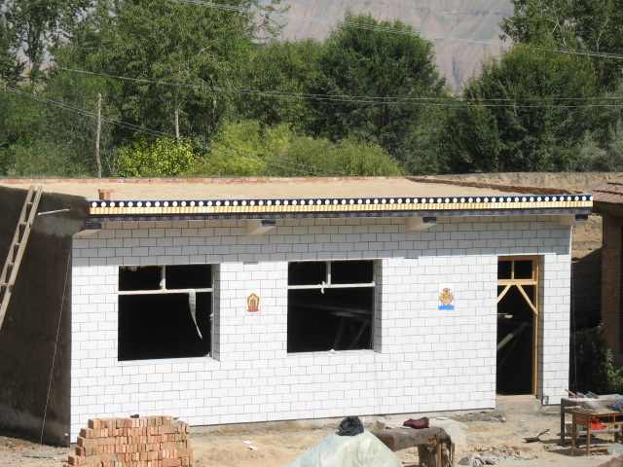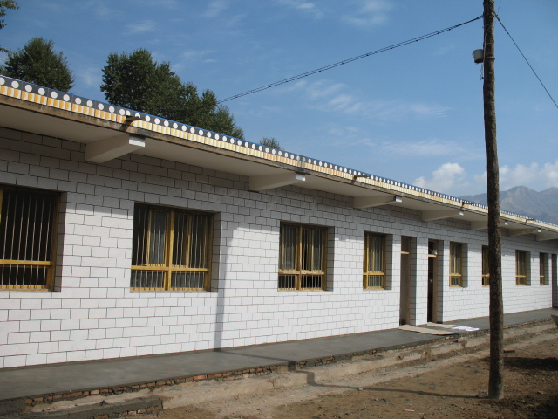

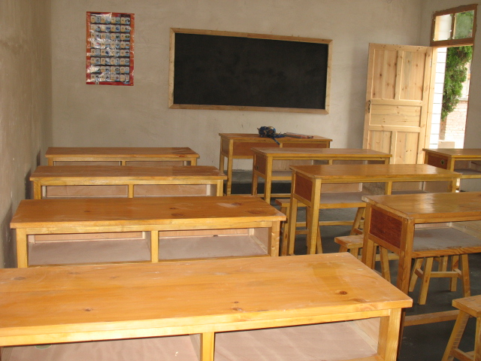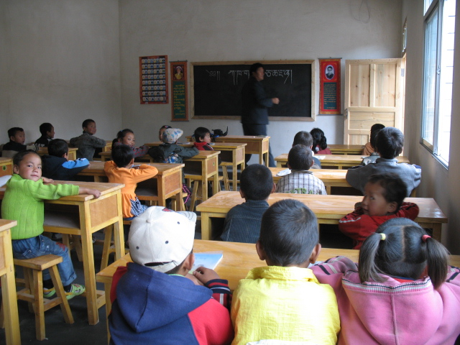

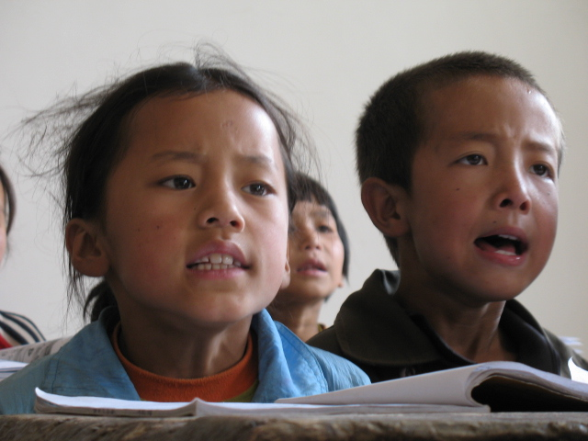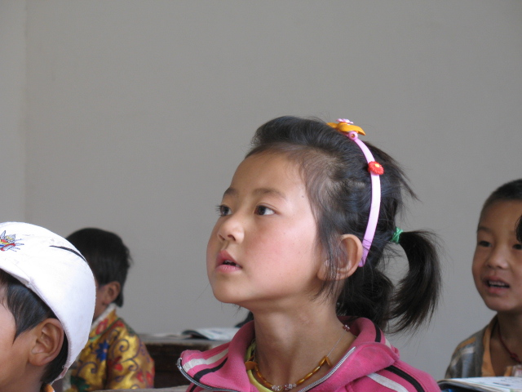

Description from top to down
Picture Number 1 and 2. Completed classrooms of Aujia Primary School.
Picture # 3: Newly bought desk and stools in the new classroom.
Picture #4: Students are having class in the newly built classroom.
Picture #5 and Picture 6: Tibetan students are learning in the new classrooms.

