Geoscience
Peer Academic Coaching
Fall 2020
PAC hours: 7pm-9pm on Sunday, Tuesday, Wednesday, Thursday and 10am-12pm on Monday, all via zoom (https://skidmore.zoom.us/j/95603289245). Come by !  Geoscience PAC is a helpful way to get the most out of your GEO classes at Skidmore. Right now, we work with students in Earth Systems Science (GE101). But if you are in another GE class that we don’t expressly cover, it is likely that one of our coaches has experience that can possible assist you in that class.  Justine Bolling ‘22: GE 101Ben Cro  Ben Crooke ‘21: GE 101  Maria Hoffman ‘22: GE 101  Claire Loos ’21: GE 101  Paul Machabee ’21: GE 101  Ian Maywar ’21: GE 101  Sunday: Justine & Ben  Monday: Ben & Ian  Tuesday: Maria & Justine  Wednesday: Paul & Claire  Thursday: Claire & Maria | 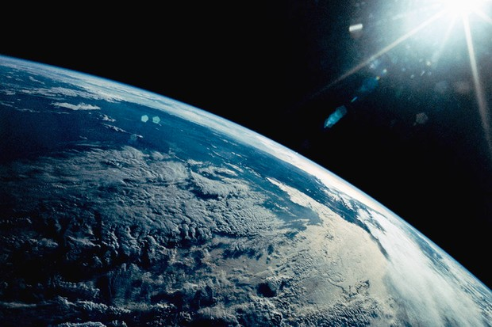
Sunday | Monday | Tuesday | Wednesday | Thursday | Friday | Saturday
30 | 31 | 1 | 2 | 3 | 4 | 5
First day of PAC | How to prep for Lab
6 | 7 | 8 | 9 | 10 | 11 | 12
 | Textbook help
13 | 14 | 15 | 16 | 17 | 18 | 19
 | How to Study for GE 101!
20 | 21 | 22 | 23 | 24 | 25 | 26
27 | 28 | 29 | 30 | 31

If you have any questions or concerns, email SASpeertutoring@skidmore.edu, or our Geo PAC Captain: Ben Crooke (bcrooke@skidmore.edu)

