ON-LINE STEP BY STEP OPEN ENROLLMENT INSTRUCTIONS
To begin reviewing your options and selecting your employee benefits for 2024, please login to Oracle Cloud through Okta at this link: Skidmore College - Sign In (okta.com)
From the “Me” tab, click on the Benefits icon.
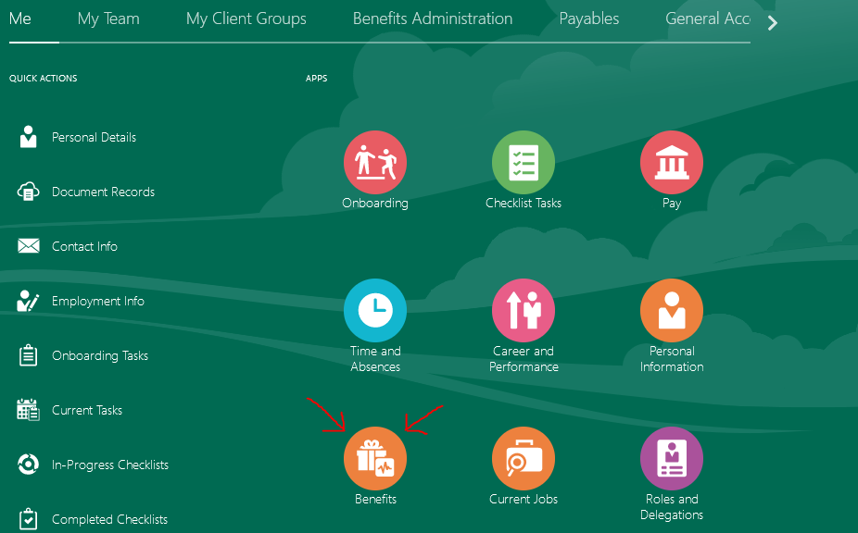

This will take you to your benefits overview page (titled “Benefits” in the upper left corner).

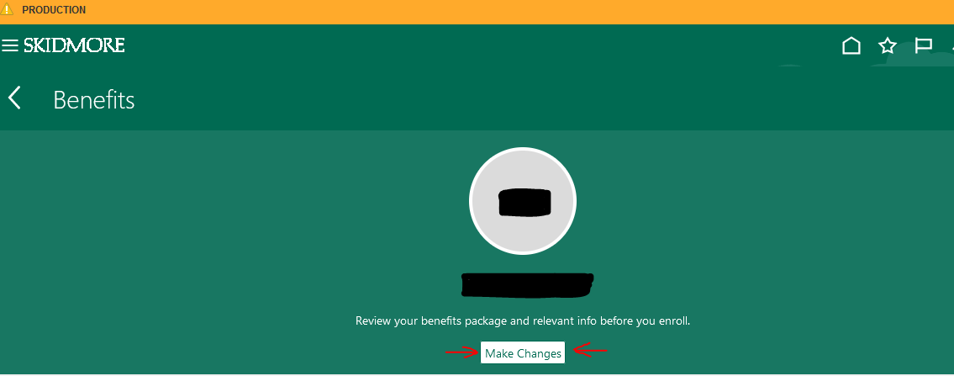

On this page, you will find resources for completing a variety of actions that may be necessary for your benefits enrollment. Instructions for these pages will be found throughout this document. Your current selections and the required tasks of the open enrollment process will determine how you navigate through the program. You may access these pages via the enrollment program’s automated direction or use these tiles to manually access them as you see fit.

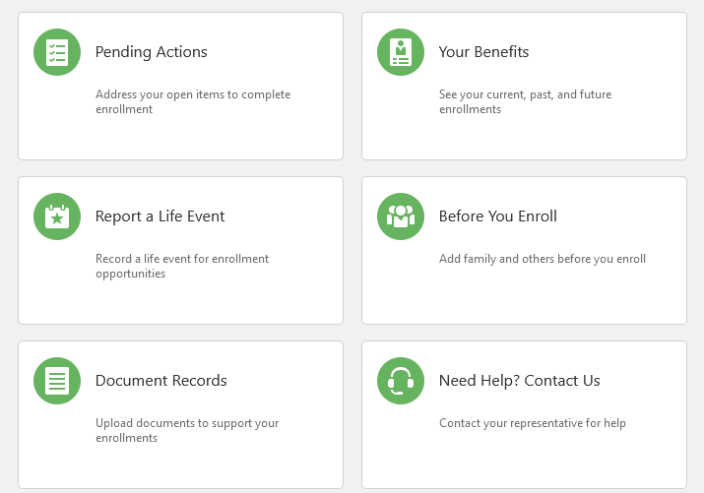
To begin making your selections, click the white “Make Changes” button under your name in the green ribbon at the top of the page.
This brings you to the Before You Enroll page. You will see a list of dependents and beneficiaries. If you have a dependent or beneficiary not on this list, please add them now by clicking the Yellow Add button. If all of your dependents/beneficiaries are currently listed, just hit continue on the top right and skip down to the start enrollment section below.
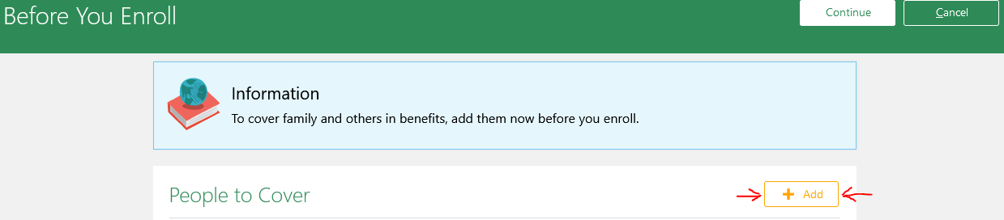
When you finish click the white Continue button and proceed to the Start Enrollment page.
Before You Enroll
You may be directed to the “Before You Enroll” page. This will provide a list of people covered by your benefits and your designated beneficiary organization, if any. Please review both groups.
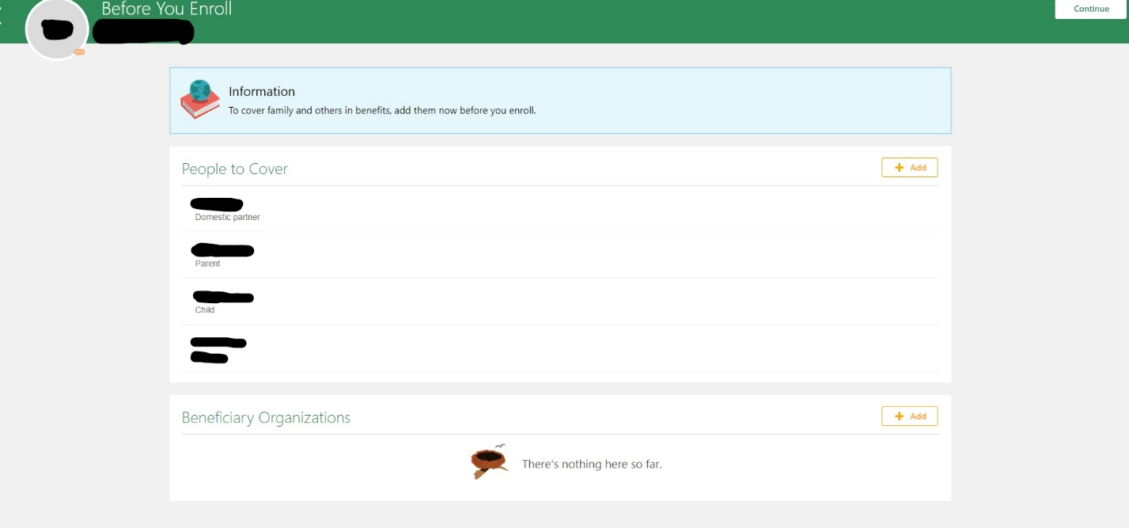
To add a new person to your benefits coverage, click the “Add” button in the upper right corner of the People to Cover panel. This will take you to the “New Contact” screen, where you will be prompted to enter personal details for the person you choose to add. If you do not complete all fields, you will receive an error message and will be unable to add this person. Click “Submit” to enter the person you are adding, or “Cancel” to back out of the action.
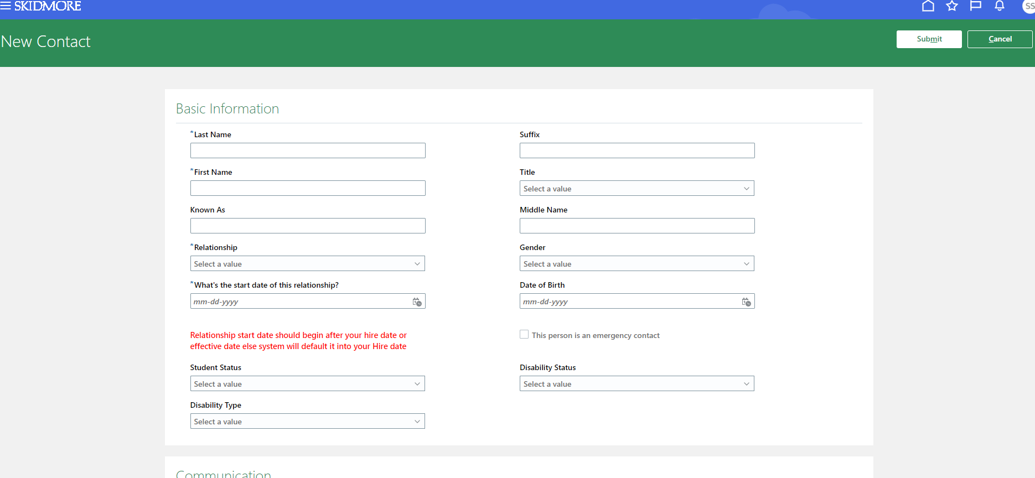

Please review the list of covered people and the personal information for each listing. You may click on the name of the listed person to see the previously entered information. To edit any information, select the “Pencil” icon on the right-hand side of the panel you wish to edit. To remove a person from your coverage, click the white delete button on the right-hand side of the green ribbon at the top of the page. This will return you to the original “Before You Enroll” page.
If you wish to select an organization (as opposed to individuals as your beneficiary) or trust you may select them from the beneficiary organization section. If you don’t see the organization you are looking for, you will need to contact Laura Goodwin, 518-580-5808 or lgoodwin@skidmore.edu in order to have it added. Select your organization from the dropdown list and follow the prompted steps to identify the organization you are selecting. Click Save.
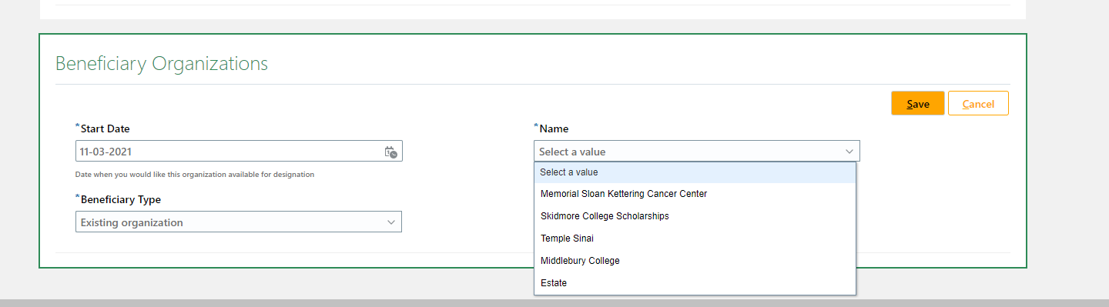
To change or remove an organization, select the “Pencil” icon on the right-hand side of the panel. Select delete to remove the existing beneficiary organization. If you wish to replace the previous entry with a new selection, follow the steps to add a beneficiary organization above.
When you have reviewed and updated both the People to Cover and Beneficiary Organization sections, please click on the white “Continue” button on the green ribbon at the top of the page. This will take you to the “Health and Welfare Benefits Program” page to begin your benefits selections. You may also choose to click on the back arrow to return to the Benefits page.
If you have any questions regarding adding people or beneficiary organizations to your benefits, please contact Laura Goodwin at 518-580-5808 or lgoodwin@skidmore.edu.

Start Enrollment
Click on the “Health and Welfare Benefits Program” to begin your benefits selections.
The 403(b) Retirement Contribution is available to make any changes to your contribution but is not necessary to click for Open Enrollment.
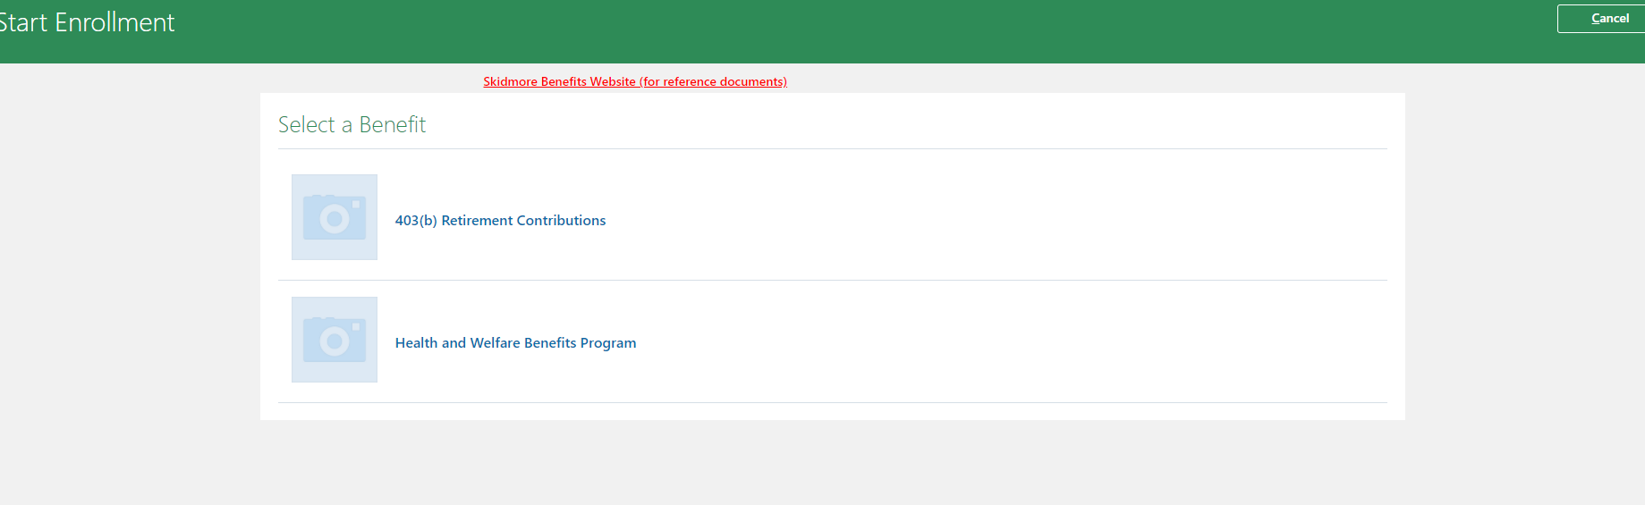

Before beginning your selections, you must sign off on the Authorization information by clicking the Accept button.
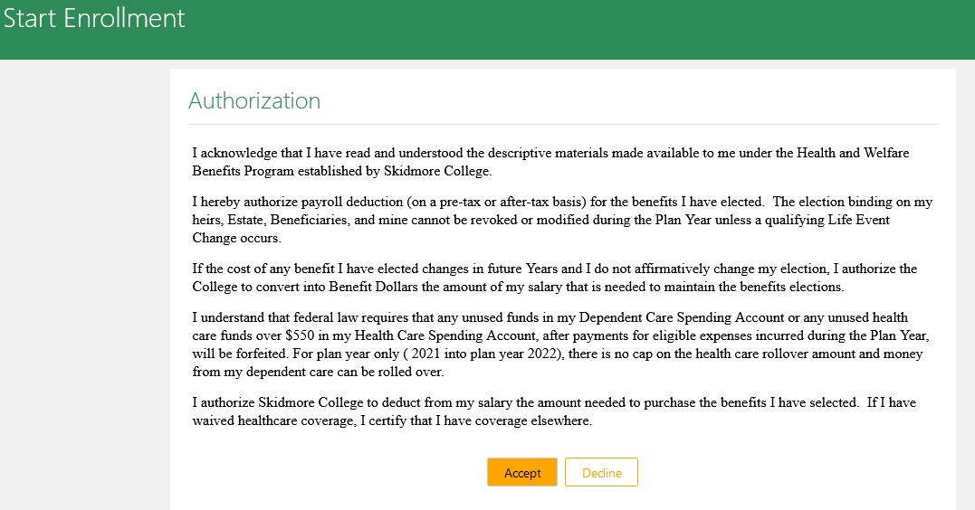
Health and Welfare Benefits
The “Health and Welfare Benefits Program” page will allow you to make your elections for 2024. Please note that this page reflects your enrollment selections for the current year (with the exception of the FSA accounts, that has been set to waived). You may make changes to each panel by clicking on the “Edit” button on the right-hand side of the panel. For each offered benefit, it will show the options available to you. Make selections by clicking in the checkboxes to the left of the options. The cost of each option is listed to the right in each panel. A running total cost will appear in the topmost panel as you proceed through your elections. *As a reminder, if you are in a shared position, your healthcare costs will not be accurate in the system, they will be overridden after open enrollment closes.

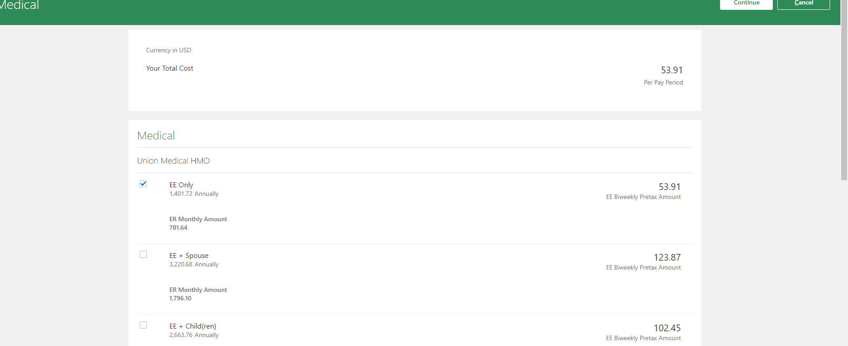

Please note that there may be an option to waive a benefit.

Supplemental and Dependent life insurance – if you are increasing your current amount or signing up for either benefit for the first time, you will need to fill out an evidence of insurability (EOI) form and either upload it in cloud (you will see the request under your pending action items) or send in to HR by November 27, 2023.
When you have completed your election(s) for each particular benefit, please click the white “Continue” button on the green ribbon at the top of the page to proceed to the next benefit. When all benefit selections have been made, click the white “Submit” button on the green ribbon at the top of the page.
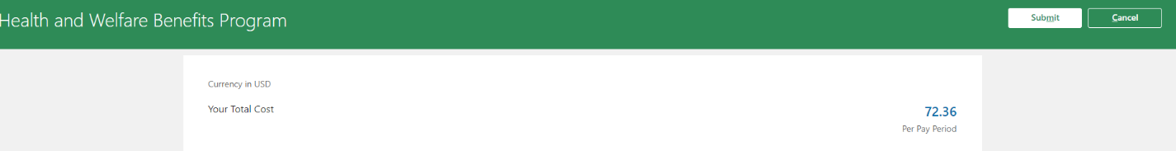

You will be directed to the “Confirmation” page, which will provide an overview of your selections for each offered benefit, as well as costs for each and the per pay period total for all selections.
Please note that you may make changes to your selections until the closing of the open enrollment period.
Please print this page for your records by clicking on the green “Print” button on the green ribbon at the top of the page.
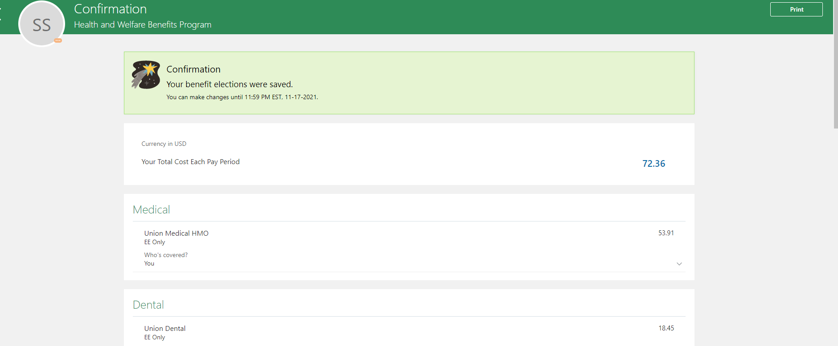

Below is guidance for the other actions you may take from the Benefits page.
Pending Actions
Click on the “Pending Actions” tile to review any open actions, such as qualifying life events requests or uploading required documentation. Pending Actions will need to be completed before new benefit elections can be made for 2024.
If you have no open pending actions, you will receive the following message:

If you have any questions regarding open pending actions, please contact Laura Goodwin at 518-580-5808 or lgoodwin@skidmore.edu or Elizabeth Walsh at 518-580-5803 or elwalsh@skidmore.edu.
Your Benefits
To view your current benefits selections, click on the “Your Benefits” tile and then Health and Welfare Benefits Program link. This will show you your selections for the current year, as well as take you to the “Health and Welfare Benefits Program” page to begin your benefits selections.
Report a Life Event
Use this tile to request a life change event. This option will not be available during the Open Enrollment period. All life change information for next year can be added as part of the open enrollment benefit selection process. For changes impacting current year benefits, please request dates that do not correspond to Open Enrollment. If you have any questions regarding current year benefits, please contact Laura Goodwin at 518-580-5808 or lgoodwin@skidmore.edu or Elizabeth Walsh at 518-580-5803 or elwalsh@skidmore.edu.

Document Records
This tile allows you to upload documentation supporting your benefits enrollments or beneficiary designations. Click the “Add” button in the upper right corner of the Document Records panel and select a Document Type from the dropdown menu. After selecting a type, complete the remainder of the form, attach the documentation, and click the white “Submit” button in the green ribbon at the top of the page.


