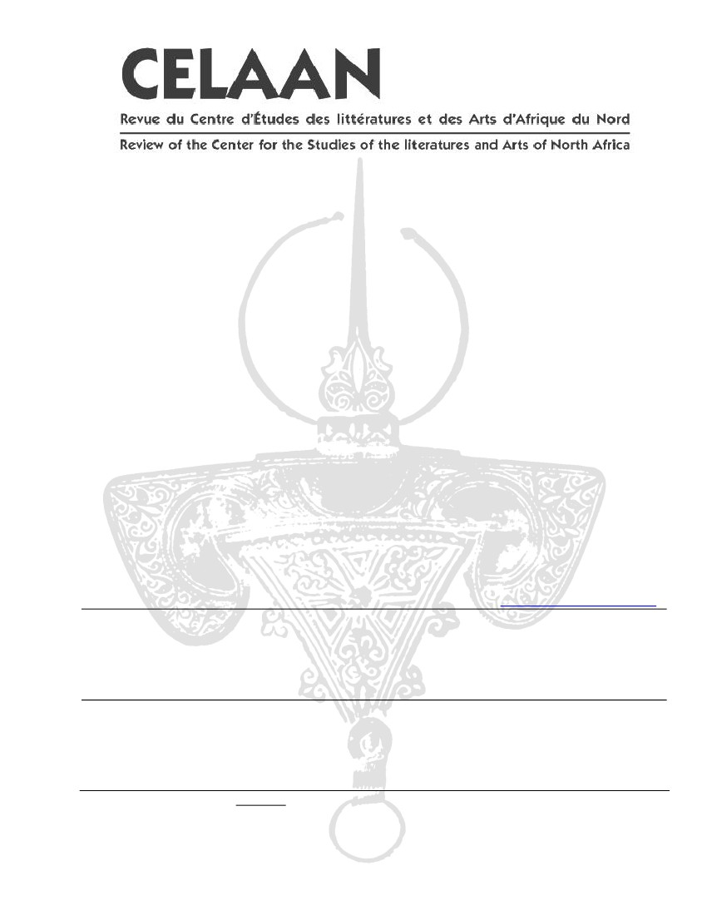
CELFAN BACK ISSUES AND MONOGRAPHS ORDER FORM
NAME:
_______________________________________
(FIRST)
(LAST)
INSTITUTION:
ADDRESS:
_______________________________________
_______________________________________
_______________________________________
_______________________________________
______________
_______________________________________
_______________________________________
___________________
CITY / STATE:
ZIP/POSTAL CODE:
COUNTRY:
EMAIL:
I HAVE ENCLOSED A CHECK OR MONEY ORDER FOR:
Rates are for North America only; please contact the Editor for international
ordering information via the below U.S. address or by email at hjaouad@skidmore.edu.
REVUE CELFAN REVIEW – THE COMPLETE 8 VOLUME SET (21 ISSUES):
□INDIVIDUAL ($100.00 + $10.00 SHIPPING AND HANDLING)
□INSTITUTION ($200.00 + $20.00 SHIPPING AND HANDLING)
CELFAN EDITION MONOGRAPHS – THE COMPLETE SET OF 10:
□INDIVIDUAL ($50.00 + $5.00 SHIPPING AND HANDLING)
□INSTITUTION ($100.00 + $10.00 SHIPPING AND HANDLING)
SEND TO: CELFAN BACK ISSUES/MONOGRAPHS
SKIDMORE COLLEGE
DEPT. OF FOREIGN LANGUAGES AND LITERATURES
SARATOGA SPRINGS, NY 12866 USA

