Impacts of Urbanization and Thermal Loading within the Kayaderosseras Creek Watershed:
Implications for Trout Survival and Fish Stocking

Skidmore College
ES Capstone Spring 2015
Jessica Dunning, Zachary Gordon, and Alice Wu

Abstract

Kayaderosseras Creek is a fishable trout stream that is often used for recreational purposes by both the local community and visitors. Each year, around 7,000 brook, brown, and rainbow trout are stocked into the creek and its tributaries. Trout are cold water fish that are very sensitive to temperature changes. Increased urbanization has lead to thermal loading of runoff and increased stream temperatures in many river systems. To determine whether urbanization in the Kayaderosseras Creek watershed is causing increases in stream temperature, a thermal urban runoff model (TURM) was run on 15 residential sites throughout the watershed and used the SCS runoff curve number method and a mixing model to determine final stream temperatures. A storm event that occurred at Bear Brook in Clifton Park, NY, in 2009 was modeled to test the accuracy of TURM. This validated the model for predicting runoff and stream temperatures in Saratoga County and the results indicate that the percent of impervious cover at the sites had a large impact on both runoff and stream temperatures, and that the baseflow of the streams and hydrologic soil group of the sites also impacted stream temperature increases. This study shows that while baseflow and soil type need to be accounted for, impervious cover in the watershed is leading to increased temperatures in the Kayaderosseras Creek. Low impact development and other techniques for reducing runoff in urban and residential areas should be utilized in the Kayaderosseras Creek watershed if it is to remain a trout habitat.

Introduction

The Kayaderosseras Creek covers 189 mi² in Saratoga County, NY. Brook trout are the main native species in the Kayaderosseras, while around 7,000 brown and rainbow trout are stocked every spring (DEC, 2014). The Department of Environmental Conservation classifies the Kayaderosseras as a fishable trout stream. That said, it is primarily known for being more trout habitat in terms of livability, but not qualified for spawning. The local communities currently use it as a valued recreational asset, continuing to generate widespread involvement from residents of all generations in terms of helping with fish stocking practices.

Impacts of thermal loading on stream temperature
Cold water streams such as the Kayaderosseras are vulnerable to thermal loading from paved surfaces. Thermal loading occurs when high levels of warm runoff are introduced to streams (Herb, 2008). This causes physical changes, such as temperature “hot spots,” to the river that have large effects on the overall ecosystem. Many models have been developed in order to predict how new developments will affect the streams due to the corresponding, potential negative effects on cold and cool water fish habitat. With climate data used as inputs many studies have been successful in modeling runoff temperature for single storm events in small areas (Herb, 2008; Janke, 2008). It has been shown that the heat export is more affected by rainfall intensity, duration, and pavement temperature than the physical properties of the pavement (Janke, 2008).
That said some streams can shield the effects of warm runoff better than others. There are many significant models for calculating runoff temperature, but converting this to show the overall effects on stream temperature is a more complicated process. Stream temperature, discharge, and morphology all have effects on this calculation. The runoff curve number method is a proven method to measure the volume of runoff from storm events. The Soil Conservation Service (SCS) developed the model in 1954 to design flood control plans (Tedela et.al. 2012). It takes into account soil type, land cover, and rainfall depth to produce a volume in inches. The uses of this method have expanded to a variety of hydrological issues since its development. We use it in this model to see how runoff temperature affects stream temperature at different locations.

Effects of changing temperature on trout survival and stream classification
The temperature of the surrounding water influences many of the biological processes of trout. Brown and brook trout have similar tolerance ranges between 35 °F and 70 °F, with optimal temperatures at 55 °F (Environmental Agency, 2008; Elliot, 1976; Xu et al., 2010). Rainbow trout, however, have a tolerance range between 45 °F and 75 °F with an optimal temperature at 55 °F (Matthews and Berg, 1997). Trout living in temperatures as low as 32-39 °F or as high as 66-86 °F will display increasing lethargy until they are essentially immobile with the exception of their eyes, pectoral fins, and gill covers (Environmental Agency, 2008). The temperature of the water also affects their reproductive success and the mortality rate of their eggs. More than 95% of the embryos would survive in temperatures between 34 °F - 46 °F, but only 50% would survive at 54 °F and none would survive at 59 °F or higher (Armstrong et al., 2003). Similarly, the hatch time of these eggs are also affected by the temperature; eggs incubated at 41 °F take 100 days to hatch while eggs incubated at 50 °F take 50 days to hatch. These differences in hatching times can greatly influence the survival of the fry, as the eggs are laid in the fall so that they will hatch during the spring when there will be more food available to eat (Environmental Agency, 2008). Due to these requirements, brown trout are more adapted to survive in cooler waters than warmer ones.
Additionally, warm waters can influence the metabolism of the trout in a manner that would cause them to pick up behaviors that are not ecologically sustainable. When trout are exposed to warmer temperatures, they experience faster metabolisms which can cause them to grow bigger, defecate at a faster rate, and require a greater amount of food and oxygen to sustain their larger bodies (Brown, 1946; Elliott, 1973; Elliott, 1976; Armstrong et al., 2003). This increased consumption can become problematic in warmer waters, as aquatic macroinvertebrates that make up a fair portion of the trout’s diet are less likely to survive in higher temperatures, and dissolved oxygen concentrations are lower due to the gas’ ability to escape the liquid when temperatures are increasing (Jensen, 1990; Breder, 1927). It is possible that the trout populations within the Kayaderosseras Creek watershed will soon be experiencing these challenges, as more areas in the watershed are being converted to developed areas with impervious surfaces that contribute warmer runoff into the streams.
Since the classification of a stream is dependent upon factors such as pH, temperature, color, hardness and other toxicity pollutant levels. (Zambrano, 1998) The Department of Environmental Conservation carries out the procedures for such site specific standards. These state-wide standards are also influenced by the Environmental Protection Agency standards for all water quality, outlined in the Water Quality Standards Handbook. The standards are primarily put in place to maintain the characteristics of the water body in which sustain the current biological populations and overall aquatic life. The classifications of these water bodies are based on the human interaction level such as recreational or industrial use, which remain contingent upon the quality of the water in all categories. For a class C trout stream, such as the Kayaderosseras, the standards for such a sight include not only the toxicity, suspended substances and radioactivity but also accounts for the thermal discharges. For trout waters no discharge may exceed 70 degrees Fahrenheit at any time. (DEC, 1999) In regards to the summer months, when waters may approach higher temperatures and have the largest fish population, it states that no discharge is allowed to raise or decrease the stream temperature more than two degrees Fahrenheit. (DEC, 1999)

Using the Kayaderosseras Creek watershed as a test site
With the increasing conversion of undeveloped or forested areas to residential development, there is an emerging risk that stream temperatures within this watershed may rise to these discouraged levels that are dangerous to trout and would disqualify the Kayaderosseras Creek and its tributaries as trout streams. Should this occur, trout would no longer be stocked within the stream through the DEC programs. In addition, any remaining trout populations would likely disappear over time due to the unsuitable habitat. Such an event could be highly detrimental to the economy of Saratoga County, as trout fishing attracts many tourists to the region, and losing this source of revenue could be detrimental to the watershed town economies. Additionally, there is the potential cost to restore the ecological status of the river before they could recommence trout stocking. However, the main issue is not economic but social in terms of losing this quintessential community stream. The surrounding towns and city, utilize the stream as a source of community involvement and is highly valued by its residents. The loss of the recreational use of the stream thus poses an even stronger threat to the community on a social level. So to determine the extent to which the Kayaderosseras Creek is at risk of exceeding natural temperature levels and losing trout habitat, we are studying the impacts that urbanization is having on stream temperature changes.

Methods
Selecting test sites
To determine which sites we would focus our study on, we obtained Saratoga County parcel data from 2011 and organized the parcels by their property classes and the years in which they were built. We focused on residential parcels that were built between 2000 and 2011, as this was the only time frame in which we could obtain data for changes in impervious surfaces, which were obtained from the National Land Cover Database. Once these data were categorized, we overlapped this file with shapefiles displaying subwatersheds within the Kayaderosseras Creek watershed along with the outline of the creek itself on ArcMap. Using these files, we determined which parcels were located within each basin and the proximity of these parcels to the river. We selected sites that contained either clusters of single-residential homes or apartment complexes that covered more than 10 acres of land and possessed borders no farther than 2,500 ft from the stream. Using these criteria, we chose 15 sites in total, 8 located within the lower Kayaderosseras subwatershed, 3 located within the middle Kayaderosseras subwatershed, 3 located within the Bog Meadow Brook subwatershed, and 1 located within the Geyser Brook subwatershed. Once the sites were selected, we determined the total acreage of each site using the measuring tool in ArcMap and calculated the percent of impervious areas within each location by counting the number of impervious pixels from the NLCD files that overlapped with the parcel files.

Determining rate of development within the watershed
To determine how much development had occurred within the Kayaderosseras Creek watershed, we focused on the number of residential parcels and impervious surfaces that were added to the region for the past 50 years. To do so, we categorized residential parcels by the decade in which they were built, beginning at 1960 and ending in 2011, and calculated the amount of impervious cover within these parcels. We then plotted the number of impervious area added each decade for the past 50 years to determine the average rate in which areas of the watershed were being converted to impervious cover.

Modeling effects of post-development on runoff temperature
To determine the effects of urbanization in the Kayaderosseras Creek watershed on stream temperatures, we used a Thermal Urban Runoff Model (TURM), developed by the Dane County Land Conservation Department and the University of Wisconsin-Madison (Roa-Espinosa et al. 2003; Thomson et al. 2008). The model is used to estimate temperature changes in streams due to impervious cover changes. The parameters of the model are dependent on storm conditions and require assumed inputs such as rainfall depth, duration of the storm, hour of the day the storm began, wind speed, humidity, and initial temperatures of the rain, impervious surfaces, and atmosphere in the area. To obtain conditions that mimicked a storm in Saratoga Springs County, we accessed climate archives on Weather Underground to find average summer storm conditions within the past decade. We used an interactive web tool designed by Cornell University to analyze extreme precipitation conditions in New York and New England to determine average rainfall depth and duration.
TURM also required site-specific conditions such as the percent of connected impervious areas, the total area of the site in acres, and the time of concentration within each site (T_{c}) to determine runoff temperatures. T_{c} is the time it takes for runoff from the most distant point in the watershed to reach the drainage point (Thomson et al. 2008). There are three different flow types associated with time of concentration: sheet flow, shallow concentrated flow, and open channel flow. Sheet flow is the flow of water over a plane surface located near the headwaters of a stream, shallow concentrated flow is the path following the sheet flow that stops at the edge of the stream, and the open channel flow is the path following the stream and ends when the channel is drained into a body of water or is merged with another stream. The T_{c} for each site is calculated by combining the travel time (T_{t}) of each flow section, which is calculated using the following equations obtained from the Hydrology National Engineering Handbook:
Sheet Flow:
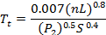 (1)
T_{t} = travel time (h)
n = Manning’s roughness coefficient
L = length of section (ft)
P₂ = 2-year, 24-hour rainfall (in)
S = slope

Shallow Concentrated Flow:
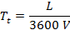 (2)

Paved surface: V = 20.3282 ∙ S ^{0.5} Unpaved surface: V = 16.1345 ∙ S ^{0.5}

T_{t} = travel time (h)
L = length of section (ft)
V = average velocity (ft/s)

Open Channel Flow:
(3)

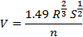 (4)

T_{t} = travel time (h)
L = length of section (ft)
V = average velocity (ft/s)
R = hydraulic radius (ft) = 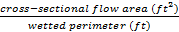
S = slope
n = Manning’s roughness coefficient

Using TURM, we calculated the travel time of the sheet flow by inputting the length, slope and surface code, or land cover type, of each of our sites into the system. The model uses the surface code to calculate the value for n and the value for P₂ is input elsewhere and used as a constant for all sites. Sheet length is generally estimated to be 25 ft in the northeast, so we used this value as the length for all sites. To calculate the travel time of the sheet flow, we only needed to input the length, slope, and surface code (paved or unpaved) into the system, which translates the values of the slope and surface code to a velocity to input into the equation. The travel time of the open channel flow was calculated by inputting the length, slope, n value, cross-sectional flow area, and wetted perimeter of the streams into the model, which transformed the last three variables into the velocity to input into the equation. The length and slopes of each section were determined using the path tool and elevation profiles available on Google Earth, and the surface codes, roughness coefficient, cross-sectional flow area, and wetted perimeter were all determined using estimates made on site and using satellite images of the channels on Google Earth.
Once the storm conditions and site properties were entered into the model, TURM calculated the temperature of the runoff entering the stream post-development and provided a base temperature (66.2 °F) for runoff under pre-development conditions for comparison. We then used the post-development runoff values to determine the changes in stream temperatures after a storm event.

Determining Changes in Stream Temperatures
To determine how runoff from each of these sites impact stream temperatures after storm events, we used a runoff curve number (RCN) method to estimate runoff volumes from each location. Curve numbers were calculated using the land use type, impervious cover percentage, and hydraulic soil class, and these values were then used in a series of equations to determine runoff volume (USDA, 1968):

S = 1000CN-10 (5)

Ia = 0.2S (6)

Q = (P-Ia)2(P-Ia) + S (7)

Q = runoff (in)
P = rainfall (in)
S = potential maximum retention after rainfall begins
Ia = initial abstractions

Once runoff in inches was determined, it was converted to feet and then ft³ by multiplying it by the square foot area of the parcel. This was converted to a runoff rate using the duration of the storm as the time, which was constant at 3 hours for all tests. Initial stream temperature was assumed to be constant for all the streams at 60 °F and baseflow was calculated as a function of basin area. This was then input into the following mixing equation to determine final stream temperature:
T_{f} = (T₀F_{b}) + (T_{r}F_{r})F_{b} + F_{r} (8)

T_{f} = final temperature
T₀ = initial temperature
T_{r} = runoff temperature
F_{b} = baseflow
F_{r} = runoff rate

Statistical Analysis
Statistical analyses were done using JMP software. Best fit regressions were calculated for impervious cover and baseflow compared to stream temperature changes. A t-test was run to determine statistical significance of hydrologic soil class on stream temperature changes. F statistic, p-value, and degrees of freedom are reported for all statistical tests.

Results

Model Validation
A site was used to test how accurate TURM is when applied to conditions within Saratoga County, as it was originally developed for use within Dane County, Wisconsin. We ran the model for a storm event that occurred in August 2009 at Bear Brook in Clifton Park, NY, and compared our findings to recorded stream temperature during that event (Trout Unlimited, 2009). The site that we focused on was a shopping complex located at the headwaters of the stream, which had an area of approximately 22 acres and had 100% impervious cover. Stream temperatures during this event were monitored using three temperature loggers that recorded temperatures at 1-hour intervals and were placed 0.01 miles, 0.57 miles, and 0.74 miles downstream from Maxwell Road, where the runoff from the shopping complex drains to. Using the characteristics of the site and conditions of the storm, which were obtained from Weather Underground, we ran the TURM model to determine the temperature of the runoff from the site and final stream temperature. This was then compared to the measured temperature of the stream during the storm event to see the accuracy of the model. The initial temperature of the stream was 68 °F. The test of TURM gave a final stream temperature of 79.7 °F, with a temperature change of 11.7 °F. The temperature recorded at the stream during the storm was 80 °F giving a 12 °F change. This supports that the TURM remained accurate when being used outside Dane County, WI and in Saratoga County, NY. Using these results we were able to apply TURM to the Kayaderosseras creek.

Site Details
The sites were located in four of the six main sub watersheds of the Kayaderosseras Creek (Fig. 1). The watersheds studied ranged from 23.4 mi² to 49.4 mi². Bog Meadow Brook is the smallest watershed but has the largest amount of impervious cover with the Middle Kayaderosseras having the least (Fig. 2). The sites ranged in area from 10.32 acres to 115.15 acres (Table 1), while the impervious cover ranged from 3.08 to 29.91 percent.

Changes in Impervious Cover and Residential Development
Over the past 50 years, a total of 829.79 acres was converted to impervious cover in the watershed due to residential development. In 1960, only 437.94 acres were impervious residential areas, but by 2011, there were 1267.74 acres of impervious residential cover. On average, 165.9 acres were converted to impervious residential area each decade, and by 2011 these areas comprised 1.05 % of the total watershed area (Table 1). However, the total amount of impervious area in the Kayaderosseras Creek watershed by 2011 was 4309.84 acres, which is equivalent to 3.58 % of the total watershed (Fig. 2).

Changes in Runoff Temperature
There was a large range in the total area and percent of impervious cover in the different sites, as the total area ranged from 10.32 acres to 115.15 acres, and the percent of impervious cover ranged from 3.08 % to 29.91 % (Table 2). Changes in runoff temperature post-development varied greatly from each site, ranging from 0 °F to 13.0 °F (Table 2), while changes in stream temperature varied from 0.002 °F to 2.60 °F (Table 3). The main factor that affected runoff temperature post-development was impervious cover on the site, as there was a strong positive correlation between these two variables (linear regression: r²=0.98, F=821.98, df =14, p<0.001; Fig. 3).
Multiple factors had large effects on the changes of stream temperature, such as the percent of impervious cover at the sites, the baseflow of the stream, and the hydrologic soil group of the parcel. Increases in the percent impervious cover in the site was generally connected with increases in temperature change of the stream, and impervious cover explains 44 % of the variation in the temperature changes (linear regression: r²=0.44, F=10.08, df=14, p=0.007; Fig. 4). The baseflow of the stream that the runoff flows into was another important factor determining how much the stream temperature increased. Changes in stream temperature decreased exponentially as baseflow of the stream increased, and baseflow alone explained 37 % of the variability in temperature change (logarithmic regression: r²=0.37, F=7.71, df=14, p=0.016; Fig. 5). The hydrologic soil group also had a large influence on changes in stream temperature. The majority of the sites we studied were either in soil class A or C, and sites in soil class A had a much lower temperature change than sites in soil class C (t-test: F=8.52, df=13, p=0.013; Fig. 6).

Discussion

TURM has been applied to recently developed residential areas in Saratoga County, NY to see the effects on thermal loading on the Kayaderosseras Creek watershed. Runoff temperatures varied greatly between different sites along the creek. The variables that affected the variation the most were soil type, percent connected impervious cover, and stream baseflow. This study gives a good baseline for how residential housing affects stream temperature, and suggests how to minimize the effects of development on stream temperature.

Past Temperature Data
Looking at past data gathered by Bob Thomas and compiled by Kelly McDonnell, we also noticed a trend of increasing stream temperatures in parts of the Kayaderosseras, specifically the middle sub watershed. The temperatures for through the years 2008-2010, when cross referenced with trout stress level temperatures, indicated that they were approaching if not exceeding these levels specifically in the summer months. This issue with this spike in temperature, especially during the time in which the largest populations of trout inhabit the creek, is that there are hot spots already forming thus resulting in losses of trout habitat. Trout cannot function well in these areas and if the temperatures were to persist and increase throughout the Kayaderosseras in future years, the trout could have little to no habitat at all.

Impervious Cover
The trend in our data showed that the amount of impervious cover at a site had a correlation with the amount of temperature change in the stream. This is what was expected but the trend was not as strong as what was expected. This could be due to the fact that all of the sites in this study were residential. This means that the sites had generally low percent impervious cover. The green area in the sites also have a large influence on the runoff temperature from that site. This means other factors that involve the pervious cover have high impacts. Soil type, slope, and infiltration are the main factors affecting runoff from pervious areas (Thompson, 2008). These factors play a larger role in areas with medium to low impervious cover. In our validation site at Bear Brook in Clifton Park, NY the site is 22 acres of 100% impervious cover (Clearwater Trout Unlimited, 2009). This means that the other factors such as soil type play a much smaller role and the temperature increase of the stream is much higher.
While the impacts of each site on their own were small together the impact could be much larger. The model used in this study was not designed to be used at watershed level, but other studies have looked at the effects of impervious cover at watershed scales. Some conclude that large scale effects of runoff begin at 20 % impervious cover within a watershed (Brun, 2000). Others believe that 10 % impervious cover is grounds for an impaired watershed (Steinman, 2006). The Kayaderosseras Creek is well below this at about 3 % impervious cover, but based on the past and present data thermal runoff effects are already impairing the water for the native trout.

Baseflow
Baseflow of the stream plays an important role in shielding against large inputs of warm runoff. Sites in our study ranged anywhere from under 10 cfs to upwards of 130 cfs and there was an exponential negative trend with temperature change and baseflow. Excluding one site any site with over 40 cfs had less than 0.5 temperature change no matter how high the runoff temperature was. Sites 7 and 9 show this comparison well. The difference in runoff temperature between the two is 3.2 F. Site 7, which is located in the lower Kayaderosseras subwatershed, has a base flow of 132.7 cfs and the temperature change of the stream is 0.002 F. Site 9 has a significantly higher temperature change at 1.47 F because of the lower baseflow, which is 22.9 cfs. This trend is shown on a site by site examination, but when modeling the overall watershed the trend might be different. Other studies have shown that larger catchment size leads to larger runoff amounts and higher peak flows (Brown, 1999). While this study shows site specific influences, broader overall trends in the watershed would likely be different. This said, headwaters and smaller tributaries are more vulnerable to large runoff inputs due to their lower base flows.

Soil Type
Soil types are divided into four groups (A-D) based on standards from the USDA. Soils in group A have the lowest runoff potential, while soils in group D have the highest potential (Werner et. al., 2009). Most of the soils in the Kayaderosseras Creek watershed are in hydrologic soil classes A and C, with some in B. Sites in areas with soil in class A had much less overall runoff than in sites with soil class C. This led to lower impact on stream temperatures. Developers can use this information to require different amounts of green space on parcels with different soil types. Parcels located in areas with soil classes B and C would need larger green spaces than parcels in soil class A. It would be straightforward to implement policy to require green space. Disconnecting impervious cover with soil that absorbs water well is a very effective way lower the impacts of runoff (Hager, 2003). This is one inexpensive way to lower runoff volumes from residential parcels.

Future suggestions
The Kayaderosseras Creek currently has summer temperatures over the stress levels of Brown and Brook Trout, and is nearing the stress levels of Rainbow Trout. This means that Saratoga County needs to start addressing the problem. Residential areas account for a large portion of Saratoga County. On average 16.6 acres of impervious cover is added per year as a result of residential development alone. Based on the data we collected it is easy to say that residential parcels do not have a large impact on stream temperature, but combined the impact can be great. Low impact development (LID) is a new way urban areas have been dealing with runoff problems (Hager, 2003). Some LID techniques are rain barrels and rain gardens. Rain barrels are relatively cheap and along with preventing runoff from impervious cover, they provide a source of water for nonpotable uses. This technique involves placing usually two barrels below the gutters of a house to collect the water falling from the roof. They collect the first flush of rain from roofs that can add a great deal to the thermal load (Hager, 2003). Rain barrels are inexpensive and range in price will some of the most sophisticated systems only cost $2000 - $3000 per house. Another LID technique is rain gardens. There are a variety of different types of rain gardens, but the general concept is that storm water runoff is channeled into a garden where the plants absorb and use the water to grow. The overflow can either be redirected to other rain gardens or added to the conventional stormwater drainage system. Rain gardens have been especially effective in lowering peak flows and nutrient inputs to streams (Dietz, 2005). While rain gardens can be more expensive than rain barrels they have been used across the country and are successful in many cases.
Many could argue that it is upon the DEC to take responsibility for the regulation of the non-point source discharge and increasing temperature changes within the creek. However, it should be noted that the majority of initiative could be placed in the hands of the city, towns and in general the communities of the watershed. There are currently new regulations being put in place for the City of Saratoga outlining the necessity for larger buffer zones and the use of more permeable soils on new development projects. (K. Maynard, personal communication, 2014) There is also call for the attention to the headwaters based on our analysis of the watershed, due to the vulnerability of such areas and susceptibility to impervious cover impacts. In order to ameliorate such impacts, buffer areas could be expanded near headwaters as well as the increase of green areas in order to strengthen the areas susceptibility. That said, based on our analysis of the TURM model through validation fuse on the Bear Brook site, it can be assumed that the model itself poses the most valuable asset to the current and new development projects within the watershed. As a valuable resource of analysis of effects of new development, it would be well advised for the watershed local governments and even communities to utilize this tool in future endeavors in order to decrease the threat of higher temperatures within the Kayaderosseras Creek and inevitably the loss of trout habitat.

Acknowledgements
We would like to thank the Skidmore College Environmental Studies Department, specifically Catherine Gibson Ph.D., Andrew J. Schneller Ph.D., and Robert Turner Ph.D. We would also like to thank Blue R. Neils chair of Saratoga County Water Quality Coordinating Committee for providing past data and insight and Joshua Ness for providing temperature loggers. As well as Alex Chaucer for guidance in GIS and Kate Maynard for providing insight on development practices in Saratoga County.

References

Armstrong JD, Kemp PS, Kennedy GJA, Ladle M, Milner NJ. 2003. Habitat requirements of Atlantic salmon and brown trout in rivers and streams. Fisheries Research 62(2): 143-170.

Breder Jr. CM. 1927. On the Temperature-Oxygen Toleration of Brook Trout. Copeia
163: 36-39.

Brown, V. A., McDonnell, J. J., Burns, D. A., & Kendall, C. (1999). The role of event water, a rapid shallow flow component, and catchment size in summer stormflow. Journal of Hydrology, 217(3), 171-190.

Clearwater Trout Unlimited. 2009. “Clearwater chapter of trout unlimited: temperature monitoring Dwaas Kill/Bear Brook.” Last updated 2009. Accessed May 3, 2015.

Department of Environmental Conservation. “Fish Stocking.” Last updated 2014. Accessed November 19, 2014. http://www.dec.ny.gov/outdoor/7739.html

Department of Environmental Conservation. “Part 703: Surface Water and Groundwater Quality Standards and Groundwater Effluent Limitations.” Last updated 1999. Accessed May 3, 2015. http://www.dec.ny.gov/regs/4590.html

Dietz, M. E., & Clausen, J. C. (2005). A field evaluation of rain garden flow and pollutant treatment. Water, Air, and Soil Pollution, 167(1-4), 123-138.

Elliott JM. 1973. The food of brown and rainbow trout (Salmo trutta and S. gairdneri) in relation to the abundance of drifting invertebrates in a mountain stream. Oecologia 12(4): 329-347.

Elliott JM. 1976. The energetics of feeding, metabolism and growth of brown trout (Salmo trutta L.) in relation to body weight, water temperature and ration size. Journal of Animal Ecology 45(3): 923-948.

Hager, M. C. (2003). Lot-level approaches to stormwater management are gaining ground. Stormwater. January/February.

Herb, W. R., Janke, B., Mohseni, O., & Stefan, H. G. (2008). Thermal pollution of streams by runoff from paved surfaces. Hydrological Processes, 22(7), 987-999.

Janke, B. D., Herb, W. R., Mohseni, O., & Stefan, H. G. (2009). Simulation of heat export by rainfall–runoff from a paved surface. Journal of Hydrology,365(3), 195-212.

Jensen A J. 1990. Growth of Young Migratory Brown Trout Salmo trutta Correlated with Water Temperature in Norwegian Rivers. Journal of Animal Ecology 59(2): 603-614.

Matthew, K.R., Berg, N. H. (1997). Rainbow trout responses to water temperature and dissolved oxygen stress in two southern California stream pools. Journal of Fish Biology 50: 50-67.

Northeast Regional Climate Center. (2010). Extreme precipitation in New York and New England: An interactive web tool for extreme precipitation analysis. Online at http://precip.eas.cornell.edu/.

Roa-Espinosa, A., Wilson, T. B., Norman, J. M., & Johnson, K. 2003. Predicting the impact of urban development on stream temperature using a thermal urban runoff model (TURM). In National Conference on Urban Stormwater: Enhancing Programs at the Local Level. February (pp. 17-20).

Steinman, Alan, et al (2006). "An environmental assessment of an impacted, urbanized watershed: the Mona Lake Watershed, Michigan." Archiv für Hydrobiologie 166.1: 117-144.

Thompson, A. M., Wilson, T., Norman, J. M., Gemechu, A. L., & Roa‐Espinosa, A. (2008). Modeling the effect of summertime heating on urban runoff temperature.

U.S. Geological Survey. (2012). The StreamStats program for New York. Online at
http://water.usgs.gov/osw/streamstats/new_york.html.

United States Department of Agriculture. 1986. Urban hydrology for small watersheds: TR-55. Online at http://www.nrcs.usda.gov/Internet/FSE_DOCUMENTS/stelprdb1044171.pdf

Werner, Jon, Woodward Donald E., Nielsen, Robert, Dobos, Robert, Hjelmfelt, Allen, Hoeft Claudia C. (2009) U.S. Department of Agriculture NRCS. Part 630 Hydrology National Engineering Handbook, Chapter 7 “Hydrologic Soil Groups”.

United States Environmental Protection Agency. 1994. Water Quality Standards Handbook - Chapter 3: Water Quality Criteria (40 CFR 131.11). Online at http://water.epa.gov/scitech/swguidance/standards/handbook/

Xu, C.L.; Letcher, B. H.; Nislow, K. H. (2010). Size-dependent survival of brook trout Salvelinus fontinalis in summer: effects of water temperature and streamflow. Journal of Fish Biology 76 (10): 2342–2369

Zambrano, John. Stoner, Scott. 1998. Division of Water Technical and Operational Guidance Series (1.1.1) http://www.dec.ny.gov/docs/water_pdf/togs113.pdf

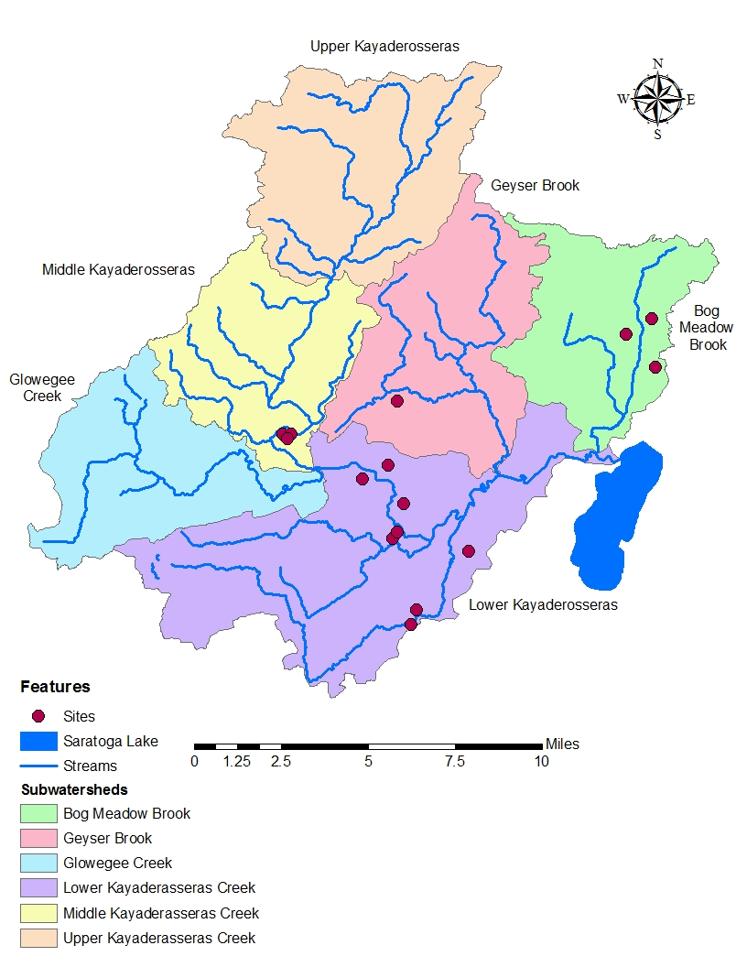
Figure 1. Locations of the 15 focus sites within the Kayaderosseras Creek watershed

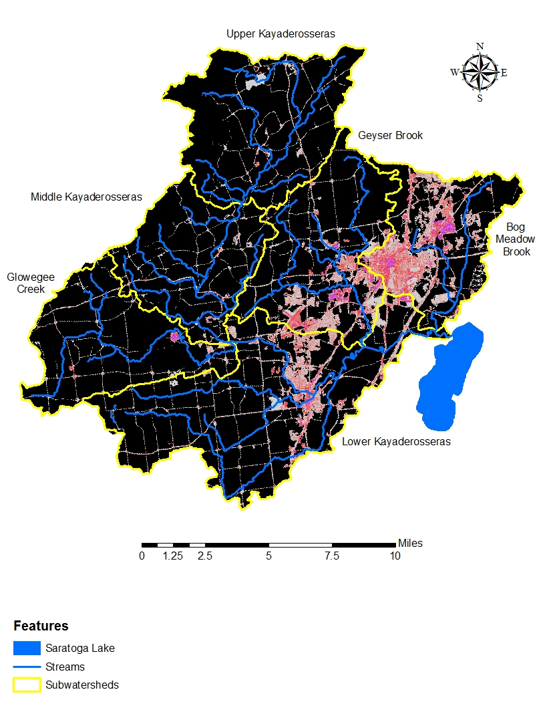
Figure 2. Impervious cover throughout the Kayaderosseras Creek watershed in 2011

Figure 3. Correlation between post-development runoff temperature and the percent of impervious area at the sites.

Figure 4. Correlation between stream temperature changes and the percent of impervious area at the sites.

Figure 5. Correlation between stream temperature changes and baseflow.

Figure 6. Average temperature changes for different hydrologic soil groups. Error bars represent standard error.

Table 1. Change in Impervious area over the past 50 years by decade
Decade | Added Impervious Residential Area (acres) | Total Impervious Residential Area (acres) | Total Impervious Residential Area (%)
2000-2011 | 236.64 | 1267.74 | 1.05
1990-2000 | 161.19 | 1031.09 | 0.86
1980-1990 | 125.23 | 869.90 | 0.72
1970-1980 | 166.39 | 744.67 | 0.62
1960-1970 | 140.34 | 578.28 | 0.48
Pre-1960 | 437.94 | 437.94 | 0.36

Table 2. Changes in runoff temperature from each site based on variables listed.
Subwatershed | Site # | Impervious Area (%) | Area (acres) | T_{C} (hr) | Runoff Temperature (°F)
 |  |  |  |  | Post-Development | Change
Upper Kayaderosseras | 1 | 7.29 | 65.39 | 0.918 | 68.7 | 2.5
 | 2 | 13.58 | 9.24 | 0.453 | 72.7 | 6.5
 | 3 | 10.45 | 16.74 | 0.246 | 71.0 | 4.8
Lower Kayaderosseras | 4 | 23.17 | 96.42 | 1.366 | 76.7 | 10.5
 | 5 | 3.08 | 52.99 | 1.376 | 66.2 | 0.0
 | 6 | 8.56 | 30.86 | 0.360 | 69.8 | 3.6
 | 7 | 15.30 | 30.58 | 0.816 | 73.4 | 7.2
 | 8 | 9.37 | 31.10 | 0.192 | 70.4 | 4.2
 | 9 | 22.92 | 45.37 | 1.410 | 76.6 | 10.4
 | 10 | 29.91 | 19.19 | 1.167 | 79.2 | 13.0
 | 11 | 25.63 | 62.80 | 1.131 | 77.7 | 11.5
Bog Meadow Brook | 12 | 8.98 | 59.65 | 1.618 | 69.7 | 3.5
 | 13 | 10.55 | 27.37 | 1.645 | 70.7 | 4.5
 | 14 | 3.68 | 115.15 | 1.421 | 66.2 | 0.0
Geyser Brook | 15 | 10.92 | 72.87 | 1.538 | 70.9 | 4.7

Table 3. Changes in stream temperature after a storm event at each site.
Subwatershed | Site # | Impervious Area (%) | Baseflow  (cfs) | Change in Stream Temperature (°F)
Upper Kayaderosseras | 1 | 7.29 | 86.26 | 0.12
 | 2 | 13.58 | 86.26 | 0.03
 | 3 | 10.45 | 86.26 | 0.04
Lower Kayaderosseras | 4 | 23.17 | 130.90 | 1.25
 | 5 | 3.08 | 130.90 | 0.09
 | 6 | 8.56 | 135.88 | 0.01
 | 7 | 15.30 | 132.71 | 0.002
 | 8 | 9.37 | 18.55 | 0.10
 | 9 | 22.92 | 20.66 | 1.47
 | 10 | 29.91 | 20.66 | 0.86
 | 11 | 25.63 | 24.43 | 2.60
Bog Meadow Brook | 12 | 8.98 | 9.15 | 0.73
 | 13 | 10.55 | 9.15 | 0.39
 | 14 | 3.68 | 9.15 | 0.83
Geyser Brook | 15 | 10.92 | 12.79 | 0.10

Table 4. Sheet flow inputs for Tc calculations.
Site # | Length (ft) | Slope | Surface Code | Manning’s “N” | T_{t} (hr)
1 | 25 | 0.001 | a | 0.011 | 0.023
2 | 25 | 0.001 | a | 0.011 | 0.023
3 | 25 | 0.001 | a | 0.011 | 0.023
4 | 25 | 0.001 | a | 0.011 | 0.023
5 | 25 | 0.001 | a | 0.011 | 0.023
6 | 25 | 0.001 | a | 0.011 | 0.023
7 | 25 | 0.001 | a | 0.011 | 0.023
8 | 25 | 0.001 | a | 0.011 | 0.023
9 | 25 | 0.001 | a | 0.011 | 0.023
10 | 25 | 0.001 | a | 0.011 | 0.023
11 | 25 | 0.001 | a | 0.011 | 0.023
12 | 25 | 0.001 | a | 0.011 | 0.023
13 | 25 | 0.001 | a | 0.011 | 0.023
14 | 25 | 0.001 | a | 0.011 | 0.023
15 | 25 | 0.001 | a | 0.011 | 0.023

Table 5. Shallow concentrated flow inputs for Tc calculations.
Site # | Length (ft) | Slope | Surface Code | Velocity | T_{t} (hr)
1 | 4025 | 0.010 | p | 2.03 | 0.550
2 | 1360 | 0.012 | p | 2.23 | 0.170
3 | 1250 | 0.078 | p | 5.68 | 0.061
4 | 2355 | 0.022 | p | 3.02 | 0.217
5 | 3280 | 0.024 | p | 3.15 | 0.289
6 | 1220 | 0.046 | p | 4.36 | 0.078
7 | 1730 | 0.029 | p | 3.46 | 0.139
8 | 1725 | 0.033 | p | 3.69 | 0.130
9 | 1125 | 0.056 | p | 4.81 | 0.065
10 | 3275 | 0.028 | p | 3.40 | 0.267
11 | 3225 | 0.016 | p | 2.57 | 0.348
12 | 2200 | 0.016 | p | 2.57 | 0.238
13 | 3910 | 0.015 | p | 2.49 | 0.436
14 | 1525 | 0.054 | p | 4.72 | 0.090
15 | 2420 | 0.024 | p | 3.15 | 0.213

Table 6. Open channel flow inputs for Tc calculations.
Site # | Length (ft) | Slope | Manning's Roughness | Hydraulic Area | Wetted Perimeter | Velocity | T_{t} (hr)
1 | 15441 | 0.008 | 0.04 | 106.40 | 51.40 | 5.41 | 0.792
2 | 19688 | 0.006 | 0.04 | 106.40 | 51.40 | 4.69 | 1.167
3 | 5370 | 0.008 | 0.04 | 106.40 | 51.40 | 5.41 | 0.276
4 | 11217 | 0.008 | 0.04 | 106.40 | 51.40 | 5.41 | 0.576
5 | 5983 | 0.002 | 0.04 | 66.40 | 31.40 | 2.75 | 0.605
6 | 4924 | 0.004 | 0.04 | 66.40 | 31.40 | 3.88 | 0.352
7 | 1656 | 0.008 | 0.04 | 66.40 | 31.40 | 5.49 | 0.084
8 | 15470 | 0.003 | 0.04 | 46.40 | 21.40 | 3.42 | 1.257
9 | 13275 | 0.003 | 0.04 | 46.40 | 21.40 | 3.42 | 1.079
10 | 5915 | 0.001 | 0.04 | 56.40 | 26.40 | 1.95 | 0.841
11 | 13237 | 0.003 | 0.04 | 20.03 | 11.53 | 2.95 | 1.247
12 | 12223 | 0.002 | 0.04 | 20.03 | 11.53 | 2.41 | 1.410
13 | 8210 | 0.002 | 0.04 | 20.03 | 11.53 | 2.41 | 0.947
14 | 2791 | 0.026 | 0.04 | 16.03 | 9.53 | 8.50 | 0.091
15 | 14840 | 0.003 | 0.04 | 14.47 | 7.47 | 3.17 | 1.300

Table 7. Assumed TURM inputs.
Rainfall Depth (in) | 1.16
Rainfall Duration (hr) | 3.0
Hour of Day Rain Began | 12
Wind Speed (ft/s) | 7.9
Rain Temperature (°F) | 73.0
Initial Temperature of Impervious Surfaces (°F) | 90.0
Air Temperature (°F) | 73.2
Humidity (%) | 80.3

