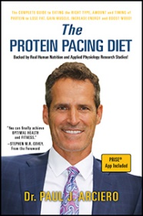
Professor Paul Arciero from the Health and Human Physiological Sciences Department has published a new book that is based on the results from a decades worth of research from his laboratory. The Protein Pacing Diet offers a plan designed to help individuals get off the diet roller coaster and live with optimal health and performance. Professor Arciero reveals the new peer-reviewed research behind his time-efficient and easy-to-follow lifestyle of optimal nutrition, fitness and mind-body exercises using Protein Pacing and his PRISE Life Protocol in a step-by-step process of just five easy strategies that result in drastic reductions in body fat, blood pressure, blood sugar and blood lipids and massive increases in lean body mass and fitness levels in women and men of all ages! The Protein Pacing Diet is available online through Amazon.com. For more information, visit the author’s website at www.paularciero.com or www.priselife.com.

