FALL 2024 EVENTS

Joseph Alpar: Jewish history and the music of the Ottoman Middle East
Ethnomusicologist, performer, and educator Joseph Alpar offers a series of workshops and a performance exploring the intertwined histories of Jews, Muslims, and Christians in the Ottoman Empire through music.
October 16 and November 16, 2024
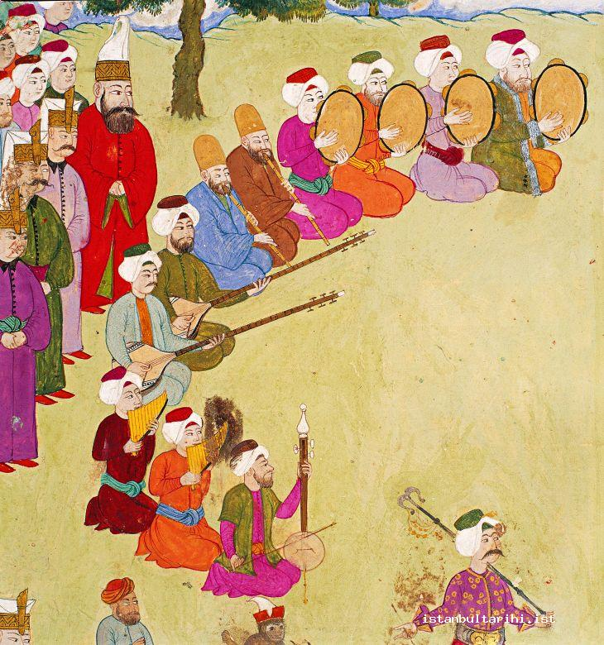

Series events schedule
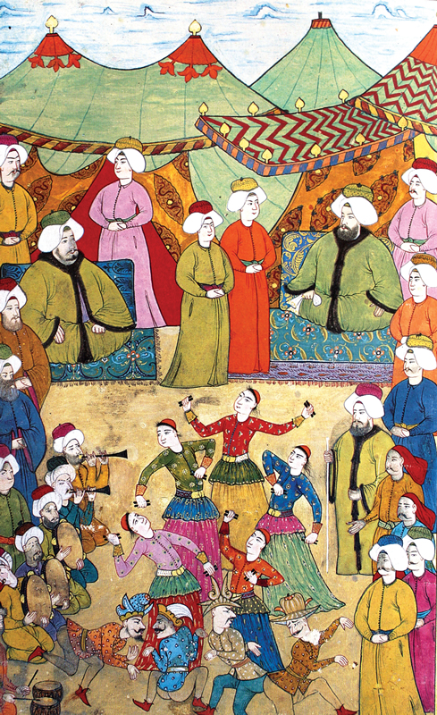
Singing Pirkei Avot in Istanbul: Synagogue Liturgy, Religious Propriety, and Changing Perceptions of Musical Beauty
Wednesday, October 16 from 12:00 to 1:30 PM
Tang Teaching Museum
Lunch will be provided during this demonstration of music and song with audience conversation.

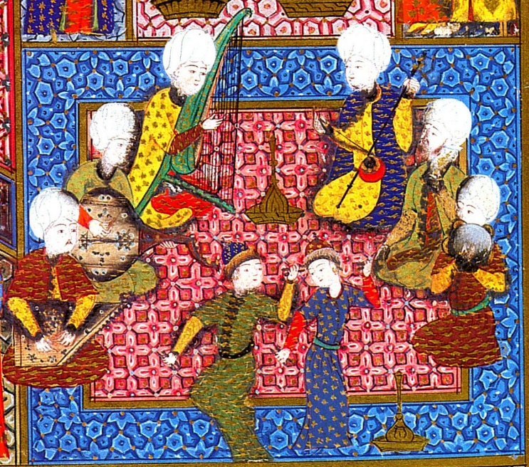
Kantikas de Sefarad: Songs of the Sephardim of Turkey, Greece, and North Africa
Singing workshop with Joseph Alpar
Wednesday, October 16 from 6:00 to 7:30 PM
Wyckoff Center in Case Campus Center
This singing workshop will introduce participants to the vibrant world of Sephardic song. Alpar will introduce the genres of romanzas and kantikas, demonstrating and teaching several examples that the participants can sing together. During the workshop and the post-workshop conversation, the group will discuss the contexts (weddings, circumcisions, courtship, parties, emigration, and more) in which such songs would be sung. Alpar will play the Greek santouri, a hammered dulcimer, and several Middle Eastern hand drums during the course of the workshop.

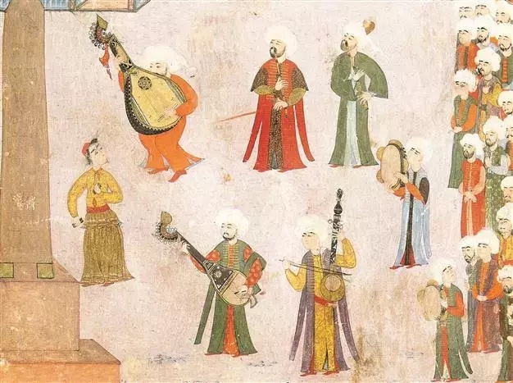
Aşk: Music, Love, and Mysticism in the Ottoman World
November 16, 2024 at 7:30 PM
Arthur Zankel Music Center, Helen Filene Ladd Concert Hall
Admission is free and open to the public.
Joseph Alpar and his ensemble will perform a diverse and exciting program of music exploring the long, intertwined histories of Jews, Muslims, and Christians in the Ottoman Empire from the 14th through 20th centuries. The central theme of the concert is love—aşk in Turkish (pronounced ah-shk)—in all its forms. Poignant songs of unrequited desire, lyrical wedding ballads about marital loyalty, bawdy tunes delighting in infidelity, driving Sufi and Jewish mystical songs about Divine and earthly beloveds, and musical vignettes of everyday courtship, relationships, and separation. The concert will tell an inspiring story of shared musical traditions and intense cultural collaboration between the peoples of the Ottoman world in several languages—Turkish, Hebrew, Judeo-Spanish (Ladino), Greek, and Arabic. Joseph Alpar will sing and perform on several Turkish and Greek instruments and will be joined by a stellar ensemble.
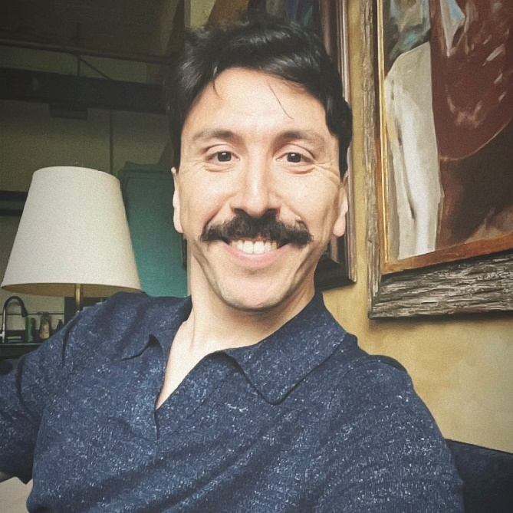
About Joseph Alpar
Dr. Joseph Alpar is an ethnomusicologist, performer, and educator who currently teaches at Bennington College. His research centers on musical and religious practices in Turkey and former Ottoman territories, Jewish music, Sufi music, and music and modernity. Alpar earned his Ph.D. in ethnomusicology from The Graduate Center, City University of New York in May 2020, having completed a dissertation titled, “Music and Jewish Practice in Contemporary Istanbul: Preserving Heritage, Bending Tradition.” His research has been supported by fellowships from The American Research Institute in Turkey (ARIT) and The Center for Jewish Studies at The Graduate Center, CUNY among other institutions. In addition to his academic work, Alpar is an accomplished multi-instrumentalist and singer of Middle Eastern and Western art music. He is the director of David’s Harp, an acclaimed Philadelphia-based ensemble specializing in the music of Turkey, Greece, and North Africa, particularly in the music of Sephardic and Mizrahi Jewish communities. He has taught previously in the music departments of Swarthmore College, Temple University, and CUNY, Hunter College. He was a fellow in the Herbert D. Katz Center for Advanced Judaic Studies to study and contribute to Jewish Life in Modern Islamic Contexts project.
Sponsored by the Jacob Perlow Series, Office of Special Programs, and the departments of Music, Environmental Studies and Sciences, Religious Studies, Political Science, and History. Funding is provided by endowments established by Jacob Perlow and by Beatrice Troupin.
About the Jacob Perlow Series: A generous grant from the estate of Jacob Perlow - an immigrant to the United States in the 1920s, a successful business man deeply interested in religion and philosophy, and a man who was committed to furthering Jewish education - supports annual lectures and presentations to the College and Capital District community on issues broadly related to Jews and Judaism. Additional funding was provided by a bequest from Mrs. Beatrice Perlman Troupin.

