SPRING 2025 EVENTS

creativity and counter-histories
Jewish historian David Biale coined the phrase "counter-histories" for stories that deliberately brush against the grain of conventionally accepted narratives. Counter-histories can be openly polemical or they can be playful, imaginatively reconstructing Jewish lives; either way, they open up new ways for us to understand the past and, thus, to occupy the present moment.
This Jacob Perlow residency sponsors two consecutive evenings that link creativity with counter-histories. Please join us in the Wyckoff Center in Case Center for these events which are free and open to the public.
March 25 and 26, 2025
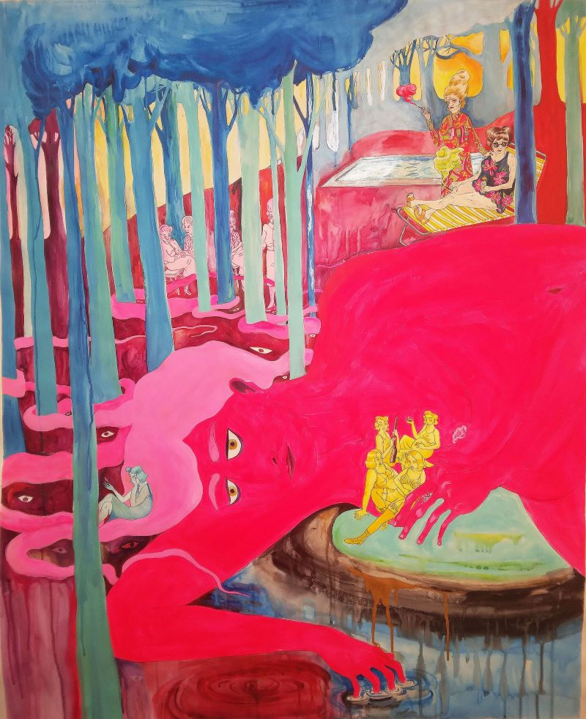
Artwork by Leela Corman

Series events schedule

Countering Histories: A Conversation Between Steve Stern and Leela Corman
Tuesday, March 25 at 7:30 PM
Wyckoff Center in Case Campus Center
Novelist Steve Stern and graphic novelist Leela Corman talk with each other about the stories they choose to tell. Both authors center Jewish characters who arrest our attention and grapple with the absurdities of life. Stern and Corman will discuss recent and ongoing projects, the role of research in honing their craft, and how their fictions reverberate with facts.
Creating Sounds, Creating Images: A Collaboration Between Thalia Zedek and Leela Corman
Wednesday, March 26 at 7:30 PM
Wyckoff Center in Case Campus Center
Dissonant guitar, raspy vocals, noise loops, paintings that bleed emotion and color: Thalia Zedek and Leela Corman combine forces for an evening of musical and visual improvisation. The artists will jointly present a multi-media show, described as a "haunting, immersive atmosphere," followed by questions and answers.
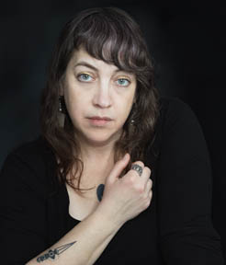Leela Corman, graphic storyteller and author of Unterzakn (2012), You Are Not a Guest (2023), and Victory Parade (2024), teaches at the Rhode Island School of Design. Celebrated equally for her striking, expressionist art as for her bracingly honest writing, Corman's creative output is deeply informed by historical trauma. Among numerous residencies, Leela was at Yaddo in 2019 and 2023, and she has received awards and grants from the Xeric Foundation, Koyama Provides, and the Museum of Comic and Cartoon Art. Photo by Dena Rosenberg.
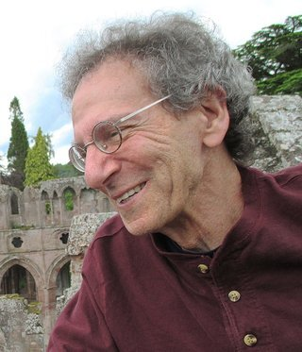Steve Stern, whose novels and short stories rework Jewish folklore into contemporary fiction, is Professor Emeritus of English at Skidmore College. Stern won the National Jewish Book Award for The Wedding Jester (1999), has been awarded Guggenheim and Fulbright fellowships, and delivered the 2014 Edwin M. Mosley lecture on "Creative Amnesia, or the Persistence of Magic." Recent, lauded books by Steve include The Frozen Rabbi (2010), The Pinch (2015), and The Village Idiot (2022). Photo by Sabrina Jones.
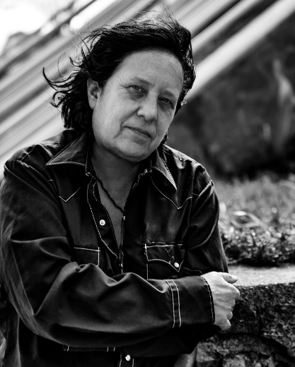Thalia Zedek, legendary alt rock singer, songwriter, and guitarist, has fronted bands such as Uzi, Live Skull, Come, and E. Highly respected in the independent music scene, Zedek's four decades of musical output melds art rock with post punk brio. Thrill Jockey lauds her, "fiery voice and frank lyricism," and she has been collaborating recently with Leela Corman for live performances. Photo by Mark Shaw.
Sponsored by the Jacob Perlow Series, Office of Special Programs, and Religious Studies Department. Funding is provided by endowments established by Jacob Perlow and by Beatrice Troupin.
About the Jacob Perlow Series: A generous grant from the estate of Jacob Perlow - an immigrant to the United States in the 1920s, a successful business man deeply interested in religion and philosophy, and a man who was committed to furthering Jewish education - supports annual lectures and presentations to the College and Capital District community on issues broadly related to Jews and Judaism. Additional funding was provided by a bequest from Mrs. Beatrice Perlman Troupin.

