IPPC Subcommittee on Responsible Citizenship
Strategic Planning White Paper

1. How does your group view the College today?
Keywords: civic engagement; citizenship; community

The SRC, as a subcommittee of IPPC, appreciates that “informed, responsible citizenship” has been one of four pillars of the Strategic Plan and acknowledges its status. We also recognize some significant accomplishments, indicating widespread student, staff, and faculty participation in civic engagement activities.
- Annually since 2009, Skidmore has been included in the President’s Higher Education Community Service Honor Roll by the Corporation for National and Community Service.
- In 2010, Skidmore obtained the Carnegie Elective Classification in Community Engagement.
- In 2012, the SRC became a permanent subcommittee of IPPC.
- In 2012/2013…
  - 66% of students participated, at least occasionally, in civic engagement activities through coursework or co-curricular activities.
  - 62 service-learning courses were offered, up from 20 in 2006/2007.
  - 40 community agencies served as collaborative partners.
  - 22 charitable fundraisers were held, donating over $22,000.
  - 40 Honors Forum students completed Citizenship Projects.
  - 57 students were funded to participate in civic engagement summer internships and See Beyond projects (76% of 75 funded projects).
  - 69 faculty members participated in AVD grant divisional workshops to explore civic engagement opportunities in their courses.
  - The interdisciplinary scientific literacy initiative was launched.
- Skidmore has also invested heavily in sustainability and engaged significantly in many efforts related to campus sustainability. For example, our Environmental Studies major is just over ten years old and is now the fifth largest major on campus. Our four faculty members within the program, coupled with our numerous Affiliated Faculty from across the College, offer a rigorous and diverse curriculum. Also within the past ten years, we have hired a Campus Sustainability Coordinator and two Sustainability Fellows, added an Associate Dean of the Faculty position for Infrastructure, Sustainability, and Civic Engagement, and increased the number of courses from across the College that include sustainability-focused material and experiences. Furthermore, major efforts by groups including Facilities Services, Financial Services, and Dining Services are transforming our campus into an educational tool for sustainability; our recent Sustainability Leadership Award from the Association for the Advancement of Sustainability in Higher Education for our geothermal systems and our recent NYSERDA grant to launch the New York Executive Clean Energy Leadership Institute are both indicators of our success.

At the same time, the SRC acknowledges that, despite our efforts to make civic engagement a top priority, we face continuing challenges in making it part of our institutional culture. We share some illustrative data below:
- While 95% of students come to Skidmore with service experience and 69% expect to continue with their service, they volunteer on a regular basis significantly less than students at our peer institutions.
- Less than half of our students believe civic engagement is a high priority for themselves or for the College.
- Compared to many of our peer institutions, we have not invested as heavily in FTE staff to support civic engagement activities.

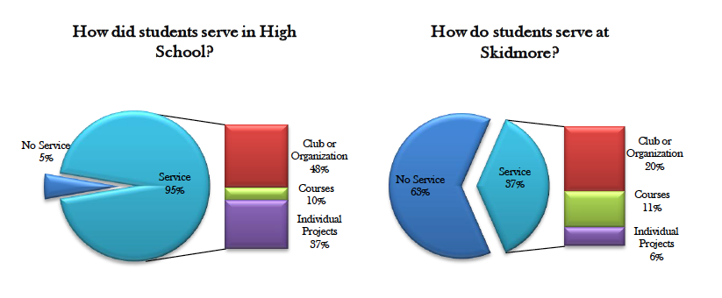
(Assessment of Service and Civic Engagement Survey, 2010)

Note: These data are based on a review of websites, focusing on full-time, dedicated positions in civic engagement offices, including those that may be temporary, grant-funded positions. They do not include sustainability positions, shared appointments, or part-time positions, which are common at Skidmore and at our peers. For Skidmore we are only including our one full-time, permanent position dedicated exclusively to civic engagement (our Director of Community Programs), although we should recognize that at the moment we do have seven grant-supported faculty Civic Fellows and a Director of our AVD grant focused on civic engagement, an Associate Dean of the Faculty for Infrastructure, Sustainability, and Civic Engagement, an Associate Dean of Student Affairs and Director of Campus Life, and our Quadracci Chair in Social Responsibility, all of whom, along with numerous faculty members, contribute to our civic engagement efforts.

2. How does your group view the external world?
Keywords: civic engagement; citizenship; leadership

Currently, a national movement is seeking to promote civic engagement in higher education. For example, the largest organization that has focused on this, Campus Compact, had 235 member institutions in 1991. At that time, those institutions offered limited civic engagement opportunities for students: 16% of students in Campus Compact institutions were actively volunteering in the community; 15% had offices of community service; and 59% of faculty were “not at all” or “little” involved in civic engagement work. Today, Campus Compact has 1,100 members. Thirty-one percent of its collective students are actively volunteering in the community; 94% of member institutions have offices of community service; and 90% of member institutions incorporate civic learning as an important learning outcome in their strategic plans.

The AAC&U’s National Task Force on Civic Learning and Democratic Engagement has defined four areas of civic endeavor for higher education:
1. Foster a civic ethos across all parts of campus and educational culture;
2. Make civic literacy a core expectation for all students;
3. Practice civic inquiry across all fields of study;
4. Advance civic action through transformative partnerships, at home and abroad.

We believe that the Skidmore community needs to recognize more deeply the major advances underway in civic engagement at our peer institutions and among the leadership of major higher education associations.

3. How does your group describe the College you would like to see us become by 2025?
Keywords: civic engagement; citizenship; leadership

American society faces significant challenges from terrorism to climate change to political gridlock. The world needs Skidmore graduates who are ready to critically evaluate and respond to such complex issues—informed, responsible citizens. Although there is significant pressure to define higher education as a private good, we encourage Skidmore to embrace civic engagement as a prominent feature of our liberal education.

While we recognize and celebrate the manifold civic engagement activities at Skidmore, we believe they need to be made even more visible and robust to allow students to perceive and choose from a wide range of activities and options. We would also like to see a continuation of dedicated resources and a clear plan for continuing campus leadership for civic engagement.

By 2025, the SRC would like to see Skidmore recognized for:
- More explicit commitment to civic engagement;
- Widespread student involvement and leadership of ongoing civic engagement activities;
- Additional signature civic engagement projects in partnership with our surrounding communities.

Sponsler, Laura E. and Matthew Hartley. 2013. Five Things Student Affairs Professionals Can Do to Institutionalize Civic Engagement. Washington, DC: NASPA Research and Policy Institute Issue Brief.
National Task Force on Civic Learning and Democratic Engagement. 2012. A Crucible Moment: College Learning and Democracy’s Future. Washington, DC: Association of American Colleges and Universities.

