Religion 241: Theorizing the Sacred
Instructor: Dr. Onishi Skidmore College
Office: Ladd Hall 210 Office Hours: by appt.
Phone: 714 833 4345 Email: bradley.b.onishi@gmail.com
Time: TR 4:30-6:20pm

Course Description
This course engages important theoretical approaches to the study of religion and introduces students to different questions and methodologies in the field. Readings will come from a selection of influential thinkers on religion from a variety of fields, including psychology, sociology, anthropology, and philosophy. Themes considered will include defining ‘religion,’ understanding the nature of religious experience, decoding the symbolic language of ritual, mapping the social function of religion, and probing the reality behind mystical experience.

Objectives
- Articulate a range of approaches to the study of “religion” throughout the history of the discipline.

- Be able identify assumptions about the nature of religion and critical ways of addressing or studying religion and religious phenomena.

- Demonstrate understanding of critical concepts in the study of religion such as: world religions, pluralism, function, totem, the sacred, and so on.

- Clarify an understanding of religions and the study thereof in dialogue with central conversations across the field.

Attendance
Attendance is important but our primary concern at this time is your health and well-being. In this difficult climate, I ask that you only miss class when necessary (no explanation is needed). If you do need to miss class, I will work with you to the extent possible. Such absences will not be counted against you.
You can always reach out to me via email. We can setup individual Zoom meetings at any time in the semester.
However, in lieu of attendance requirements, you are required to send a minimum of 3 questions via Marco Polo throughout the semester.
- That means, 3 questions = for the whole semester.
  - One before February 15.
  - One before March 15.
  - One before April 15.
  - If you don’t fulfill this requirement, I will deduct 3 percentage points from your final grade.
You can sign up with an email address (phone number is not required). Marco Polo allows for video messaging. It is essentially an easy way to send video text messages. You can record a short video of your question and I will respond with a similar video message. This will make asking questions “face-to-face” easier. You won’t always need a Zoom meeting or have to write out an email. It is as easy as hitting a button and asking your question. I will try to respond within 12 hours.
Find me on the app: 714 833 4345.

https://www.marcopolo.me/

Class Structure: Synchronous/asynchronous
Each week there will be an asynchronous video or podcast to watch/listen to for the Tuesday slot of class.
- This will be linked to the first reading of the week.
- The podcast or video will be posted under the Announcements tab on theSpring.
- Your Mind Map assignment each week will be linked to this first reading and video/podcast.
Each week we will have a synchronous meeting via Zoom during the Thursday slot of the course. This will be linked to the second reading of the week.
- I know synchronous can be difficult due to schedules, different time zones, etc. My hope is that you all will be able to attend this meeting each week. I think it will help build the discussion and understanding amongst all of us. However, you will not be penalized if you can’t attend.
- The recordings will be made available for on-demand viewing.

Summary:
Each week you will:
- Tuesday: Watch/listen to a podcast or video.
- There will be a reading linked to this podcast/video.
- Complete a Mind Map assignment related to this content.

- There will be a meeting via Zoom on Thursday during class time. It will be recorded.
- There will be a reading for this meeting. DO IT BEFORE THE MEETING.
- Most weeks you will complete a read-watch response to this meeting. The exceptions are 10/1 and 11/12, when our analysis papers are due.

Assignments

- Mind Map: 24% (MM) (2x12)
- Analysis Paper: 20%
- Creative Dialogue Projects: 20% (4x5)
- Case Study Un-Essay: 36%

Assignment Details

Creative Dialogue Projects
See Separate Sheet

Mind Map Assignments

There are 12 Mind Map Assignments (MM) for this course. Due dates are listed on theSpring.

What is a mind map?
“A mind map is an easy way to brainstorm thoughts organically without worrying about order and structure. It allows you to visually structure your ideas to help with analysis and recall.
A mind map is a diagram for representing tasks, words, concepts, or items linked to and arranged around a central concept or subject using a non-linear graphical layout that allows the user to build an intuitive framework around a central concept. A mind map can turn a long list of monotonous information into a colorful, memorable and highly organized diagram that works in line with your brain's natural way of doing things.” (mindmapping.com)

Goal
To make a visual map of the assigned reading and content. Mind maps allow you to organize the information in a visual format that allows for creativity and personalization. The goal is to place the main topic in the center and then to work outward in order to create a visual representation of the main ideas and their corollaries.

Examples

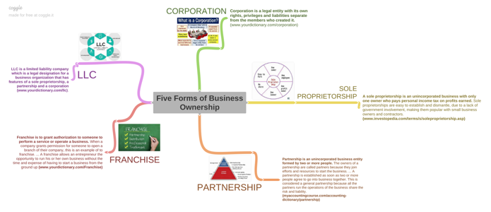

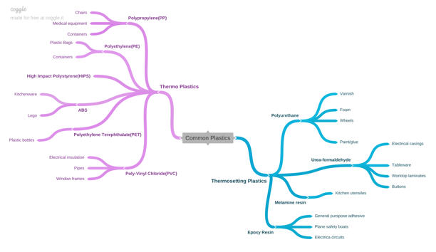

How Do I Make a Mind Map?
- If you like to work by hand, you can create your mind maps manually using pens and pencils. One of the major benefits of this is that manual production is shown to help retention and recall. If you choose this method, you will take a picture of your mind map and upload it to the assignment tab.

- You can use Microsoft Word. Here is a helpful tutorial: https://www.edrawsoft.com/mindmap/create-mind-map-on-microsoft-word.html

- You can use software: https://coggle.it/

Rubric
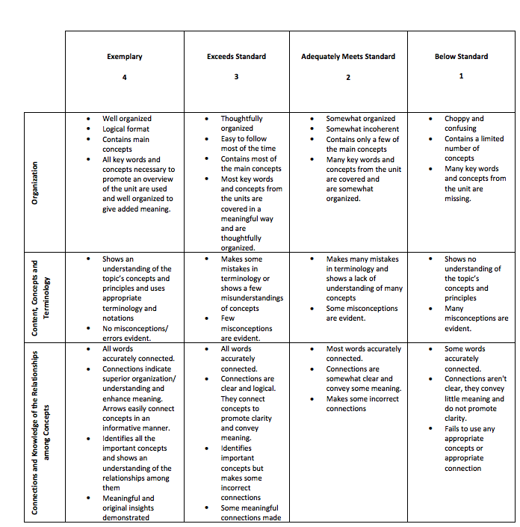
Each Mind Map is worth 2pts.

- 4 = 2pt.

- 3 = 1.5pt.

- 2 = 1pt.

- 1 = .5pt.

Books to Purchase
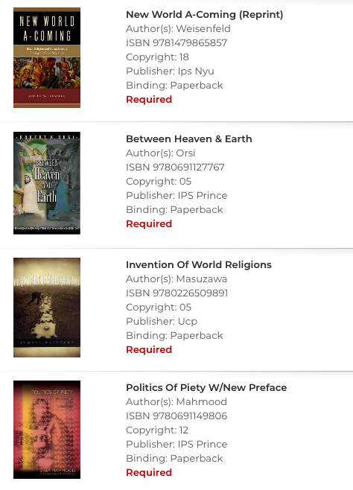

Schedule

World Religions or Nah?
2/2: Introduction
2/4: J.Z. Smith (theSpring)
2/9: Masuzawa
2/11: Masuzawa
2/16: Keeping it 101: Ep. 103 + 104 (link in Announcements @theSpring)
2/18: Diana Eck (theSpring)
2/23: Hulsether, Grammar of Racism (theSpring) + podcast
2/25: Decolonizing Religious Studies: Podcast + https://olh.openlibhums.org/articles/10.16995/olh.421/

How Close Should We Get?
3/2: Eliade: Sacred and Profane + On Eliade’s Sacred and Profane
3/4: McCutcheon, Critics, Not Caretakers
3/9: Tyler Roberts, Against McCutcheon
3/11: Orsi
3/16: Break Day
3/18: Orsi
3/23: Saba Mahmood
3/25: Saba Mahmood

What Do “Religions” Do?
3/30: Review + Project Explanation
4/1: Midterm
4/6: Durkheim
4/8: Tweed
4/13: Mari Kondo, Episode + Home: https://therevealer.org/sparking-joy-religion-representation-marie-kondo/
415: Chidester, Authenticity and Fakes
4/20: Weisenfeld + (podcast)
4/22: Weisenfeld

The Leftovers
4/27: Discussion of Leftovers
4/29: Why We Don’t Say “Cult” (Keepin It 101)
5/2: TBD

Health and Safety Protocols
The College expects all members of the community to adhere to health and safety protocols at all times, including when entering and exiting academic buildings and classrooms. In addition, we are all expected to pay attention to signage that directs traffic within buildings; clean classroom work stations at the beginning and end of classes; refrain from drinking and eating in the classroom; wear a mask at all times in public spaces, including in classrooms; and practice safe social distancing.
You must wear a mask covering your mouth and nose fully at all times in the classroom. If your mask is not providing sufficient protection because it has slipped in some way, you are responsible for adjusting the fit. If I ask you to wear your mask properly, you must comply or you can choose to leave the classroom.

Contact Tracing and Classroom Seating Plans
Contact tracing will be overseen by Health Services, with the assistance of additional staff members who have been trained as contact tracers. To assist with contract tracing, faculty members teaching in-person classes are asked to maintain daily attendance records and to use seating charts (a template is attached). At the same time, we recognize that fixed seating arrangements are impracticable for certain classes due to the nature of the subject, the need to use specialized equipment, etc. In such cases, maintaining records of attendance will suffice. Last semester, attendance records and seating charts proved immensely helpful in expediting contact tracing.

Student COVID Pledge
Over the winter break, our colleagues in Student Affairs worked with students to revise the COVID pledge which has now been shared with the student body: https://www.skidmore.edu/campus-planning/secure/student-pledge.php (multiple screens). The same sanctions used in the fall for students who violate the pledge remain for this spring: https://www.skidmore.edu/reslife/docs/covid-policy-grid.pdf.

Title IX, Disability Accommodations, Grades, Religious Observance
Accommodation

If you are a student with a disability and believe you will need academic accommodation, you must formally request accommodation from Meg Hegener, Coordinator of Student Access Services (mhegener@skidmore.edu). You will also need to provide documentation which verifies the existence of a disability and supports your request. For further information, please call 580-8150 to contact Student Academic Services in Starbuck Center.

Title IX Statement

Skidmore College considers sexual and gender-based misconduct to be one of the most serious violations of the values and standards of the College. Unwelcome sexual contact of any form is a violation of students’ personal integrity and their right to a safe environment and therefore violates Skidmore’s values. Sexual and gender-based misconduct is also prohibited by federal and state regulations. Skidmore College faculty are committed to supporting our students and upholding gender equity laws as outlined by Title IX. If a student chooses to confide in a member of Skidmore’s faculty or staff regarding an issue of sexual or gender-based misconduct, that faculty or staff member is obligated to tell Skidmore’s Title IX Coordinator or Title IX Deputy Coordinator. The Title IX Coordinator or Deputy Coordinator will assist the student in connecting with all possible resources for support and options for reporting both on and off campus. Identities and details will be shared only with those who need to know to support the student and to address the situation through the college’s processes. If the student wishes to confide in a confidential resource, the Counseling Center Staff, Health Services, and Victim Advocates (anonymous) are all options available.

More information can be found at the Sexual and Gender-Based Misconduct website or by contacting the Title IX Coordinator, Joel Aure (jaure@skidmore.edu), 580-5708, or Deputy Coordinator for Student Affairs, Gabriela Melillo (gmelillo@skidmore.edu), 580-5022.

Grades

During the Spring 2021 semester, students who opt for the S/U mode of grading will earn the grade of “CR” (credit) if they receive a C-, D+, or D for their coursework.

Conscientious Religious Observance Policy:

If religious observances cause absence from class, campus employment, athletic practice, and/or game days or necessitates accommodations, students should notify their faculty, coaches, or supervisors prior to the date(s) of their absence. New York State policy and Skidmore College policy mandates that students be allowed to make up academic work and/or campus employment requirements without penalty. These accommodations should not reduce the overall expectations of a course nor unduly burden the student requesting accommodation. Faculty must permit students to take a makeup examination without any penalty if they have to miss an examination due to religious observances. Similarly, faculty must permit students to submit missed assignments by an agreed upon due date, without penalty.
Although not required, the College highly recommends that students submit written notification of the pending religious observances at the start of the semester or at least one week before the date. As an option, students may use this form. Distributing the written notification during the first week of classes, campus employment, or the start of the athletic season gives students, faculty, coaches, or supervisors time to prepare for the absence.
If a student, supervisor, coach, or faculty member feels the policy is being violated, they should contact the Dean of Faculty Office at 518-580-5705 (Palamountain 416), the Dean of Students Office at 518-580-5760 (Case Center 313), or Human Resources at 518-580-5800 (Barrett Center first floor).

