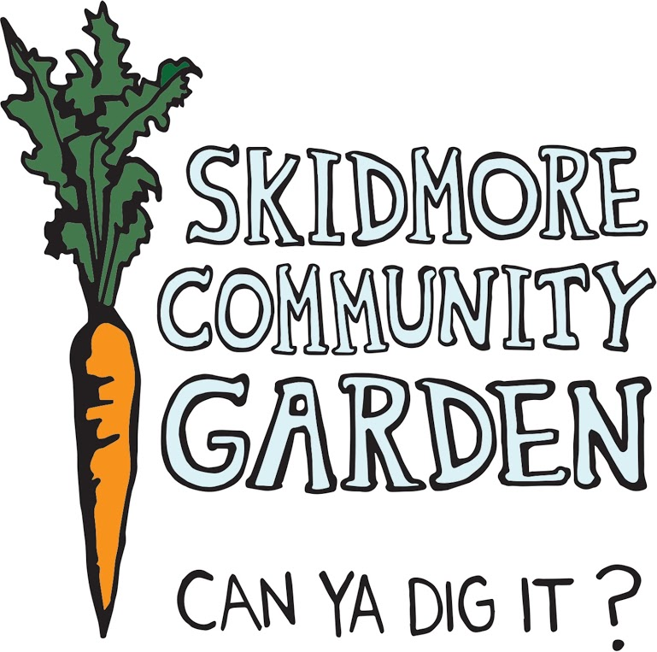

Skidmore Community Garden Manager
Sustainable Skidmore

Location: Skidmore College
Dates: Spring 2015 Semester, 4 hours/week
Summer 2015 (1st & 2nd Summer Session), approximately 30 hours/week;
Fall 2015 Semester, 4 hours/week
Compensation: Summer- $10/hour and room and board provided at Skidmore College,
Academic year- $8.50/hour

Description:
The primary responsibilities of the Skidmore Community Garden Manger will be to work with Sustainable Skidmore and garden volunteers to plan and maintain the Skidmore Community Garden. The manager is responsible for the planting, maintenance, and harvesting of vegetables; finding and retaining volunteers; recording harvest yields; creating invoices and recording financial transactions; communicating with Skidmore Dining Services, maintaining the garden blog and Facebook page; as well as reaching out to the Skidmore and Saratoga communities for events and educational outreach. The North Woods Stewards will assist the Garden Manager for 6 hours each week during the summer.

The position begins during the Spring 2015 and continues into the summer and through the end of the 2015 Fall Semester. The Garden Manager will report to Levi Rogers, Sustainability Coordinator. The Manager will work the 10-week summer period stated above, for regularly scheduled hours, as well during the spring and fall 2015 semesters with a reduced workload.

Duties:
Planting, Ongoing Maintenance, and Harvesting of Vegetables in the Garden
- Design a plan for the vegetables, herbs, and fruits in the Skidmore Community Garden & the Herb Garden based on interests of the community involved, suggestions from Dining Services, and insight garnered by reading previous years' annual reports
- Carry out the purchasing and planting of seeds and transplants
- Manage the ongoing weeding, watering, and maintenance of the Garden & the Herb Garden throughout the summer
- Harvest vegetables and herbs taking careful documentation of weight and variety, and deliver them to Dining Services along with a structured invoice of delivered produce
Administrative Tasks
- Keep track of the visitors/volunteers you have in the garden
- Create weekly invoices for Dining Services to keep track of financial transactions
- Log your hours for Sustainable Skidmore
- Attend regular meetings with Levi Rogers and North Woods Stewards
- Create an Annual Report based on previous years' reports. This document will contain successes, challenges, and tips for future managers to learn from and will serve as a journal to be edited throughout the growing season and submitted at the end of the year
- Coordinate weekly work parties while school is in session
- Coordinate the SCG’s annual Harvest Dinner in the fall semester
Reach Out to the Saratoga & Skidmore Community
- Write frequent blog posts on the SCG Tumblr and post on the SCG Facebook page to update the Skidmore and Saratoga communities on events and progress of the Garden
- Design innovative ways of spreading the word about the garden
- Create educational materials to promote the garden (i.e. videos, posters, and brochures)
- Reach out to local organizations for potential collaborations (Community Gardens of Saratoga, Sustainable Saratoga, the Farmers Market)
- Plan children’s activities with Camp North Woods 1-3 times over the summer and with groups such as the Early Childhood Center and the Greenberg Child Care Center on campus during the school year
- Collaborate with Skidmore faculty during the school year to host field trips and educational sessions at the garden
- Be a source for students and other Skidmore and Saratoga community members interested in the garden to connect with other educational opportunities relating to food and sustainable agriculture

Requirements:
- Previous experience in gardening and leadership roles
- Must be comfortable with moderate manual labor (i.e. shoveling, hoeing, etc)
- Previous experience working with volunteers and in community outreach
- Self-starter
- Submission of interest letter, resume, and two references (at least one Skidmore faculty/staff)

Please Submit Materials by November 23, 2014
with Community Garden Manager Application as the Subject Line to:
Sustainable Skidmore @ sustainability@skidmore.edu

Candidates will be notified by December 3, 2014 in regards to their application and top candidates may be asked for interviews prior to their hire.

